

Proud to be part of West Yorkshire

Health and Care Partnership

# Dynamic Support Register

# Self-Referral Consent Form

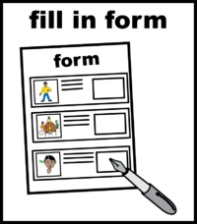

When you fill out the form to find out if you can be added to the Dynamic Support Register (**DSR**) please also fill out this form too.

Send both forms together.

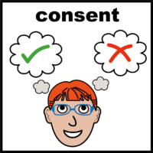If you are finding out if you can be added to the **DSR**, you must agree to it. This is called consent.

This means you can understand, think about and remember the information you need to decide.

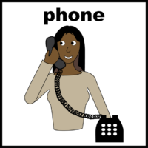If you need help to fill in this form, please call us on 07584 823503

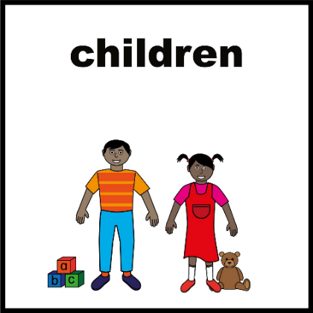

If you are under 16 years old, your parents or guardian would need to give consent for you.

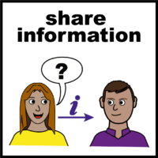

You will also need to decide to share your information with the health staff who will decide what to do about this form and to help offer support.

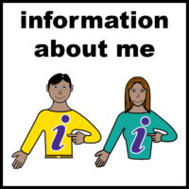If you would like to find out more about what happens to your information, please visit the

[WY Privacy Notice Webpage](https://www.westyorkshire.icb.nhs.uk/privacy-notice)

[www.westyorkshire.icb.nhs.uk/privacy-notice](http://www.westyorkshire.icb.nhs.uk/privacy-notice)

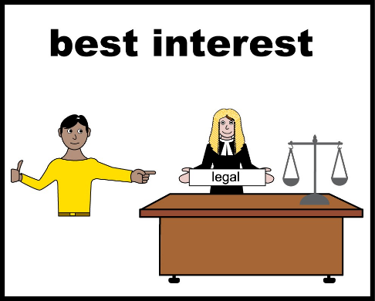

If you are not able to make this decision yourself, we will have a meeting to look at what is best for them. This is called a best interest meeting.



The best interest meeting will need to take place and be written down.

Please send us this information.

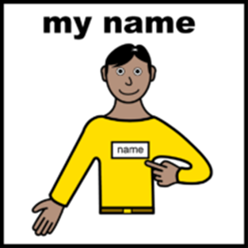

Please tell us your name or the name of the person that this form is about



Write down todays date



Have you had the right information and support to understand what a **DSR** is and why they want to find out if they can go on it?

Yes   No

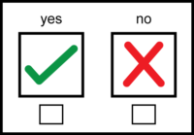

Do you consent to find out if you can be added to the **DSR**?

Yes   No

If everyone agrees you should be added to the DSR we will add your details to be discussed at the DSR meeting.

Do you consent to your information being shared with other people who will help you?

Yes   No 

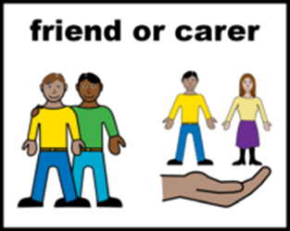

If someone helped you fill in this form and have written down their details to be contacted.

Please tell us their name

­­

Have they had the right information and support to understand what a **DSR** is and why we might have their information to contact them?

Yes   No

Do they consent to their information being shared with other people who will help support you?

Yes   No 

* [Easy read information about agreeing to a DSR.](https://www.england.nhs.uk/wp-content/uploads/2023/01/Easy-read-version-of-the-Dynamic-support-register-and-Care-Education-and-Treatment-Review-policy-and-guide-Jan.pdf)

[www.england.nhs.uk/wp-content/uploads/2023/01/Easy-read-version-of-the-Dynamic-support-register-and-Care-Education-and-Treatment-Review-policy-and-guide-Jan.pdf](http://www.england.nhs.uk/wp-content/uploads/2023/01/Easy-read-version-of-the-Dynamic-support-register-and-Care-Education-and-Treatment-Review-policy-and-guide-Jan.pdf)

* + [SeeAbility](https://www.seeability.org/resources/consent-and-capacity-easy-read)

[www.seeability.org/resources/consent-and-capacity-easy-read](http://www.seeability.org/resources/consent-and-capacity-easy-read)

* The West Yorkshire Key Worker Service for people up to the age of 25

[www.westyorkshirekeyworkerservice.org.uk](http://www.westyorkshirekeyworkerservice.org.uk)

0113 393 3240

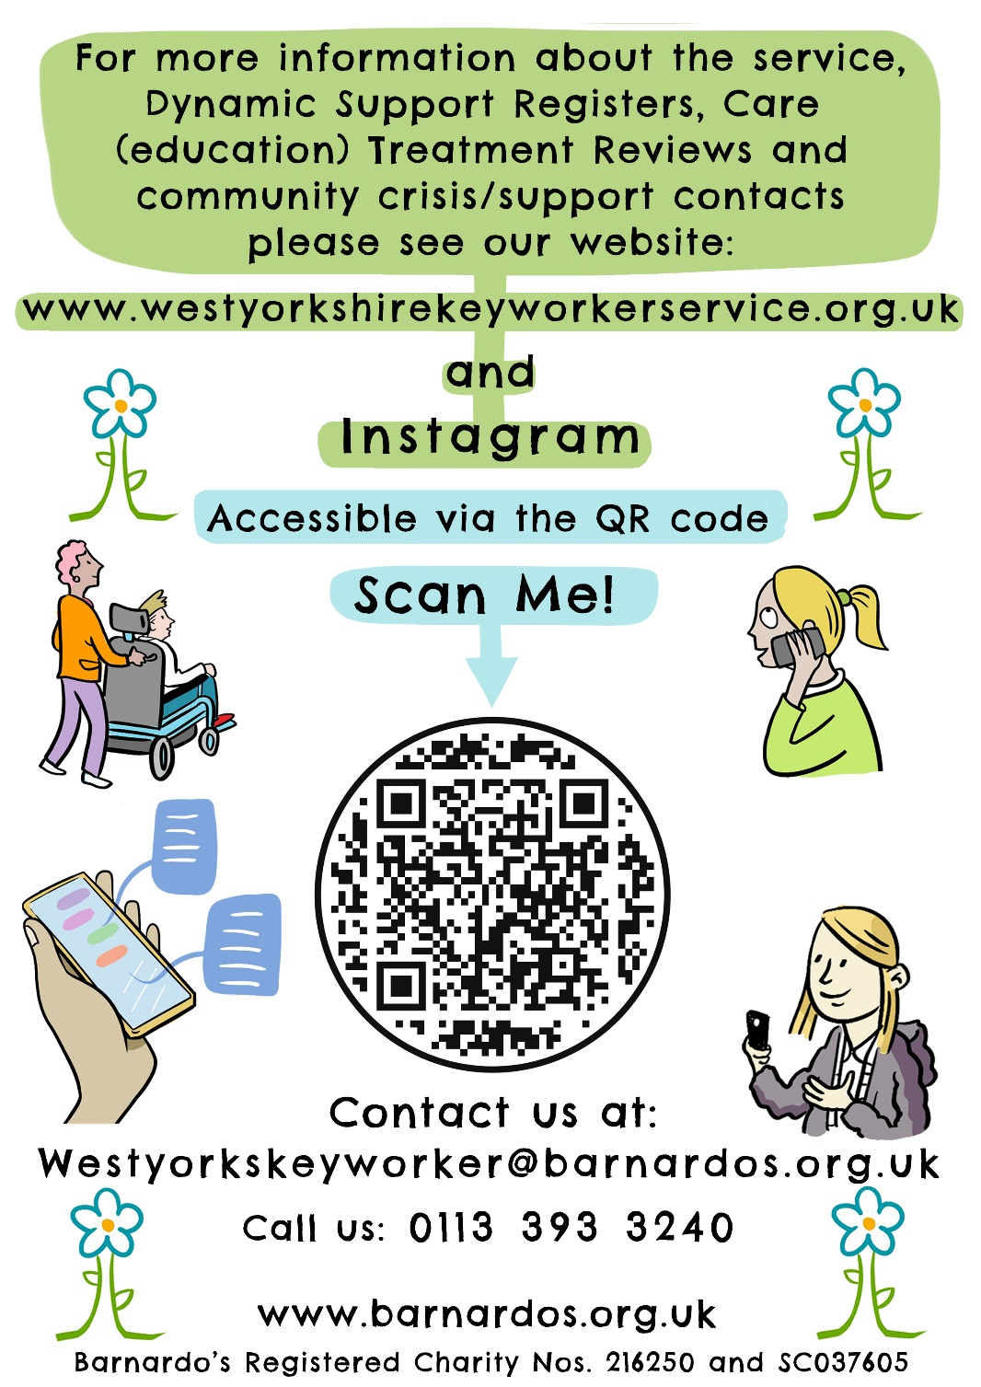

| **For Office Use Only** | Enter information below |
| --- | --- |
| Date received: |  |
| Outcome: (signposted, requires more information, accepted) |  |

Please send your completed form to :

For adults [wyicb-wak.ldandacommissioning@nhs.net](mailto:wyicb-wak.ldandacommissioning@nhs.net)

For Children and Young People [wyicb-wak.cypcommissionong@nhs.net](mailto:wyicb-wak.cypcommissionong@nhs.net)