REACH NEWSLETTER | 30 Oct

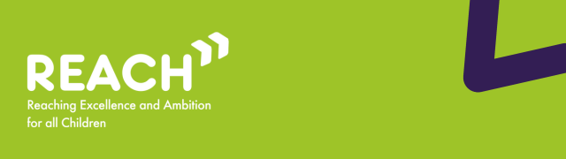

Welcome to the October edition of the REACh newsletter.
In this edition, you can find:
- Reminder: what is the Change Programme and what is it trying to achieve?;
- Updates and latest activity from across the Change Programme Partnerships;
- Spotlight on the REACH support offer: Hackathons and the Local Inclusion Support Offer;
- SEND & AP Change Programme: Phase 1 Insights Summary;
- Research, Reports and Events
Best wishes,
Luke Evason-Browning
Council for Disabled Children

Reminder: what is the Change Programme and what is it trying to achieve?
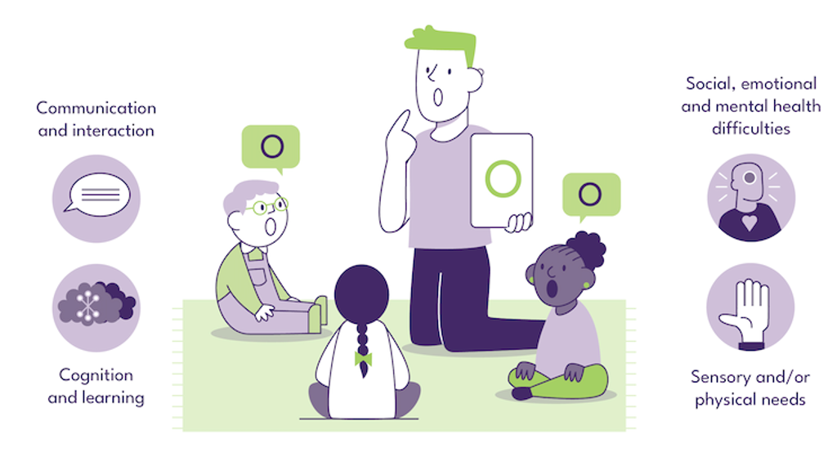
The Change Programme involves 32 local areas undertaking a ‘test and learn’ approach to changes across their local system, collaborating in Change Programme Partnerships (CPPs) in each of the 9 regions of England. Originally set up to test reforms set out in the SEND and Alternative Provision Improvement Plan, in its current phase, the Change Programme is working with these local areas to test a range of programmes collectively to strengthen the inclusion support offered to mainstream settings.
Building on earlier phases, the programme now covers continued work on the use of Alternative Provision through a 3-tier model of interventions and extending the Early Language Support for Every Child pathfinders that are enabling earlier identification and intervention for speech, language and communication needs. In the extension, the Change Programme has strengthened links with two other existing initiatives from the DfE: Alternative Provision Specialist Taskforces (APST) and the Programme for Inclusion of Neurodiversity in Schools (PINS) so that more of the local areas can test these models. Change Programme local areas also have the opportunity to test Assistive Technology ‘lending libraries’ that give schools the ability to test the effectiveness of these tools for their students so that they can make best use of funds to meet need.
The Change Programme involves working collaboratively with local areas and alongside partners from health, education and social care, as well as parent carers, children and young people, recognising that the insights and expertise of all of these groups are key to creating any new system. The Change Programme also works in parallel with other DfE programmes and wider work that is happening in the SEND sector, such as the Family Help reforms and Ofsted’s curriculum and assessment review, acknowledging the significant potential that these changes and initiatives have to be complementary to the activity on the Change Programme as well as the learnings from it.
The Reaching Excellence and Ambition for all Children (REACh) consortium are the DfE’s delivery partner for the Change Programme. The REACh consortium are made up of PA Consulting, IMPOWER, Council for Disabled Children and Olive Academies. REACh support local areas to implement and learn from nationally and locally developed initiatives, whilst also capturing learning from these initiatives and disseminating this to other Change Programme Partnerships as well as the DfE.

Updates and latest activity from across the Change Programme Partnerships
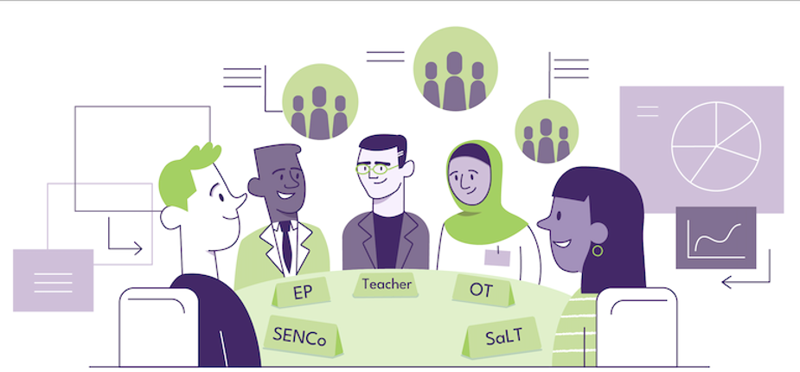
Workforce development
Local areas are continuing to place a strong emphasis on workforce development and inclusive practice guidance as part of the Change Programme, with a focus on strengthening the skills, knowledge and confidence of professionals working with children and young people with SEND. In Islington, the Mass Inclusion Training Programme has been launched, bringing together five local providers to deliver 19 training modules on a wide range of SEND-related topics through in-person, online and hybrid formats. This comprehensive training offer enables professionals to share learning, reflect on practice and build collective expertise across the local area. Alongside the delivery of training, local authorities are working to expand workforce capacity and confidence, with Islington introducing the Curriculum Inclusion Teacher (CIT) training and implementing a self-evaluation tool, developed by Educational Psychologists (EPs), to assess and review staff competencies and confidence in inclusive teaching. These developments are supporting a more reflective and skilled workforce, better equipped to meet the diverse needs of children and young people.
APST Model
Several LAs are piloting or expanding APST, often as outreach or intervention models and with multidisciplinary teams. In Durham, APST will focus on Years 5 to 8 to support children and young people who are at risk of exclusion or whose attendance is poor due to ill health or unmet need

Spotlight on the REACH support offer: Hackathons and the Local Inclusion Support Offer
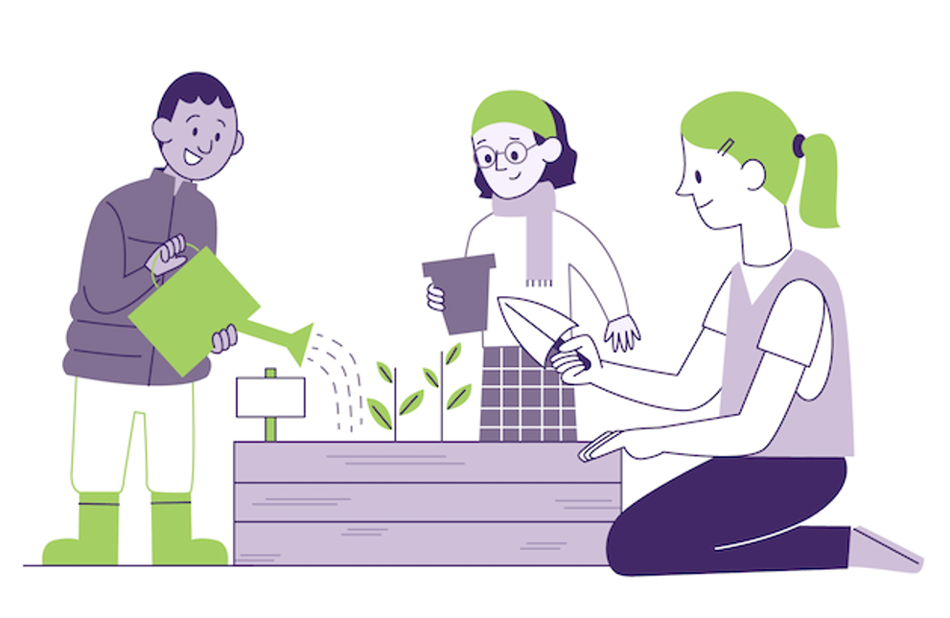
To encourage practice sharing and problem solving for the testing of the Local Inclusion Support Offer, REACh is running five “hackathons” across October and November. For this month’s newsletter, we are sharing insights about the purpose of a hackathon, the challenges explored so far, and some of the initial solutions developed by local areas.
What is a hackathon?
Hackathons are structured sessions to generate ideas and potential solutions around a focused problem statement, with no “right answer”. They can be delivered in-person or online but need to be adapted for each context – this term’s hackathons take place on online, using an interactive whiteboard to capture everyone’s ideas and reflections. The work should be done in the virtual room, and there is nothing for participants to prepare beforehand. Key is to come willing to generate ideas, using what they know from their local area context and role in testing the reforms.
What happens after each session?
As the focus of the hackathon is practical, it should result in sketched-out solutions to the problem statement. Participants initially work silently to come up with their solutions, choose their favourite idea, which are clustered into overarching themes by the facilitators. Participants then work together in breakout groups to write down an initial plan for a practical “hack” that another local area could take forward. This is an opportunity for cross-local area collaboration, and their plan should cover: first steps, how to build on what we know works in local areas already, key “do’s and don'ts” and the intended impact.
After the Hackathon, the REACh delivery team, along with a Subject Matter Expert, produce a summarised output, covering the problem statement, clusters of ideas, and the shortlist of potential mapped approaches.
What topics have we covered so far?
The two sessions delivered so far this term explored the following problem statements:
- How can we accurately identify and respond to what individual schools, and communities of schools, need from the LISO to strengthen mainstream inclusion?
- How might we best organise and integrate multiple disciplines within the LISO so that schools, children, and families benefit from a coherent and effective offer?
These questions reflect conditions of success for a LISO: the importance of reliable ways of assessing and understanding the needs of schools, so that planned support is relevant, timely and needs-led, as well as different approaches to locating and embedding multidisciplinary working which has the right skills to ensure high-quality support and aligns with other relevant reforms, such as Families First.
What have local areas come up with?
Participants have come up with fantastic, practical solutions which speak to their knowledge and expertise. As we develop the outputs, we can share a few highlights:
- Mechanisms to provide clear access to support for schools, e.g. calendars of training, SEND surgeries, and menus of support that have been refined and reviewed in light of the LISO.
- The importance of how you set up your LISO to strengthen stakeholder relationships, for example by reviewing and auditing what support is currently available to schools through workshops and other types of engagement, with the aim of finding gaps, what works for schools and where they go for help, as well duplication mapped and collated.
- Using multiagency and setting-level level data dashboards to give a holistic view of needs within settings and target support effectively, identify key trends and patterns of support for schools, and benchmark outcomes to highlight good practice and inform commissioning of services.
All outputs from the five hackathons will be shared with all participants and local areas testing the LISO and may form part of a wider problem-solving product for local areas beyond the Change Programme. We aim to include other useful insights and learning from the programme that link to the identified solutions.
The next three hackathons will explore issues such as funding and resources, and how to enhance and redesign the existing offer. We look forward to learning more from local areas as the term progresses and creating outputs that provide useful tips and practical steps other local areas can take forward.

Spotlight on Learning

SEND & AP Change Programme : Phase 1 Insights Summary

The Reaching Excellence and Ambition for all Children (REACh) consortium are the Department for Education's (DfE's) delivery partner for the Change Programme. As the delivery partner, a key part of REACh's role is to support local areas to implement and learn from nationally and locally developed initiatives, whilst also capturing learning and insights from these initiatives to share with the CPPs, the DfE and other key organisations and individuals outside of the Change Programme.
This section contains some of the key learning and insights from the Change Programme so far.
Headline learning from Phase 1 of SEND & AP Change Programme:
- Strengthening partnership working & collaboration: There is room to improve the breadth and depth of collaboration between local partners, particularly in relation to mainstream provision available for children and young people with SEND or those who need AP. While some areas already do this well, most need to invest in this and ensure all partners understand their role in its success
- Building trust & confidence with parents: Strength of existing co-production and engagement with parents, children and young people correlates to the pace of change. Clear communication is critical, and parents expect a higher degree of transparency, as well as access to trusted information about support available.
- Effective & targeted use of Alternative Provision: Alternative Provision (AP) should play an important role in the support available both within and alongside mainstream schools. Many local areas are seeing positive results from working together to commission AP that is better targeted and designed to offer structured, short-term support—such as outreach services that help children stay in or return to mainstream education.
- Using data on outcomes & experiences: Many local areas have worked with their mainstream settings to agree what good support for children with SEND should look like and all have pockets of good practice to build upon. However, collaboration with the local authority is mostly voluntary for settings, making it difficult to ensure ongoing participation and monitor effectiveness.
- Accessing specialist capacity in mainstream education: Specialist capacity in the SEND system is often heavily utilised by assessment and planning for statutory support. However, programmes like ELSEC are highlighting different ways to use this workforce to build capacity of mainstream staff to meet needs, as well as creating pathways that provide targeted support for groups of children and young people below statutory threshold.
- Supporting the quality of inclusive practice in education: Bringing data together and using it across services is a sign of a well-developed local system. To improve inclusion in mainstream schools, more work is needed to agree on the most important measures—and to link long-term data on local needs (like Joint Strategic Needs Assessments) with real-time operational data.

read more

Research, reports and events


  RISE Partnership Online Training Programme 25/26: A Programme of National Training
  Through the RISE contract, funded by the Department for Education, the Council for Disabled Children (CDC) conducted a SEND workforce survey, designed to understand workforce learning needs and identify key content for new training. CDC are organising a programme of online national training sessions, from September 2025 to March 2026, based on feedback from this survey and topics will include:
  - Data, voice and commissioning.
  - Education other than at school (EOTAS) policy briefing.
  - Navigating health and SEND.
  - The right support at the right time: An introduction to Early Years SEND support and identification.
  - Understanding the social care offer in the context of inclusion.
  Each training session is intended for a different audience, and in some cases, the trainings are run by region. These training sessions will take place online on MS Teams, either in the morning (10.00-12.30) or afternoon (13.30-16.00).
  For ease, you can find all the trainings and their registration links via the CDC Events and Training Calendar.
  If you have any questions about the RISE training programme in general, or would like to get in touch with a member of the RISE Team, please contact RISE@ncb.org.uk

Letter from Secretary of State for Education to the Education Select Committee
On the 22nd October, Bridget Philipson, Secretary of State for Education wrote to the Education Select Committee with an update in response to their report, Solving the SEND Crisis.
The letter confirms that their will be a further period of co-creation, testing proposals with families, alongside teachers and other experts. With plans for a full Schools White Paper early in 2026.
Through this period of co-creation with parents, educators, experts and representative organisations, Government will test policy options being considered and seek views through listening sessions in every region of the country, and fortnightly Ministerial meetings with key parent and expert groups.
The letter states that the SEND reforms will be underpinned by the following five principles:
- Early. Children should receive the support they need as soon as possible. This will start to break the cycle of needs going unmet and getting worse, instead intervening upstream, earlier in children’s lives when this can have most impact.
- Local. Children and young people with SEND should be able to learn at a school close to their home, alongside their peers, rather than travelling long distances from their family and community. Special schools should continue to play a vital role supporting those with the most complex needs.
- Fair. Every school should be resourced and able to meet common and predictable needs, including as they change over time, without parents having to fight to get support for their children. Where specialist provision is needed for children in mainstream, special or Alternative Provision, we will ensure it is there, with clear legal requirements and safeguards for children and parents.
- Effective. Reforms should be grounded in evidence, ensuring all education settings know where to go to find effective practice that has excellent long-term outcomes for children.
- Shared. Education, health and care services should work in partnership with one another, local government, families, teachers, experts and representative bodies to deliver better experiences and outcomes for all our children.

Children’s Commissioner ‘Children’s Plan’ report
The Children’s Commissioner has published their Children’s Plan based on the first School Census by that office with a focus on a system that is “inclusive by design” with schools equipped and supported to meet diverse needs.
- Summary version of the report
- Full version of the report
- One-pager of the recommendations

Education inspection framework: for use from November 2025
The education inspection framework sets out how Ofsted inspects registered early years settings, maintained schools, academies, non-association independent schools and further education and skills provision in England. It includes the principles that apply to inspection, and the main evaluations that inspectors make.

Thank you

Thank you for reading this edition of the REACh newsletter. We will be back next month with more insights and information from the Change Programme.
If you would like to be first to hear about this or you know of anyone who would benefit from receiving updates about the Change Programme, please subscribe here.
Read more

