REACH NEWSLETTER | 18 Dec

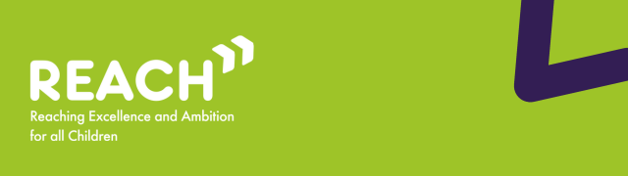

Welcome to the December edition of the REACh newsletter.
In this edition, you can find:
- Reminder: what is the Change Programme and what is it trying to achieve?;
- Updates and latest activity from across the Change Programme Partnerships;
- Local area spotlight: Enfield’s primary to secondary school Transition Improvement Programme;
- Alternative Provision Practice Notes;
- Research, reports and events;
Best wishes,
Luke Evason-Browning
Council for Disabled Children

Reminder: what is the Change Programme and what is it trying to achieve?
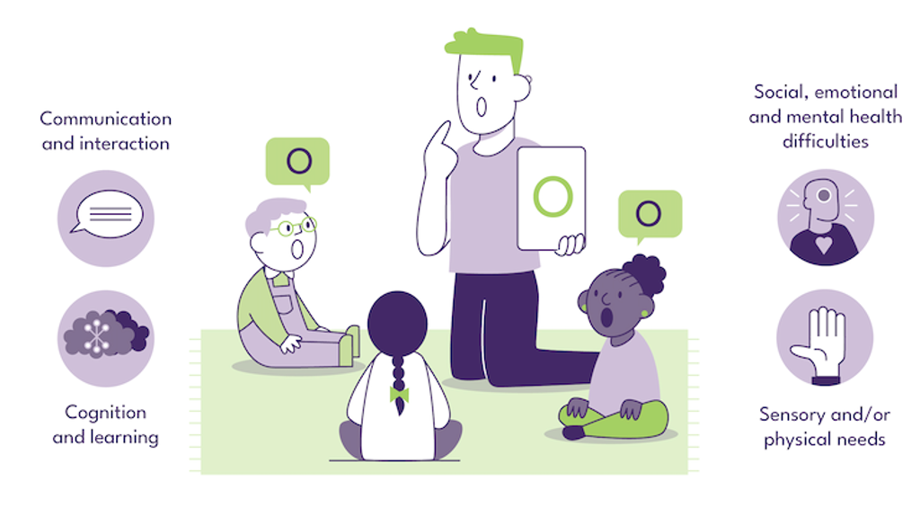
The Change Programme involves 32 local areas undertaking a ‘test and learn’ approach to changes across their local system, collaborating in Change Programme Partnerships (CPPs) in each of the 9 regions of England. Originally set up to test reforms set out in the SEND and Alternative Provision Improvement Plan, in its current phase, the Change Programme is working with these local areas to test a range of programmes collectively to strengthen the inclusion support offered to mainstream settings.
Building on earlier phases, the programme now covers continued work on the use of Alternative Provision through a 3-tier model of interventions and extending the Early Language Support for Every Child pathfinders that are enabling earlier identification and intervention for speech, language and communication needs. In the extension, the Change Programme has strengthened links with two other existing initiatives from the DfE: Alternative Provision Specialist Taskforces (APST) and the Programme for Inclusion of Neurodiversity in Schools (PINS) so that more of the local areas can test these models. Change Programme local areas also have the opportunity to test Assistive Technology ‘lending libraries’ that give schools the ability to test the effectiveness of these tools for their students so that they can make best use of funds to meet need.
The Change Programme involves working collaboratively with local areas and alongside partners from health, education and social care, as well as parent carers, children and young people, recognising that the insights and expertise of all of these groups are key to creating any new system. The Change Programme also works in parallel with other DfE programmes and wider work that is happening in the SEND sector, such as the Family Help reforms and Ofsted’s curriculum and assessment review, acknowledging the significant potential that these changes and initiatives have to be complementary to the activity on the Change Programme as well as the learnings from it.
The Reaching Excellence and Ambition for all Children (REACh) consortium are the DfE’s delivery partner for the Change Programme. The REACh consortium are made up of PA Consulting, IMPOWER, Council for Disabled Children and Olive Academies. REACh support local areas to implement and learn from nationally and locally developed initiatives, whilst also capturing learning from these initiatives and disseminating this to other Change Programme Partnerships as well as the DfE.

Updates and latest activity from across the Change Programme Partnerships
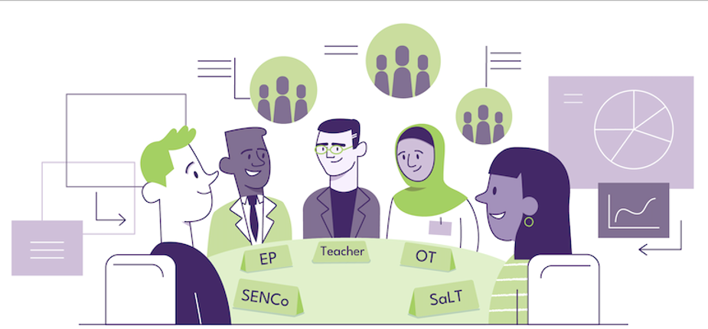
A Special Thanks
As we reach the end of the year, we would like to thank our Change Programme Partnerships for their hard work and dedication to improve the lives of children, young people and families in their areas.
Innovative, Needs-Led Support Models Increasing Engagement with Children and Young People
Local Areas participating in the Change Programme report that innovative, needs-led support models are improving engagement with children and young people, particularly through early intervention and the use of technology and interactive approaches. These models are helping services respond more flexibly to individual needs and reduce barriers to accessing support.
For example, Brighton and Hove are preparing to launch their new Assistive Technology Lending Library (ATLL), which will support more personalised learning and engagement. Similarly, Herefordshire’s Communication and Interaction Group is using a suite of adapted, evidence-based strategies to meet individual pupil needs. This includes approaches such as Attention Autism, Intensive Interaction, Lego Therapy, Gestalt approaches, and Colourful Semantics, enabling tailored interventions that support communication, interaction, and participation.
Strong Parent and Carer Engagement Supporting Partnership Working
Local Areas are also highlighting strong levels of parent and carer engagement, helping to build more effective partnerships between families and schools. Parents and carers are actively contributing to their children’s support and shaping service improvements.
Wakefield, for instance, has received positive feedback from parents who have attended provider-led events. Families have highlighted the value of the support provided and its positive impact on children’s transitions. These events have also been effective in reaching parents who may not otherwise engage with Family or Youth Hubs, supporting more inclusive and accessible engagement.

Local area spotlight: Enfield’s primary to secondary school Transition Improvement Programme
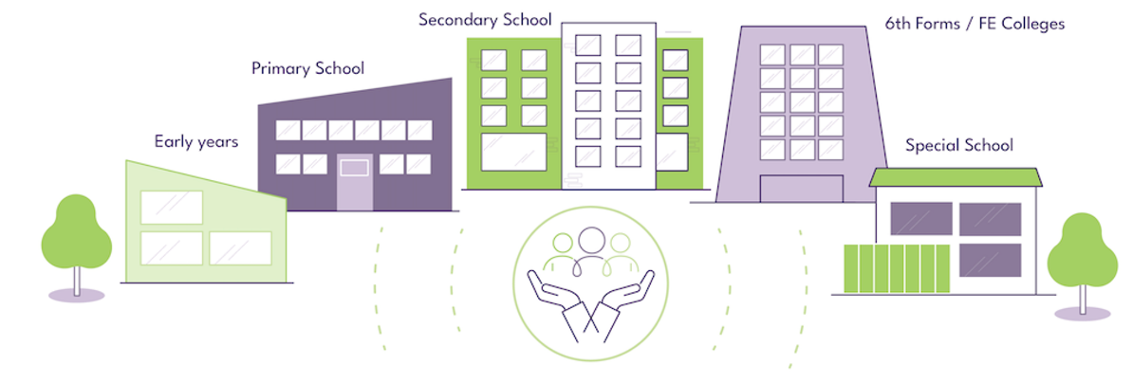
Enfield Council recognises the importance of strong and consistent transition support for all pupils, particularly those receiving SEN support without an Education, Health and Care (EHC) plan. To enhance this process, Enfield has identified opportunities to strengthen practice, including improving consistency across the borough, ensuring identification of children who may need additional support during transition, and promoting effective communication and data-sharing between mainstream primary and secondary schools.
With a commitment to creating a more coherent and equitable approach, Enfield Council sought to provide a clear and effective transition pathway for pupils moving from primary to secondary school. Enfield developed the Transition Improvement Programme through the ‘Delivering Better Value’ initiative. The programme aims to:
- Enhance early identification of children at SEN support level who require transition support by strengthening communication and data-sharing between primary and secondary school settings.
- Build staff confidence and capacity to better support pupils during key transition phases of their educational journey.
Enfield’s Transition Improvement Programme focused on three key actions:
- Co-producing a Transitions Policy and Guidance Document with schools, multi-agency partners, and parent carers to create a shared framework for supporting pupils.
- Strengthening communication and data-sharing through borough-wide events, including the Transitions Conference and Information Sharing Event, to ensure coordinated, timely support.
- Upskilling school staff via CPD, enabling them to deliver targeted interventions and make effective reasonable adjustments.
The introduction of Transition Support Plans (TSPs) provided a practical tool to capture essential pupil information, identify contextual risk factors, and support early intervention. Together, these actions created a consistent, structured approach to transitions, ensuring pupils receive holistic support and are better prepared for key educational phases.
The Transition Improvement Programme has strengthened early identification of children at SEN support level who require additional transition support and mitigated against other risk factors by improving communication and data-sharing between primary and secondary schools, enabling smoother and better prepared transitions for pupils. The programme has also equipped school staff with the skills and confidence needed to better support pupils during this critical phase.
Enfield Council launched the Transition Improvement Programme in 2024 and intends to embed the model as business-as-usual. Plans are also underway to extend the programme to the early years, focusing on transition to reception. While long-term effects are not yet evidenced, the Council has established mechanisms to track outcomes over time.
The team at What Works in SEND are currently completing an Effective Practice Case Study on Enfield’s Transition Improvement Programme, so make sure to keep an eye out for it in the new year! You can sign up to their newsletter here.

Spotlight on Learning

Alternative Provision Practice Notes
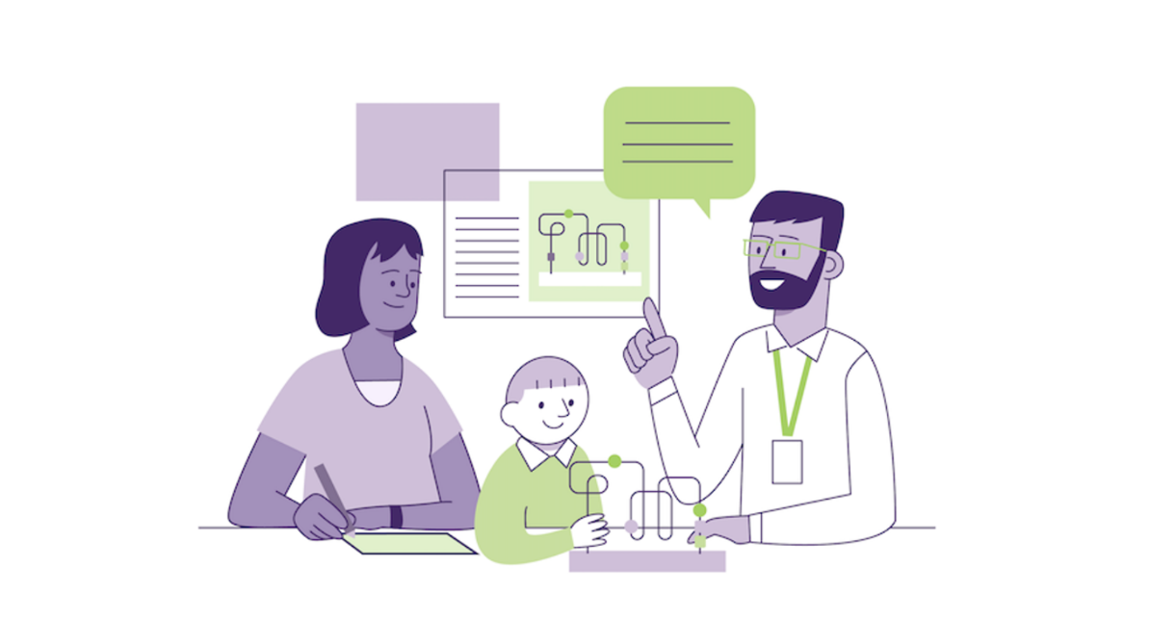
We are pleased to share the REACh Consortium’s Alternative Provision Practice Notes. These practice notes are short, easy to read summaries of key findings and actionable insights about effectively implementing Alternative Provision with supporting examples and data.
This product has been created by the REACh consortium in partnership with the Department for Education, and includes:
- Key insights on the Alternative Provision 3-Tier Model
- The use of data and evidence to inform decision-making
- Developing strong Tier-1 Alternative Provision as part of the 3-Tier model
- Strengthening re-integration through a robust 3-tier model
- Olive Academies Alternative Provision Rapid Reviews
- Exploring the effectiveness of outreach services
To read more about alternative provision, or to read about other Change Programme learning and insights from the REACh Consortium, please click the link below.
read more

Research, reports and events


  Share Your Feedback – Effective Practice Case Studies Engagement Survey
  We’re inviting you to take part in a short survey about the What Works in SEND effective practice case studies. These case studies share examples of system-level practice in local SEND systems in England that have improved outcomes for disabled children and young people and those with special educational needs.
  The purpose of this survey is to help us understand:
  - How aware stakeholders are of the case studies
  - How they are currently accessed and used
  - How relevant and useful they are for different roles and contexts
  The survey will take no longer than 5 - 10 minutes to complete, and your responses will remain anonymous and confidential.
  Please complete the survey here.
  Thank you for helping us make these resources more accessible, relevant, and impactful!
  Read more

SEND Schools Workforce Survey – please share with schools contacts
The What Works in SEND research team are conducting a survey as part of their research into the SEND workforce in mainstream schools.
By completing the survey, you will help us to get a clearer picture of how mainstream state schools are organising their workforce to support pupils with Special Educational Needs and Disabilities.
The findings from this research will be used to inform schools and DfE to help improve support for pupils with Special Educational Needs and Disabilities.
The survey should be completed by a SENCO or senior leader. Only ONE survey response is required per school.
Read more

Government launches national conversation on SEND
Government acts on commitment to make sure parents play a central role in helping shape the future Special Educational Needs and Disabilities (SEND) system, as it sets ambition to deliver the biggest national conversation on SEND in a generation.
Building on conversations to date, the government is now launching a public engagement campaign, spanning every region of the country, putting families at the heart of its plans to create a reformed SEND system that will stand the test of time.
Read more

Neurodivergent adolescents experience twice the emotional burden at school compared to their neurotypical peers
Research from the RE-STAR programme at Kings College London has found that negative experiences in school generate twice the emotional burden in autistic and ADHD adolescents compared to their neurotypical classmates, and that this is significantly linked with depression and anxiety. Previous thinking had proposed that the risk of depression in neurodivergent children is due to deficits in their ability to regulate their negative emotions, while these new findings on the contribution of emotional burden suggests the value of a more joined up approach to managing mental health risks at school in this group.
Read more

Situating emotional regulation in autism and ADHD through neurodivergent adolescents’ perspectives
Interviews with 57 young people with diagnoses of ADHD, autism, or both, have explored their ways of managing potentially upsetting experiences, shared in a new paper from the RE-STAR programme. Young people shared the importance of consistent, neurodivergent-affirming environments, flexible supports, and being genuinely accepted, and the findings underscore the value of stable, trusting relationships and the need for predictable routines.
Read more

£3bn investment to end postcode lottery for children with SEND
The Education Secretary has announced a transformational expansion of specialist, calm learning spaces in mainstream schools, equipped with facilities to support children with special educational needs and disabilities, following the launch of the largest national conversation on SEND in a generation.
Read more

Thank you

Wishing you a wonderful holiday period

Thank you for reading this edition of the REACh newsletter. We will be back next month with more insights and information from the Change Programme.
If you would like to be first to hear about this or you know of anyone who would benefit from receiving updates about the Change Programme, please subscribe here.

Copyright © 2025 National Children's Bureau (NCB), All rights reserved.
You are receiving this email because you registered for updates on our website, or because we believe the content of this email is of professional interest to you. If you disagree, please don't hesitate to update your profile.
Our mailing address is:
NCB, 23 Mentmore Terrace, London E8 3PN
Add us to your address book | forward to a friend
unsubscribe from this list

