Wakefield SEND Local Offer
Easy Read Things To Do Application Form
Things To Do is the name for services and groups that offer activities for SEND children, young people and their families.
If you need help filling in this form, please email wakefieldlocaloffer@family-action.org.uk or leave a message on 01924 965588.
 | Name of activity:
 | Basic description:  This is what your activity is. It will appear in search results. The description needs to be short.
 | Address:
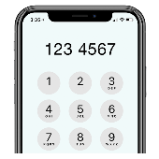 | Phone number:
 | Email:
 | Website:
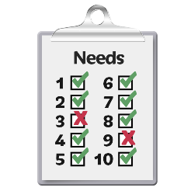 | Area of need:  ☐ Select all  ☐ ADD/ADHD  ☐ ASD  ☐ Behavioural Issues  ☐ Continence issues  ☐ Eating and drinking support  ☐ Hearing Impairment  ☐ Learning disability/difficulty  ☐ Medical needs  ☐ Mental health needs  ☐ Mobility/physical difficulties  ☐ Social and communication difficulties  ☐ Visual impairment
 | Age range:  ☐ Select all  ☐ 0-5  ☐ 5-11  ☐ 11-16  ☐ 16-25
 | When:  ☐ Select all  ☐ School Holidays  ☐ Term Time  ☐ Weekdays  ☐ Weekends
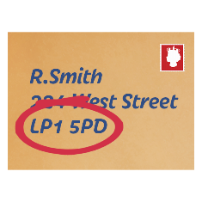 | Postcode:  ☐ Select all  ☐ LS26  ☐ Online  ☐ Out of Area  ☐ S71  ☐ S72  ☐ S75  ☐ WF1  ☐ WF10  ☐ WF11  ☐ WF2  ☐ WF3  ☐ WF4  ☐ WF5  ☐ WF6  ☐ WF7  ☐ WF8  ☐ WF9
 | Category:  ☐ Select all  ☐ Arts and crafts  ☐ Dance, drama and music  ☐ Galleries, Libraries and Museums  ☐ Indoor  ☐ Online activities  ☐ Outdoor  ☐ Sport and physical activities  ☐ Youth Clubs
 | Accessibility information for the venue:
 | How do people access the service/activity:  Please note referral and or eligibility criteria. If your service requires a referral form, please attach that to the application.
 | Cost to join/attend the service/activity:
 | Who can attend:  Please note who can attend the service (e.g., family, siblings, drop off and leave, who can stay) and if sessions need booking in advance.
 | When is the service/activity available:
 | Contact name for service/activity:
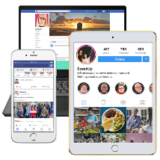 | Social Media links:

For information on how we use your data, please visit https://www.family-action.org.uk/services-privacy-notice/

