

What is Project SEARCH?
Project SEARCH is a one-year supported internship programme for students with special educational needs.
Students complete their internship in a real workplace with the support of a job coach and department mentor.

Interns also attend daily classroom sessions that focus on employability and independent living skills. These sessions are delivered onsite at the host business. The programme helps young people to successfully transition into adult life and ultimately gain full-time, paid employment.

A typical day includes:
9:00 to 10:00: Classroom learning focused on employability skills

10:00 to 15:00 Interns go to work in their placements, supported by a tutor
15:00to 15:30 classroom time to reflect on the
day’s activities



What do I get out of programme?

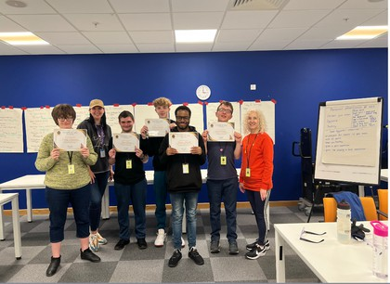
Training experiences in a real workplace Marketable job skills Increased independence, confidence
Supported Internships at Amazon Methley
A transition to work programme for young people with an
Education, Health and Care Plan
Individualised coaching and daily
feedback
Development of transferable soft skills
e.g. financial, literacy, social skills

Variety of roles available including warehousing, administration, procurement, IT and more

“I have become more independent since I started Project SEARCH.”

Who is it for?
Applicants should:

Have a current Education, Health and Care Plan (EHCP)
Be 18 – 24 years old
Have the desire and motivation to achieve paid employment

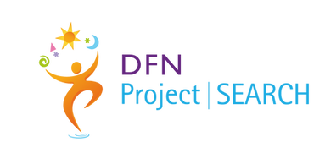
Amy Lassu - Inclusion Manager
alassu@heartofyorkshire.ac.uk
01924 789432
Learn More
aboutamazon.co.uk/news/working-at-amazon/amazon-supported-internships

