

St John's School
From 3% to 76% attendance: How Wakefield are using AV1s to reconnect pupils with school life
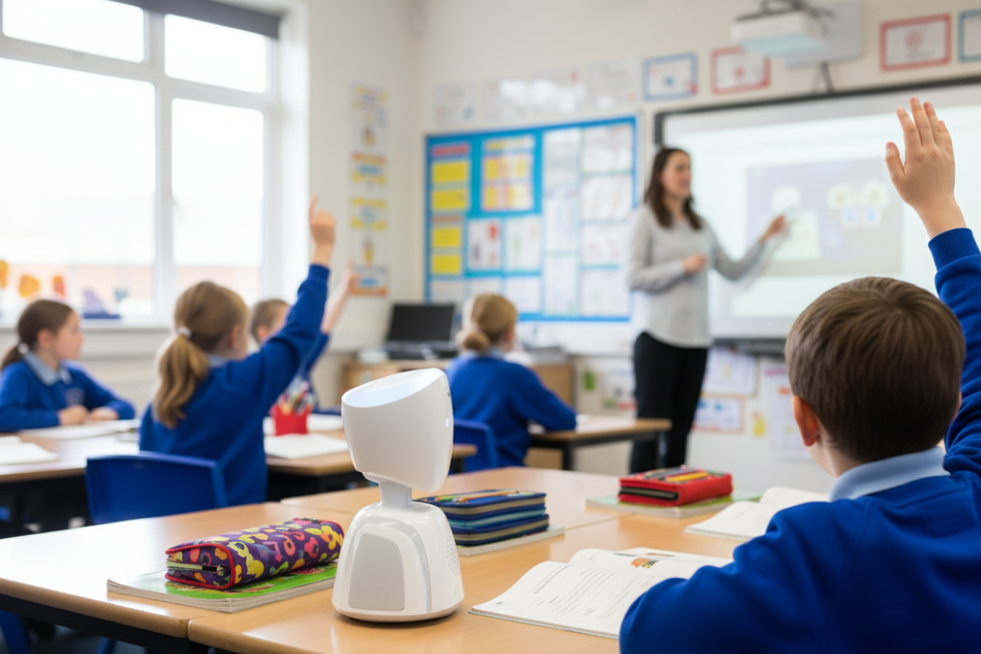

➡ Visual created using AI for illustration purposes.

Background
When a Year 3 pupil at St John’s C of E Primary School was struggling with attendance, just 3% across the year, the school turned to AV1 as a new way to help her feel safe enough to rejoin her classmates.
Within weeks, the transformation was clear. By September, her attendance had climbed to 76%. She was not only logging into lessons but also attending the summer fair and cheering on her brother at the end-of-year performance.
Sarah Jackson says the difference was simple but powerful: “It gave her access to the classroom without the sensory overload or social pressure. She could listen, join in quietly and just start reconnecting.”

A small school with growing needs
St John’s is a one-form entry school in Wakefield, with just over 210 pupils from Reception to Year 6. Like many primaries, it has long supported children with autism, but Sarah has noticed a marked rise in pupils experiencing Emotionally Based School Avoidance (EBSA), especially in Years 5 and 6.
“It’s something we’re seeing more of,” she explains. “And increasingly we need creative tools that help children feel safe enough to keep learning and stay connected.”

AV1 in action
St John’s first trial of AV1 began in June. The team provided the pupil with a timetable of lessons she might want to join and left the robot in class ready for her to log on.
The impact was immediate: after just two logins, the child felt confident enough to attend in-person events at school. Soon after, she began re-establishing friendships and meeting up with peers.
Sarah recalls the moment the AV1 lit up in class for the first time: “The children were so excited. They loved it. They’d try to talk to it, wave at it and when it lit up, it was such a buzz.”
The quiet Year 3 pupil didn’t feel any pressure to speak, but hearing familiar voices and classroom routines through the robot gradually rebuilt her confidence.

Normalising the Robot
To help the AV1 blend into school life, Sarah introduced it to pupils in a straightforward way: “I said it was a robot visitor coming to watch me teach. That way it didn’t single anyone out, it just felt like a normal part of the classroom.”
This approach helped the child feel included without being put under a spotlight while also ensuring classmates embraced the technology positively.

Looking ahead
Although AV1 is still new to the school, staff interest is growing. Sarah can already see wider applications:
- For pupils with sensory sensitivities, joining lessons from a calm space.
- For children who find transitions between teachers difficult, linking in from a familiar room like the library.
- For those who can’t sit still for long stretches, giving them flexibility without missing learning.
Staff are also reassured by the practicalities: AV1’s built-in 4G makes it reliable, while its portability means it can move between classrooms seamlessly.

Why AV1 Stands Out
Having seen other platforms used during lockdown, Sarah is clear about the difference: “Compared to Teams or Zoom, AV1 is just so much easier and safer. The child feels part of the classroom, not on the outside looking in.”
Her advice to schools thinking of trying it is simple: “Just go for it. Don’t worry. It’s such a valuable tool for children who can’t be here in person. It helps them feel part of school… not just the learning, but the social side too.”

Rebuilding Connection
For St John’s, AV1 has already rewritten one child’s story from near absence to active belonging. And for Sarah, that’s what makes it worthwhile:
“It’s about them feeling they’re still part of us, even when they can’t be in the room. That’s what helps them come back.”

