# Wakefield District Health & Care Partnership logo.

Proud to be part of West Yorkshire

Health and Care Partnership

# Easy read

# West Yorkshire Dynamic Support Register Form

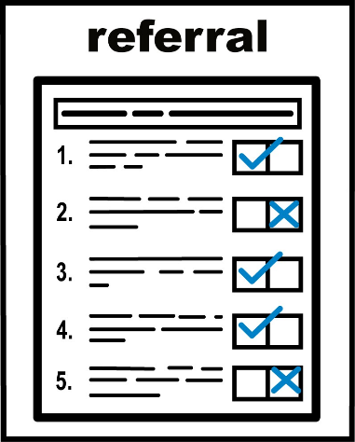This form is to ask if you can be added to the Wakefield Dynamic Support Register.

You can ask to be added to the register yourself or you can fill it in for someone you care about if they agree to it.

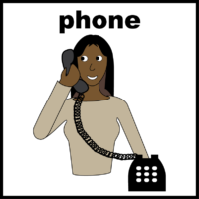If you need help to fill in this form, please call us on

07584 823503

## What is a Dynamic Support Register?

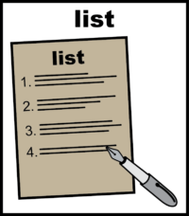A Dynamic Support Register is called a **DSR** for short.

A **DSR** is a list of people with a learning disability and autistic people who need extra support so that they don’t end up going into a mental health hospital.

## Accessibility and reasonable adjustments.

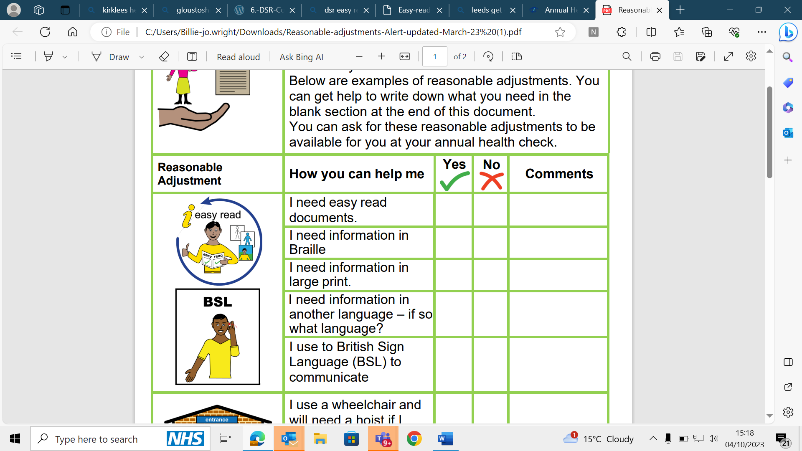

Reasonable adjustments are about changing the way we do things so that we meet everyone’s needs.

form.

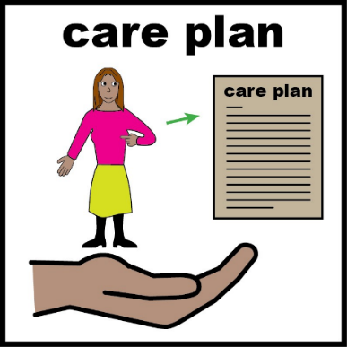

You may find it helpful to fill in an [Easy Read reasonable adjustment care plan.](https://www.kirkleeshcp.co.uk/wp-content/uploads/2021/05/Reasonable-adjustments-generic-Kirklees-2020-2021.pdf)

[www.kirkleeshcp.co.uk/wp-content/uploads/2021/05/Reasonable-adjustments-generic-Kirklees-2020-2021.pdf](http://www.kirkleeshcp.co.uk/wp-content/uploads/2021/05/Reasonable-adjustments-generic-Kirklees-2020-2021.pdf)

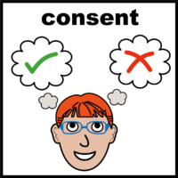

Please also fill in the form about consent.

This will help us know that people have agreed to their information being shared and used.

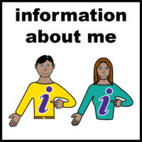If you would like to find out more about what happens to your information, please visit the

[WY Privacy Notice Webpage](https://www.westyorkshire.icb.nhs.uk/privacy-notice)

www.westyorkshire.icb.nhs.uk/privacy-notice

## Tell us about you

|  |  |
| --- | --- |
| My name | What is your name? |
| date of birth | What is your date of birth? |
| Address and telephone | What is your address?  What is your telephone number? |
| email V2 | What is your email address? |
| contact V2 | How would you like to be contacted? |

|  |
| --- |
| think about health**Tell us about your health.** Please write down in the box below if you have any health problems or if you need to take medications. |
|  |
| **Do you have a learning disability or are you Autistic?** **Or both?**worried about you**Reason for filling in this form** Please write down in the box below why things aren’t going well and why you are worried that you could need to go into hospital.  Please tell us what sort of help might have already been tried that didn’t work. |
|  |
| Support V2**What help and support do you have?** Please write in the box below if you have any help or support |
|  |

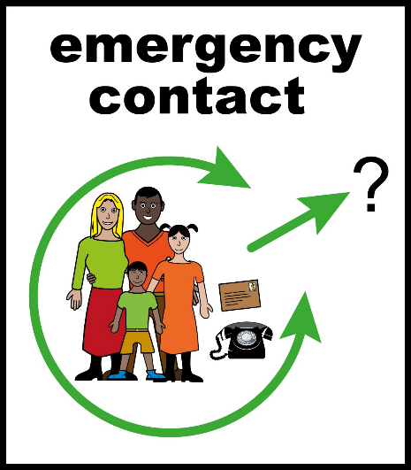**Who should we contact if something is wrong, and we can’t contact you?**

Please write down the contact details of who we should contact in an emergency.

Please check with them first before adding in their information.

|  |
| --- |
|  |
|  |
| **Any other Information** Please send us any other documents you have about your health.  If you have any other information would like to share, please write it in the box below |
|  |
| **Please send this form to**  For the attention of Michelle McVittie  White Rose House  1 West Parade Wakefield  WF1 1LT  Adults [wyicb-wak.ldandacommissioning@nhs.net](mailto:wyicb-wak.ldandacommissioning@nhs.net)  Children and Young People wyicb-wak.cypcommissioning @nhs.net |



## Date

Please tell us the date you sent this form

__________________________________

# Next steps

## What happens next?

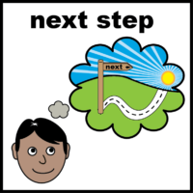We will contact you to let you know we have received this form.

We will contact you again to tell you if you will be added to the **DSR** or support you to get help from a different service.

## How so we work out the risk?

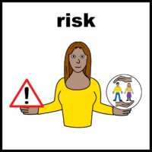The information provided will help work out how risky the situation is.

## A risk is something bad that could happen.

## Can I be Involved?

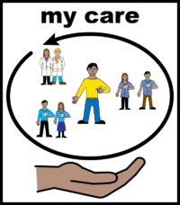Yes! You have the right to tell us your thoughts, choices, and anything that might worry you.

This will help professionals understand you better.

## Who should you contact for more information about DSR or for help this form?

## contact

07584 823503



The West Yorkshire Key Worker Service for people up to the age of 25

[www.westyorkshirekeyworkerservice.org.uk](http://www.westyorkshirekeyworkerservice.org.uk)

0113 393 3240

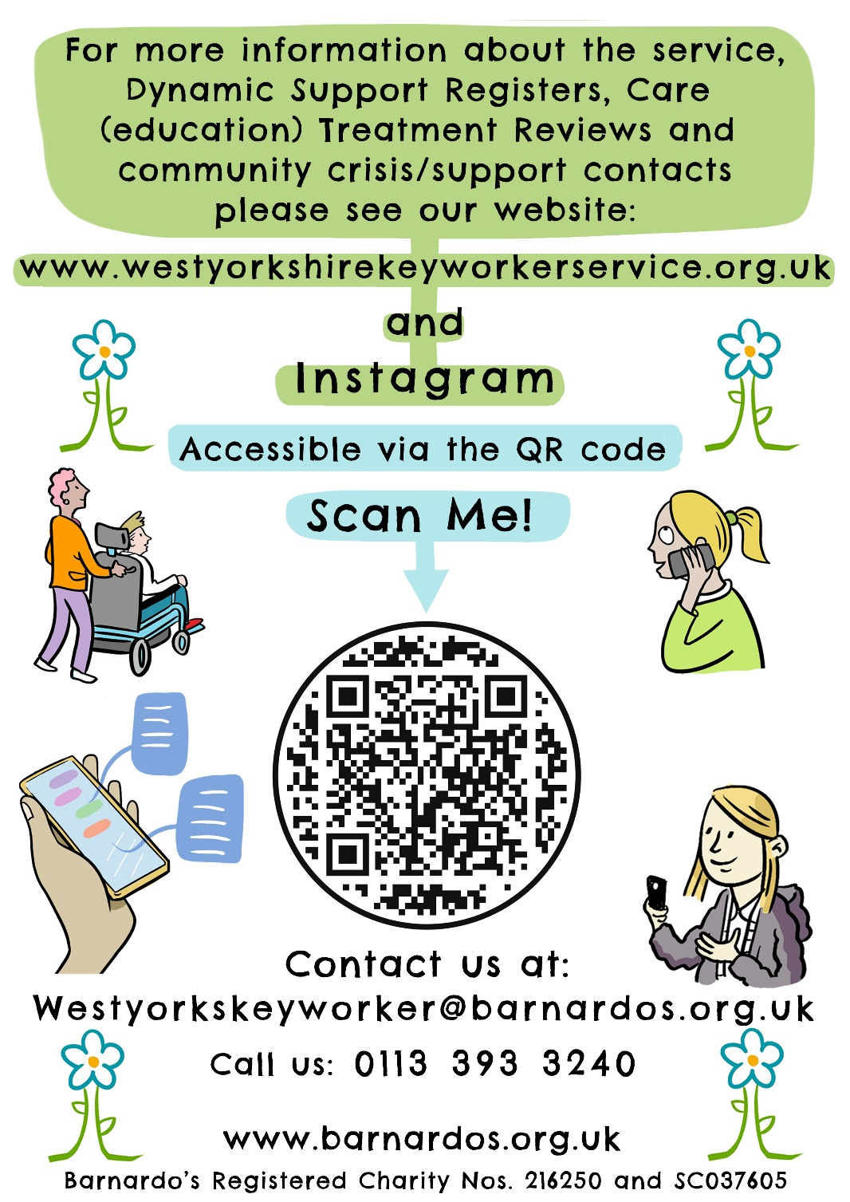

## Were you helped to fill in this form? If yes, by who?

If this form is being filled in by someone other than the person themselves, please talk to the person first.

|  |  |
| --- | --- |
|  | What is the name of the person who has helped you fill in this form? Please check with them first before adding in their information. |
| Friend or carer | How do you know them? |
| Address and telephone | What is their address?  What is their telephone number? |
| email V2 | What is their email address? |
| contact V2 | How should we contact them? |

**For office use Only:**

Date referral received

__________________

Date/time of first contact

____________________

Date of risk rating with service user / family / carer input ___________________

Outcome: (signposted, requires more information, accepted)