Dynamic Support Register Referral Form
This form is to refer someone for inclusion on the Dynamic Support Register.
If you have any questions or need help completing this form, please contact dsr.ckw@swyt.nhs.uk

What is a Dynamic Support Register?
A Dynamic Support Register is sometimes called a DSR.
A DSR is a list of people with a learning disability and autistic people who need additional support and are at risk of going into hospital if they do not get the right care and treatment in the community.
The register tells health and care staff about the type of support a person with a learning disability or an autistic person needs to stay well at home. They work together with healthcare providers and caregivers to make sure the people on the register get the right care and support at the right time.
Please let us know if you have any queries or need help completing this form.

Patient details | Please enter the name of person being referred, their date of birth, address and contact details in the form below
Full name
Date of birth
Address
Telephone number
Email address

You can find out how Kirklees Health and Care Partnership will use and process information at our privacy notice www.westyorkshire.icb.nhs.uk/privacy-notice/dynamic-support-register. This includes details about the rights people have in relation to personal information held and processed by Kirklees Health and Care Partnership.

Consent
Please ensure you have discussed this referral with the person being referred and have gained their consent. If that person lacks capacity to give consent, a best interest meeting will need to take place and be documented.
If someone is under 16 years of age their parents or guardian would need to give consent for them. The child or young person should be asked if they give their consent too.
Please indicate below how consent was given and attach the documentation when submitting this form.
Consent was given, the consent form was completed and attached:
Yes ☐ No ☐
If the person is unable to give consent:
The best interest meeting forms completed, or details of the discussion has been wrote down and have been attached:
Yes ☐ No ☐
Resources
- www.england.nhs.uk/wp-content/uploads/2023/01/Dynamic-support-register-and-Care-Education-and-Treatment-Review-policy-and-guide.pdf
- Further easy read information on capacity and consent can be found at SeeAbility
- www.seeability.org/resources/consent-and-capacity-easy-read

Health information
Please provide any further medical history and current health conditions below

Reason for Referral
Does the person being referred have a learning disability or autism, or both?

Please tell us about their current situation and the concerns that has led to this referral:

Please tell us what type of help might have already tried that may have not worked. Tell us how often it was used or was in place:

Current Support
What support, if any, do they currently receive?

Supporting documents
Please attach any additional information or documents you feel may be relevant such as recent medical reports, assessments or current medication taken.
If you have any additional information you would like to share, please use the box below

Contact Preferences
Please let us know below if the person has a preferred method of communication or any specific communication needs or requirements.

Emergency Contacts
Please provide below any names and contact information of a family member or a person that we could contact in the case of an emergency.

Please send the referral and consent form to
dsr.ckw@swyt.nhs.uk

Date of referral:

Assessment and Outcome:
The information you provide will be assessed against the DSR criteria.
We will let you know the outcome of this referral and if the person meets the criteria to be added to the DSR.
If they do not meet the criteria, we will signpost them to support which may help them.

Other information and support can be found at:
- www.kirkleeslocaloffer.org.uk
- www.southwestyorkshire.nhs.uk
- The West Yorkshire Key Worker Service for people up to the age of 25
www.westyorkshirekeyworkerservice.org.uk
0113 393 3240
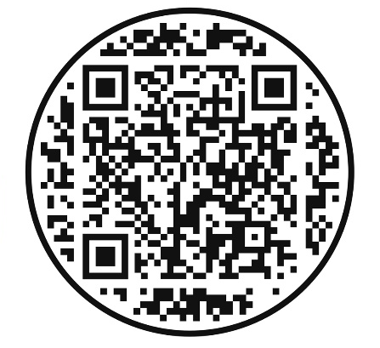

Next steps
What happens next?
The Dynamic Support Lead will contact you to inform you if they need further information and if you meet the criteria for the dynamic support register. They can also help refer you or signpost you on to a more appropriate service.
How is the risk rating determined?
Based on the information gathered, professionals will rate the level of risk. This rating helps them prioritise support.
Can I be Involved in the process?
Absolutely! Your input and involvement are important throughout the risk assessment process. You have the right to be heard and to contribute your thoughts, choices, and concerns. Your perspective is valued and helps professionals gain a better understanding of your unique situation.
Remember, risk assessments are aimed at helping to ensure your safety and well-being. By identifying and addressing potential risks, professionals can support you in living a fulfilling life while minimising any potential harm.

Process and Timescales for the Referral Response
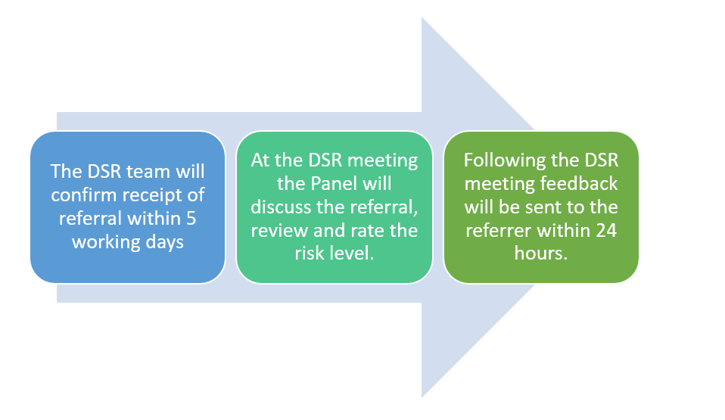
- The DSR team will confirm they have received the referral within 5 working days.
- At the DSR meeting the Panel will discuss the referral, review it, and rate the risk level.
- Feedback will be sent to the organisation or person who made the referral (the referrer) within 24 hours after DSR meeting.
- The process for receiving referrals, rating the risk and informing the referrer and person/their carer/family of the outcome should be completed within four weeks from the point of the referral being received.

Details of the person asked you to make this referral | Please enter name, relationship, address and contact details in the form below
Full name
Relationship to the person referred.
(e.g., family member, friend, healthcare professional)
Telephone number
Email address
Consent was given for this information to be stored and used to make contact if needed? | Yes ☐ No ☐
Did someone ask you to refer this person? If so, please tell us their details below

For Office Use Only | Enter information below
Date referral received:
Date/time of first contact
Date of risk rating with service user / family / carer input
Outcome: (signposted, requires more information, accepted)

