

King's School: From quiet corners to confident returns
How King’s School uses AV1 to build belonging and reintegrate learners

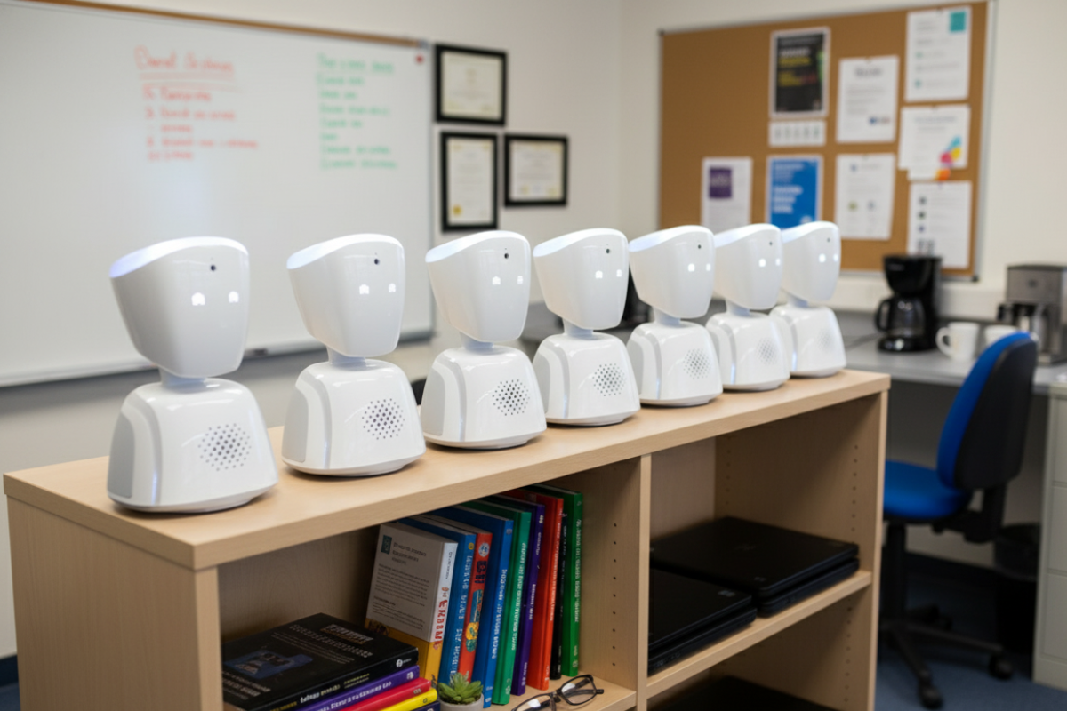

➡ Visual created using AI for illustration purposes.
Background

When one student at The King’s School first connected through AV1, she was too anxious to enter a busy classroom. Using the robot from the school’s quiet ‘Hive’ provision, she reconnected with lessons in a way that felt manageable, then asked to stretch herself in English. Within three months she returned to mainstream full time. And as Helen Pettitt reflects, “she’s brought me her book today and she’s written five pages of a story.”

Wakefield’s momentum behind inclusion
The King’s School (Pontefract Academies Trust) is part of Wakefield Council’s fast growing AV1 programme to support pupils with EBSNA and medical needs. Just seven weeks after the council’s first fleet of 15 robots, they expanded by a further 12 units - giving them 27 in total. That strategic backdrop gave The King’s School confidence to pilot, learn and scale.

How AV1 is used in practice
Helen’s team uses AV1 as a flexible bridge between the Hive and mainstream lessons, matching the environment to each pupil’s needs.
- Quiet room access to loud lessons: “In our provision, our students struggle to go into mainstream lessons… if they struggle in Spanish because it’s a loud classroom, the robot goes to Spanish and then they’ve done the lesson in the room".
- Stretch and aspiration: “One of the students… asked to have a go in a higher class… even though she was in year seven she did a year nine English lesson.”
- EHCP and new starters: One pupil has AV1 written into her EHCP, another is about to reconnect after a long break: “she’s going to log on tomorrow for the first time and hopefully start her education journey for the first time in six years."

Winning staff confidence, building a culture
Initial staff nerves eased quickly once teachers saw what AV1 does, and doesn’t, do.
- Early reactions: “You could tell at first that the teachers were a bit like, ‘What is this little thing?’”
- Reassurance and routine: Helen introduced the device ahead of lessons, explained the purpose and positioned it carefully: “One teacher was so excited… ‘Can she see better?’… ‘can she see okay here?’”
- Normalising the presence: “They’d actually sometimes ring up and say, ‘Is the robot coming to lesson today?’”
- A touch of warmth: “We made them little hats.”

Why it’s different from video calls
Teachers often ask how AV1 compares to Teams or Google Classroom. For Helen, the distinction is presence and identity:
“They see it as a person rather than just being online… they build a relationship with that robot… they see it as a person that’s supporting them rather than ‘I’m just doing online learning.’”
That sense of “being there” smooths the return to school life: “So then when they go back they’re just replacing the robot with them.”

Impact on belonging and the pathway back
Sustained access, familiar voices and friendships kept alive through AV1 meant the Year 7 student’s step back into the classroom felt natural, not abrupt. The team is also supporting exam pressure EBSNA in Year 11 and transitions from hospital school. AV1 creates a low-stakes, high-support pathway to reconnect.

Practical takeaways for other schools
- Introduce it gradually. Bring the robot to staff ahead of first use, explain the “why,” and co-plan positioning.
- Pair with a calm base. Use AV1 from a quiet space while joining targeted lessons.
- Start light then stretch. Let pupils build confidence before trying more demanding classes.
- Expect culture change. Curiosity becomes routine once people see the benefits. “Is the robot coming to lesson today?”
And Helen’s honest counsel on costs versus value: “They might seem expensive but… the difference is you can see the difference in the student in that they see it as a person… So they’re in the classroom rather than ‘I’m just online.’”

A human note
Helen laughs that she even buckles the robots in for the ride: “I put them in the car and I put the seat belt on them because I’m like, ‘Come on, you’ve got to be okay.’” It’s a small image that captures a big truth: the tool is technical, but the outcome is human. Confidence, connection and a way back to belonging.

