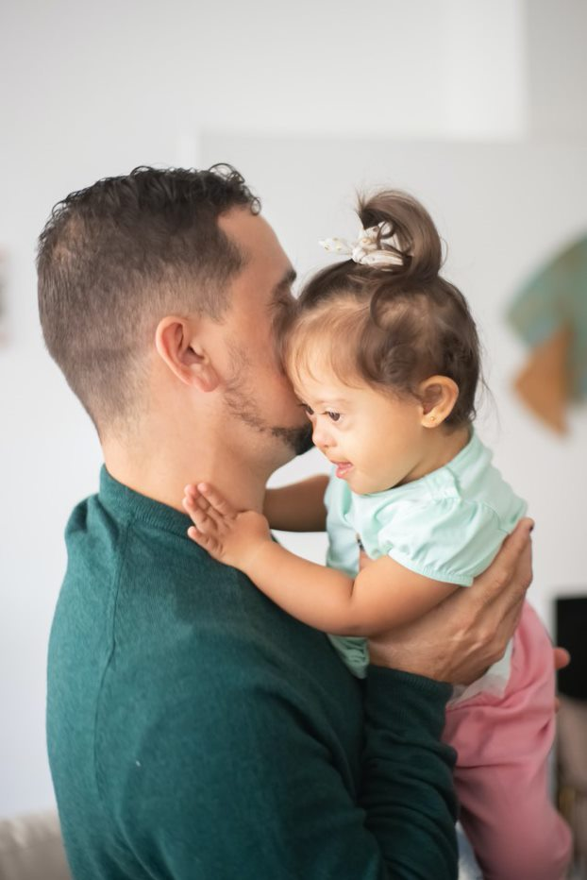
Family Action WESAIL Annual Report April 2022- March 2023

Report complied by Sue guest, operational manager
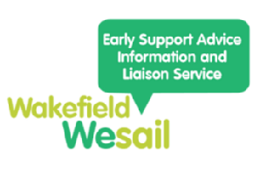
CONTENTS
- Introduction
- Delivery of Special Educational Need and Disabilities Information Advice and Support Services (SENDIASS)
2.1 Duty Line
2.2 Casework
2.3 SENDIASS Steering board
3. Key Working Support - now known as the pre and plus service
- Delivery of Wakefield’s Local Offer
- Staffing
- Incidents and complaints
- Social Value
- Strengths of the service & successes (operational developments)- impact statement
- Challenges/concerns/what can we improve
- Development opportunities & Future plans

- Introduction
This year has brought significant change to the Wakefield Early Support, Advice, Information and Liaison service (WESAIL) with a change in provider from Barnardo’s to Family Action on 1st April 2022. The service has implemented many smarter operational practices to enable the continuation of quality service delivery within a reduced budget envelope.
WESAIL is jointly commissioned by Wakefield Council and Yorkshire and Humberside ICB to deliver:
- The Special Educational Need and Disabilities Information Advice and Support Services (SENDIASS)
- Key Working Support
- Wakefield’s Local Offer
- Delivery of Special Educational Need and Disabilities Information Advice and Support Services (SENDIASS)
Wakefield City Council and Wakefield ICB are committed to providing a service at ‘arm’s length’ to ensure impartiality of the Service. The SENDIASS element of the WESAIL contract is delivered to the minimum standards published and endorsed by the DFE and Department for Health. The service provides a duty line and casework to support families in line with the minimum standards.
  - Duty Line
The duty line is open Monday to Friday, between 9:00am and 5:00pm. In a change to previous delivery, callers to the duty line are encouraged to leave a message. SENDIASS officers return calls within the contracted time of 72 hours although many calls are responded to within 24 hours.
2.1.1 Duty line Outputs
 | Q1 | Q2 | Q3 | Q4 | Total 20-21* | Total 22-23
New Initial Enquiries | 352 | 389 | 395 | 486 | 923 | 1633
*This data is from the most recent annual report published by Barnardos in 2021
In the first year of the pandemic (2020-21), WESAIL reported 923 calls managed. In the first year of the new contract, 76% more enquiries were dealt with. Demand for support rises quarter by quarter. Q4 saw a significant increase in part attributed to contact from families whose children/young people did not get the specialist provision they requested. WESAIL is now understanding the peak demand times and will be able to deploy the workforce in a managed way in the coming year. School holiday times are usually quieter and can be used to catch up on open initial enquiries.
The largest number of calls is ’not recorded’. This number is high for these reasons:
- the nature of SENDIAS means callers can keep their information confidential
- failed call-backs
A new category ‘not disclosed’ was introduced in Q4 to more accurately reflect this.

New systems have been developed to enable duty officers to support families at the point of contact without the need for casework.(85%) Families are given expert, quality advice over the phone at the point of calling. Calls are followed up by an email with signposting information. Families are encouraged to call us back at any time if further information is required. The option of more detailed casework is always available should it be necessary (8.7%).
This new way of working has reduced caseloads and waiting times considerably.

Levels of duty calls
Levels of intervention are determined on converted cases at the time of the initial enquiry according to IASS guidance. Historically, cases managed during a duty call were considered to all be at level 1.
SENDIASS Intervention levels summary
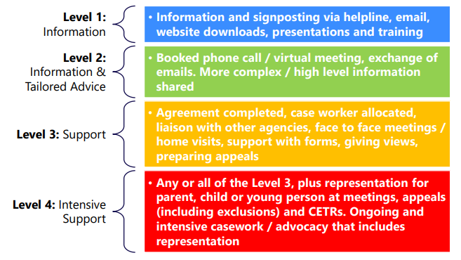
New ways of working mean that many calls supported by WESAIL on the duty line are at a higher level, with information and advice being tailored to the needs of the caller (level 2).
Action: Over the coming year we will be revisiting how duty calls are assessed and levels applied to further understand and report on the complexity of the work undertaken.
In addition, definitions of intervention levels are under review within IASS and WESAIL are involved in these nationwide conversations.
Operational developments to cope with increasing demand
WESAIL have developed several working practices to ensure calls are managed as efficiently as possible.
- Using the answerphone enables staff to be pre-prepared with information and potential signposting avenues
- Use of email whenever possible speeds up responses to calls
- The combination of email and answerphone system also allows service users to contact us at a time most convenient to them
- A series of templates have been developed to increase efficiency when responding to calls
- Common issues are identified through a process of peer supervision and team meetings allowing us to continually imporve upon quality
- Inappropriate referrals are flagged directly with professionals and any need for improved communications identified
2.1.2 Duty Line outcomes
Following a contact with our dutyline, callers are invited to complete a short feedback questionnaire. See table below for detail.
55 questionnaires were received with our service users rating our input at least 4 out of 5 across all aspects of delivery. Most callers want advice on EHCPs, My Support Plans or signposting to other services. A growing number of callers are requesting support with Emotionally Based School Avoidance (EBSA)
Action: WESAIL staff to link with Wakefield Educational Psychologists to ensure consistent messages are being given around EBSA in this growing area for support.

Question |  |  | Percentage
1 | Are you a… | parent | 60%
 |  | carer | 0
 |  | young person | 0
 |  | professional | 40%
2 | What were you hoping to get out of this call? | Advice on EHCP or My Support Plan | 22%
 |  | Support to understand my child's SEND | 20%
 |  | Advice on benefits and entitlements | 5%
 |  | Information on other services which can help me | 22%
 |  | Information on transitions | 4%
 |  | Appeals or mediation | 0%
 |  | Exclusion | 3%
 |  | Emotionally Based School Avoidance | 12%
 |  | Referral to another service | 4%
 |  | Support for pending meeting | 3%
 |  | Other | 0
 |  |  | Average
3 | How successful were we in helping you? 1 not at all, 5, very helpful |  | 4.1/5
4 | How helpful was the information, advice and support we gave you? |  | 4.4/5
5 | How timely do you think our response was to your query? |  | 4.5/5
Comments form parent/carers are always extremely positive- here is a sample which
illustrates the positive outcome for families contacting our duty line
‘XXX was extremely knowledgeable, supportive and a great listener. The problem was quickly resolved the same day. We are delighted with the service/support.’

‘Was totally happy with the advice I was given. Everything was explained to me. Nothing was too much trouble and I felt valued too.’

‘I can't be thankful enough for your advice and support. Absolutely brilliant 👏🏻👏🏻’
‘XXX was so helpful, kind and understanding. Such in-depth knowledge and expertise in this field. An asset to your team. I finished the phone conversation feeling a lot happier having her support me and knowing I can contact her again if I need. ‘

  - Casework
Family Action inherited a large caselaod and long waiting times from the outgoing provider. In addition, the funding for the service was reduced nessecitating a reduction in staffing. The greatest challenge for Family Action was to ensure that waiting times were reduced and equity of access to support was developed. Many inherited cases had been open to caseworkers for several months or even years (maximum 3 years, average 1 year) with little evidence of a clear direction for interventions. Some families were in receipt of consistent support over several years, whilst others were waiting long periods of time to access any support. This equity of access to services needed to be addressed.
A goal-driven approach to service delivery was instigated with SMART targets set in consultation with parents/carers. Once targets are achieved, cases are closed. However, the service is mindful that SEND is usually a life-long condition and families often need further support with the same or a different issue. At the point of closure, it is made clear that referral back into the service at any point is easy. With the huge reduction in waiting times, support can be given to families at the point of need with no need to keep cases open in anticipation of a future issue.
This flexibility of caselaod management has resulted in reductions in waiting times with families moving in and out of the service as and when they require support.
The table below shows the huge progress WESAIL has made with caselaod management.
 | Position on 1st April 2022 | Position on 31st March 2023
Numbers waiting | 58 | 29
Number of active cases | 151 | 64
Total caseload | 209 | 93
Current longest wait for service | 55 weeks | 9 weeks
Average time on active caseload | 50 weeks | 35 weeks
Longest time on active caseload | 160 weeks | 45 weeks
Numbers of active cases are small with greater throughput due to a goal-centred approach to intervention.
To emphasise:
Waiting times for case work have reduced from 55 weeks to 9 weeks during the last year.

    - Casework Outputs
Waiting times outputs have been described above. In addition, WESAIL has recorded the following outputs:
New cases this quarter | Q1 | Q2 | Q3 | Q4 | TOTALS | %AGE
Not recorded | 4 | 2 | 0 | 0 | 6 | 4%
L2 | 3 | 0 | 2 | 0 | 5 | 4%
L3 | 21 | 17 | 9 | 33 | 80 | 57%
L4 | 7 | 5 | 14 | 24 | 50 | 35%
TOTALS | 35 | 24 | 25 | 57 | 141
PERCENTAGES | 25% | 17% | 18% | 40%

141 cases were referred over the year with 40% of these being received in quarter 4. Reasons for this uneven distribution of referrals were outlined above under ‘duty line’ and will be noted for managing cases next year. The highest number of referrals sit at level 3 (57%).

As is well documented by SEND demographics, the number of boys referred to the service outweighs girls by approximately 2:1. However, comparisons with data from 20-21 might be of interest. The percentage of girls referred to the service has increased from 27- 34%. There may be a narrative here around increasing understanding/identification of autism in girls which is being pulled through to this data.
The percentage of CYP identifying as ‘neutral’ has increase by 1% in this time, from 1 to 2%.

Categories of SEN have been the source of much debate over the year. When interpretting this data, please note, these descriptions are given to us by parents/carers using our service. These are parental opinions of their child’s main SEN and therefore might be different from other SEND data gathered by the local authority.
Autism continues to be the most common SEN category for parents contacting WESAIL. SEMH is now the second largest with 14% of the callers recording this as the main SEN. This compares starkly with data from 20-21 where only 3% of the caseload were identified with SEMH as the main SEND. This underlines public health findings in relation to the impact of the pandemic on our children and young people
‘Some children with SEND appear to have suffered substantial impacts on their mental health and experienced greater anxiousness during the pandemic than children without SEND.’ COVID-19 mental health and wellbeing surveillance: report by Office for Health Improvement and Disparities: April 2022.
Very little support is requested by the families of young people aged 17- 25 or by the young people themselves. The age of CYP on our caseloads is predominantly 5-16 although 12% are pre-school.
    - Casework Outcomes
Many operational changes have been undertaken within WESAIL as decsribed in detail above. Whilst we have facilitated a reduction in waiting times and streamlined our casework considerably, it is really important to understand the impact of these changes on the outcomes and experiences of our families.
Following closure, parents/carers are invited to complete a feedback questionnaire. This is currently a lengthy questionnaire to gather information in relation to all KPIs in the contract and to help us to shape service delivery. Returns of questionnaire has been small compared to the number of closures with 17 completed questionnaire received over the year. The questionnaire will be reduced next year with the aim of gathering feedback from a wider audience.
The average score across all questions is 4.75 out of 5.
Under ‘how did we do?’ of particular significance are the high ratings for the following questions
- I felt listened to and understood by service staff.
- The information, advice and support I received met my/our needs
- The service was impartial and fair
Under ‘what difference have we made?’ service users we asked ‘How effective has WESAIL been in helping you with what you want to achieve?’ Scores again were 4.7/5. Ion addition, the following comments were received:
‘Been there when I needed to be supported with school meetings’
‘Help with school meetings and getting our word across for us -filled in paperwork to a very high standard’
‘Clearly cared about my situation and sought to understand it thoroughly.’
‘XXXX is amazing, she lifted me up when I was struggling and gave me the strength to keep fighting.’
‘Getting my autistic child into a specialist provision school’

What did we do well?
"Nothing"
‘Maybe sessions where you could meet other parents’
‘By taking him to groups where people are the same as him’
‘Facilitating access to home support ‘

What could we have done better?

"Just great knowing the service is there when I’m struggling’
"XXX has been fantastic- friendly and supportive -am very grateful "
‘Brilliant at getting answers for us’

Any other comments?
We were keen to understand the impact of the operational changes we had made and asked the following question:
‘Do you have any comments or feedback in relation to the new processes introduced by WESAIL regarding the management of your case?’
The only replies we received were: "Fantastic support " and “Very friendly easy staff to work with’

In addition, no formal complaints have been received by the service in the last year.
Feedback from our families is overwhelmingly positive. We have received no complaints about any aspect of the service. We believe we provide a quality service which consistently succeeds in supporting families to achieve their outcomes.

  - SENDIASS steering board
2 steering board meetings have been facilitated this year. Professionals attended from SENART, commissioning, school (x2) and the young lives consortium. 3 parents attended plus representatives from the parent carer forum.
Both meetings have been chaired by staff employed by WESAIL. However, best practice is to have the board chaired by a parent/carer and adverts are currently being circulated to elect a chair and also to increase membership of the board.

Agenda items and discussions this year:
- Introducing Family Action as the new provider of WESAIL
- Sign-off of revised Terms of Reference for the board
- Operational changes proposed and feedback from board members
- Revised service spec including new pre-and plus offer replacing keyworking
- Communication and marketing: new service leaflet, amalgamated Facebook pages, revised website
- Steering board chair recruitment

WESAIL have been delighted with the support and challenge they have received from board members. The steering board ensures service provision is in line with the needs of the community.

- Key working Service - now known as the Pre and Plus service

Historically, WESAIL have provided a ‘key-working’ service to families meeting specific criteria. The current service specification states the need …. to deliver time limited key working for families with SEND related needs based on jointly agreed outcomes, which require coordinated support and is over and above what is available via the main SENDIASS service. The aim of key working is to provide an integrated approach to supporting children, young people, parents and carers; providing a consistent and single contact for families to support and enable them to access their entitlement to services, navigate the SEND system and EHCP Plan process and to also build the families resilience and independence.
Under the new tender and with a decreased budget, it was essential that the key working element of the service was delineated and understood further.
In conjunction with commissioners a ‘Pre and Plus’ service specification was developed which aims to support families as described in the specification.
The Pre & Plus work is offered in two formats:
- Complex Pre worker cases (predominantly pre-school where SENDIASS is not yet appropriate)
- A “Bolt-on” Plus service which will add enhanced support to SENDIASS cases.
The service is time-limited and goal-driven. The aims of this service are to
- Move towards a predominantly “Bolt-on” service by 2023
- Support families to self-identify their priorities whilst a case is open
- Use a model of scaffolding to empower families to work autonomously beyond our intervention and build their confidence
- Offer predominantly virtual support wherever possible
- Manage families’ expectations of the parameters of the service including understanding the time limited approach to the intervention we offer
This new model is in its infancy, but 3 full complex ‘pre-working’ cases have now been completed and evaluations are excellent.

A case study of a pre-working case follows to showcase this work.
The Marshall Family- A Pre-working case study
The Marshall family were referred to WESAIL by their social worker. Jo is grandmother to 2 grandchildren who live with her through kinship care arrangements. Both children have autism and/or ADHD with SEMH traits also believed also be present. The children had experience trauma and neglect and there were multiple challenges managing and understanding behaviours at home. Jo was feeling isolated, overwhelmed and unsure of what support was available for her.
The pre-worker initially met up with the family at a sensory stay and play session in one of the Wakefield family hubs and proceeded to get to know Jo and the children through regular contact. Next steps and goals were identified with Jo, to best support her current needs. The pre-worker liaised with all professionals involved with the family, including both settings attended by the children, HomeStart, portage and community paediatrics.
Jo was signposted and supported to access several services and also signposted to services to look after her own mental health.
At closure, all goals had been achieved. Jo was aware of all the support available to her and a HomeStart worker was visiting. She had accessed training to help her to understand the behaviour of the children focusing on sensory processing, sleep and behaviour and had introduced new behaviour methods at home. She was also accessing kinship care support and knew where to go for support with her own mental health.
The pre-worker left Jo and the family in the care of several other appropriate services and with a much better understanding of how to work together as a family- but also with details of how to come back to us if it was required.

Currently WESAIL have not implemented systems to capture numbers and outcomes for ‘plus’ working cases. We are working with our IT department and this information will be available at the end of Quarter 2 2023.

- Wakefield’s Local Offer
The full Local offer report is here:
A summary of key developments and progress this year follows:
- Facilitated a seamless transition from Barnardo’s to Family Action
- Launch of the new Wakefield Local Offer website
- 3 x local offer newsletters produced with articles included which were requested by service users as well as from children and young people
- Local offer organisational group launched
- 13% more local offer webpages visits and 36% more local offer users than last year
- A single, new Local Offer and WESAIL Facebook page launched
- Participation in peer reviews

- Staffing
9 staff TUPE transferred from Barnardo’s to Family Action on 1st April 2023. A restructure process was instigated immediately to reduce the staff team to 6. Fortunately, 2 staff members succeeded in finding alternative employment and resigned from WESAIL. A third was redeployed within Family Action. The current staff team consists of:
1 Service Manager
1 Senior SENDIASS Officer
3 part time SENDIASS officers (1.8 whole time equivalents)
1 Administrator and local offer worker (3 days a week)

- Incidence and Complaints
None documented this year.
- Social Value
A summary of social value added by WESAIL in 22-23 is below. This is as reported on the TOMs framework via the social value portal.
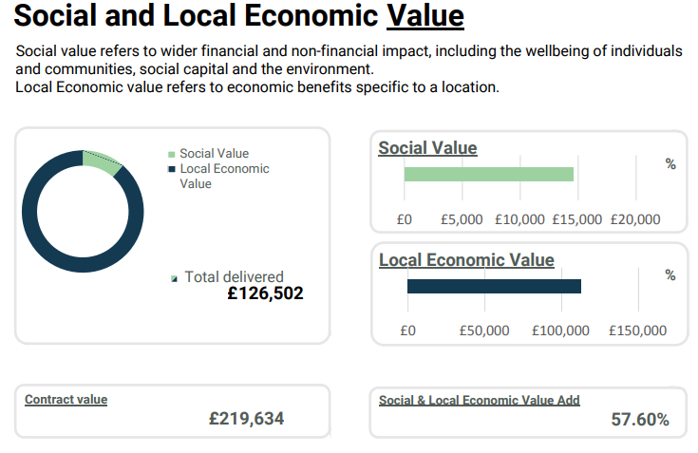
Our social value pledge covers the 2 years of the contract. Delivered value in 22-23 includes:
- Retention of a number of jobs within the Wakefield district to deliver the service
- Provision of support to third sector organisations- 181 hours evidenced. Activity counted
- Improving skills and qualifications of the staff involved in the delivery of the Contract
- Reducing inequalities- Living Wage

Full details of the social value added by WESAIL can be found in this report:

- Strengths of the service & successes- impact statement
Please see impact statement below

- Challenges/concerns/what can we improve.
- Ever increasing demands on the service are a challenge. Numbers of referrals steadily increase quarter by quarter.
- Emotional demands on staff-Supporting families in crisis is challenging and takes a toll on staff members unless carefully managed. Family Action are aware of this, and staff take duty calls for half a day not a full day. As the number of calls increases, this might not be possible.
- The heightened impact of any staff absence (be this planned leave or sickness) on such a small team needs to be emphasised.
- Waiting lists in other services impact on our ability to move cases forward.
- Development opportunities & Future plans
- Family Action are now the biggest provider of SENDIAS services in the country. A new SEND thematic group has been developed within the charity with the aim of developing and sharing best practice. WESAIL staff will be an integral part of task and finish groups to push this work forward.
- Coproduction with an emphasis particularly on the local offer
- Increasing membership of the Steering board and electing a new chair.
- A focus on communication and marketing. 1 year on, WESAIL need to ensure consistent messages are share around the service and its re-design.
- A final push to reduce waiting times to a few weeks needs to be a priority
- Outputs and outcomes relating to the pre and plus service need developing and reporting on
- Family Actions’ priority for this is year is a focus on quality of practice. WESAIL will be engaging with this objective and developing work- plans to improve quality.
- Work improving the accessibility of the local offer website will continue.
- Identifying training needs of staff to support common themes and worries being shared by parents/carers. This is especially in relation to EBSA and SEMH
- Main SEND categories will be revisited as part of the thematic task and finish groups and consistency developed across all SENDIASS services.
- Engaging in national discussions around the definitions of IASS levels of support and considering levels when reporting on work within WESAIL

Sue Guest 23/05/23

