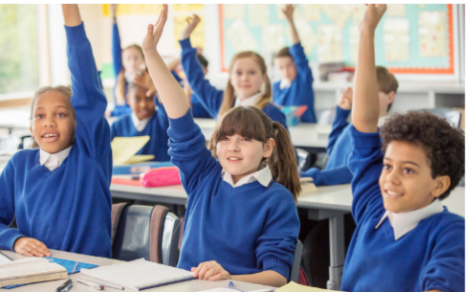
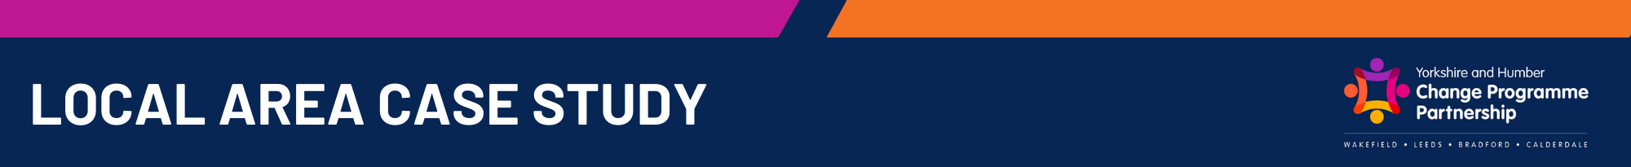
- 30 staff trained across 13 schools in the district.
- Staff now equipped with practical strategies and resources to deliver targeted emotional support.
- Increased confidence and competence in addressing emotional well-being needs.

Staff Development

Inclusive Schools - IRP Impact Summary January 2026

Direct Pupil Impact

Impact on Parents

- Parents report improved communication and trust with schools.
- Greater confidence that children’s emotional needs are being met.
- Impact to continue to be monitored as pupil complete the ELSA Programme.

- Emotional literacy interventions delivered by trained staff are expected to have a sustained positive effect on pupils’ emotional well-being, engagement, and resilience.
- Monitoring Plan: Direct pupil impact will continue to be tracked following CPD through:
  - Pupil progress reviews (academic and emotional well-being indicators).
  - Feedback from pupils, parents, and staff.
  - Behaviour and attendance data analysis.

- Enhanced capacity to deliver inclusive education.
- Reduction in referrals to external services for low-level emotional needs.
- Strengthened collaboration between schools and trusts on inclusion priorities.
Impact on Schools and Trust Level

- Improved emotional regulation and resilience among pupils receiving ELSA support.
- Early indications of better engagement in learning and reduced behavioural incidents.
- Positive feedback from pupils on feeling “listened to” and supported.

Impact on Children

