Information Network / Disabled Children Register
Application Form
The Information Network (IN) is what Wakefield Council calls the Disabled Children’s Register (DCR).The Council has a statutory duty to keep and update the register under the Children’s Act 1989, although it is voluntary for people to join it.

The details you provide can also allow us and our partners, Family Action, and Wakefield Parent Carer Forum to contact you about support, services, and events you may be interested in taking part in. You can tell us if you want to receive this information or not by filling in Section 1. Consent.

You can also decide if you would like your details to be shared with Family Action to receive the local area newsletter issued each term.

For more information about this please see section 2 in the IN-Privacy Notice.

Ways to view the Privacy Notice

Visit: Wakefield Local Offer https://wakefield.mylocaloffer.org/information-network/how-will-you-share-the-information/ or scan the QR code below:

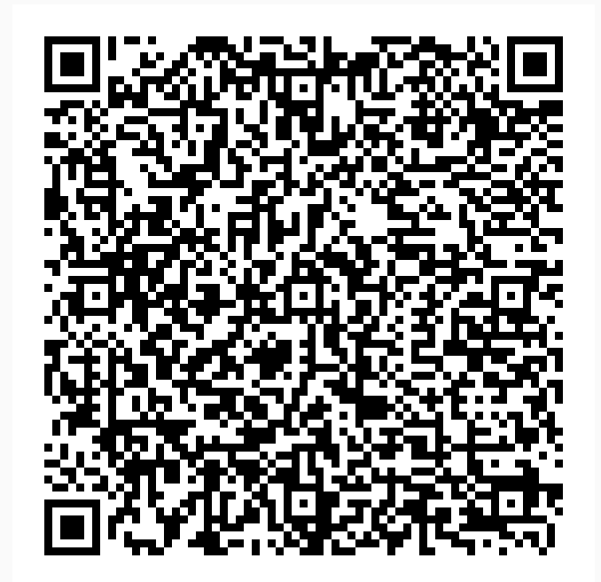
You can join by filling in this form and posting to us, or you can complete an online form by visiting the Wakefield Local Offer website https://wakefield.mylocaloffer.org/information-network/how-can-i-join/ or scan the QR code below:
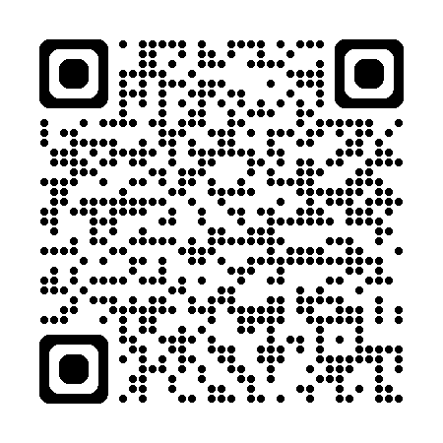
For any Further support please contact WISENDSS Team on Informationnetwork@wakefield.gov.uk or phone 01924 302471

If you have more than one child with additional needs, please fill in a supplementary form for each child.

Once you have completed the form please return it to:
Wakefield Inclusion SEND Support Service (WISENDSS)
Wakefield One Floor 3 North
Burton Street
Wakefield
WF1 2EB
Section 1– Consent
To be able to use, store and share your information we need you to agree for your child’s information to be recorded on the Disabled Children’s Register (DCR)

I am a parent/carer, and I am filling in this form
Please let us know when you read the statements below if you agree or disagree by putting a tick in the box. You can read more about how your data may be shared by reading Section 2 in the IN-Privacy Notice.
If you do not tick a statement we will assume you do not agree to our using or sharing your information in the way described.

Please tick to confirm your choices
Agree Disagree
I agree for my email address to be shared with Family Action so
they can send me details of support, services, events, training and
advice sessions that may be suitable for me and my family’s needs.
I agree for my email address to be shared with Family Action through email address so that I can receive the local area newsletter regularly.
I agree to share my email address, child’s name and age range with Playschemes to receive information about any holiday play schemes the Council may organise relevant for me and my family.
I agree for my contact information to be shared with Wakefield
Parent Carer Forum so they can send me details of support, services, events, training and advice sessions that may be suitable for me and my family’s needs.
Please state how you would like to receive this information.

Email Post

Please provide your postal address if choosing Post

Signed

Name

Dated

Please provide your email address in Section 2 of the form.
Section 1– Consent Young Person 16-25
Please leave this section blank if your parents are filling this form in for you.
To be able to use, store and share your information we need you to agree for your information to recorded on the Disabled Children’s Register (DCR).

I am a young person aged 16-25 and I am filling in my own consent
Please let us know when you read the statements below if you agree or disagree by putting a tick in the box. You can read more about how data may be shared by reading Section 2 in the IN-Privacy Notice.
If you do not tick a statement, we will assume you do not agree to our using or sharing your information in the way described.
Please tick to confirm your choices
Agree Disagree
I agree for my email address to be shared with Family Action so
they can send me details of support, services, events, training and
advice sessions that may be suitable for me and my family’s needs.
I agree for my email address to be shared with Family Action so that I can receive the local area newsletter regularly.

I agree to share my email address, name and age range with Playschemes to receive information about any holiday play schemes the Council may organise relevant for me and my family.
I agree for my contact information to be shared with Wakefield
Parent Carer Forum so they can send me details of support, services, events, training and advice sessions that may be suitable for me and my family’s needs.
Please state how you would like to receive this information.

Email Post

Please provide your postal address if choosing Post

Signed

Name

Dated

Please provide your email address in Section 2 of the form.

Section 2: Receiving your information

See section 2 of the IN-Privacy Notice for more information
Please provide your email address.

Email details

Please provide a contact telephone number.

Note: Your contact number will only be used to contact you if there are any queries/problems with the application form.

Section 3: Max Card

As part of the Information Network, you can choose to receive a Max Card to help reduce the cost of selected days out and activities across the district and the UK.

Please send me a Max Card Yes No

Postal address

Please ensure you complete the postal address section to enable us to send the Max Card out to you

Section 4: Parent/Carer Information

See section 2 of the IN-Privacy Notice for more information

Title

Name

Relationship to child or young person

Section 5: Child/Young Person
For more information see sections 2 IN Privacy Notice

Name of Child/Young Person 1

Date of Birth e.g. 02 05 1997
Gender

Male Female Other – please tell us

Child/Young Person 1 – Ethnicity
Tick one box which best describe the ethnicity of the child or young person
I prefer not to say
White
English/Welsh/Scottish/Northern Irish/ British
Irish
Gypsy or Irish Traveller
Other White background - please state

Mixed / Multiple ethnic groups
White and Black Caribbean
White and Asian
White and Black African
Other Mixed / Multiple - please state

Asian/Asian British
Indian
Pakistani
Bangladeshi
Chinese
Other Asian background - please state

Black / African / Caribbean / Black British
African
Caribbean
Other Black / African / Caribbean background - please state

Other ethnic group
Arab
Other ethnic group - please describe below

Child/Young Person 1 - Additional Information

Please tick all boxes that apply:
Attends Early Years Setting
Attends Mainstream School
Attends Resource Provision
Attends Special Day School
Attends Special Residential School
In Further Education (College level)
In Higher Education (University Level)
Takes part in Training or Apprenticeship
In paid employment
In voluntary employment
Home Educated
Alternative Provision
Not in Education, Employment or Training

Child/Young Person 1 – Additional Information

Please tell us about the child or young person’s Educational Needs.

Tick one box that applies.
Gets Special Educational Needs (SEN) support
Has a My Support Plan (MSP)
Has an Education Health and Care Plan (EHCP)
None of the above

Child/Young Person 1- Additional Needs

Please read the descriptions that follow and tick the boxes which best describe the additional need/s the child or young person may have.
 | Medically  Diagnosed | Awaiting  Diagnosis | No Formal  Diagnosis | Not Applicable
Physical disability (PD) like Cerebral Palsy,
Brittle Bones or Muscular Dystrophy
Specific learning difficulty (SpLD) e.g. Dyslexia, Dyscalculia, Dyspraxia and Dysgraphia
Moderate learning difficulty (MLD) e.g. Working well below expected levels of attainment
Severe learning difficulty (SLD) e.g. Difficulties to understand, learn and remember new skills
Profound and multiple learning difficulty (PMLD) e.g. Severe difficulties with seeing, hearing, speaking and moving
Social, emotional and mental health (SEMH) like anxiety of depression
Attention-deficit/hyperactivity disorder (ADHD)
Hearing impairment (HI)
Visual impairment (VI)
Multi-sensory impairment (MSI)
Autism spectrum disorder (ASD)
Speech, language and communication needs (SLCN)
Chronic illness like Epilepsy, Diabetes, Tracheostomy, Asthma or Anaphylaxis
Life limiting illness
SEN Support but no specialist assessment of type of need
Other please specify

Please list any other difficulty/disability or additional need. You can also use this section to provide any extra information about the boxes you have ticked above.

Section 5: Child/Young Person 2

For more information see sections 2 IN Privacy Notice

Name of Child/Young Person 2

Date of Birth e.g. 02 05 1997
Gender

Male Female Other – please tell us

Child/Young Person 2 – Ethnicity
Tick one box which best describe the ethnicity of the child or young person
I prefer not to say
White
English/Welsh/Scottish/Northern Irish/ British
Irish
Gypsy or Irish Traveller
Other White background - please state

Mixed / Multiple ethnic groups
White and Black Caribbean
White and Asian
White and Black African
Other Mixed / Multiple - please state

Asian/Asian British
Indian
Pakistani
Bangladeshi
Chinese
Other Asian background - please state

Black / African / Caribbean / Black British
African
Caribbean
Other Black / African / Caribbean background - please state
Other ethnic group
Arab
Other ethnic group - please describe below

Child/Young Person 2 - Additional Information

Please tick all boxes that apply:
Attends Early Years Setting
Attends Mainstream School
Attends Resource Provision
Attends Special Day School
Attends Special Residential School
In Further Education (College level, Post 16)
In Higher Education (University Level)
Takes part in Training or Apprenticeship
In paid employment
In voluntary employment
Not in Education, Employment or Training

Child/Young Person 2 – Additional Information

Please tell us about the child or young person’s Educational Needs.

Tick one box that applies.
Gets Special Educational Needs (SEN) support
Has a My Support Plan (MSP)
Has an Education Health and Care Plan (EHCP)
None of the above

Child/Young Person 2 - Additional Needs

Please read the descriptions that follow and tick the boxes which best describe the additional need/s the child or young person may have.
 | Medically  Diagnosed | Awaiting  Diagnosis | No Formal  Diagnosis | Not Applicable
Physical disability (PD) like Cerebral Palsy,
Brittle Bones or Muscular Dystrophy
Specific learning difficulty (SpLD) e.g. Dyslexia, Dyscalculia, Dyspraxia and Dysgraphia
Moderate learning difficulty (MLD) e.g. Working well below expected levels of attainment
Severe learning difficulty (SLD) e.g. Difficulties to understand, learn and remember new skills
Profound and multiple learning difficulty (PMLD) e.g. Severe difficulties with seeing, hearing, speaking and moving
Social, emotional and mental health (SEMH) like anxiety of depression
Attention-deficit/hyperactivity disorder (ADHD)
Hearing impairment (HI)
Visual impairment (VI)
Multi-sensory impairment (MSI)
Autism spectrum disorder (ASD)
Speech, language and communication needs (SLCN)
Chronic illness like Epilepsy, Diabetes, Tracheostomy, Asthma or Anaphylaxis
Life limiting illness
SEN Support but no specialist assessment of type of need
Other please specify

Please list any other difficulty/disability or additional need. You can also use this section to provide any extra information about the boxes you have ticked above.

