Dynamic Support Register

Consent Form
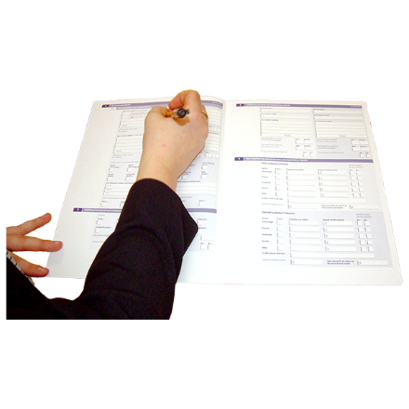
We would like to talk about adding you to the Dynamic Support Register (DSR). We cannot do that unless you agree and fill out this form.

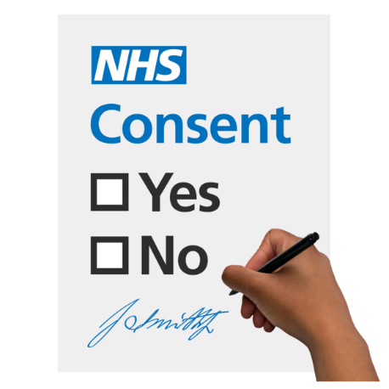
You must agree to be added to the DSR. This is called consent.
This means you can understand, think about and remember the information you need to decide.



You will also need to decide to share your information with the health staff who will decide what to do about this form and to help offer support.

If you would like to find out more about what happens to your information, please visit the
WY Privacy Notice Webpage
www.westyorkshire.icb.nhs.uk/privacy-notice

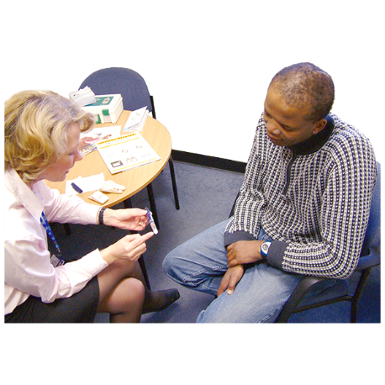
If you are not able to make this decision yourself, we will have a meeting to look at what is best for them. This is called a best interest meeting.


The best interest meeting will need to take place and the information will be written down.


Please tell us your name


Today’s date


Have you had the right information and support to understand what a DSR is and why we want add you to it?

Yes  ☐ No ☐

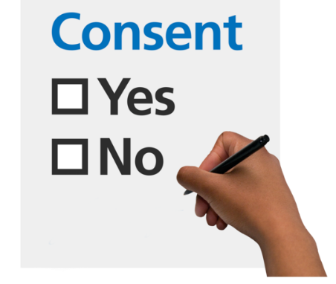
Do you consent to be added to the DSR?
Yes ☐ No ☐


Do you consent to your information being shared with other people who will help you?
Yes ☐ No ☐


Is there someone who helps you with your daily activities? If so, please tell us their name.

Have they had the right information and support to understand what a DSR is and why we might have their information to contact them?

Yes ☐ No ☐


Do they consent to their information being shared with other people who will help support you?
Yes ☐ No ☐

- Easy read information about agreeing to a DSR.
www.england.nhs.uk/wp-content/uploads/2023/01/Easy-read-version-of-the-Dynamic-support-register-and-Care-Education-and-Treatment-Review-policy-and-guide-Jan.pdf

  - SeeAbility
www.seeability.org/resources/consent-and-capacity-easy-read

- The West Yorkshire Key Worker Service for people up to the age of 25
www.westyorkshirekeyworkerservice.org.uk
0113 393 3240
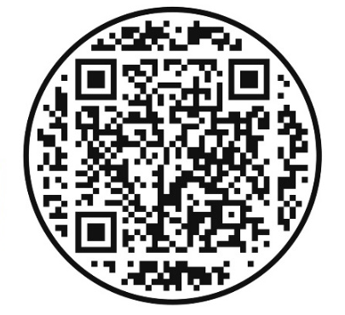
For Office Use Only | Enter information below
Date received:
Outcome: (signposted, requires more information, accepted)

