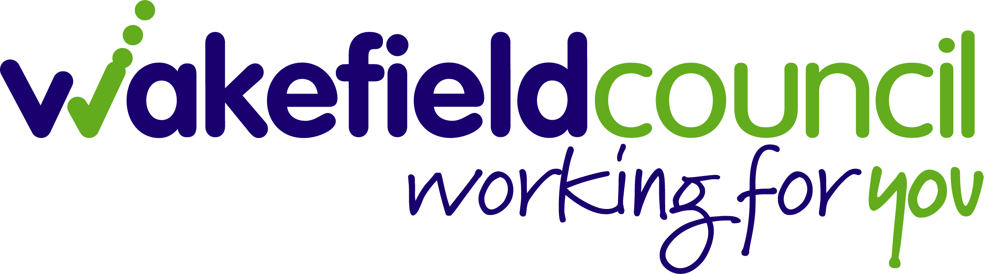

Accessibility Strategy
For children and young people with
Special Education Needs and Disabilities
(SEND)
In Wakefield

2020 - 2022

Contents Page

Introduction and Vision 3
1.0 Legal Framework 4
- Definition of Disability 4
- Definition of SEND 5
2.0 Local Context 5
- Pupil Population 5
- Schools and Settings 6
- Specialist Provision 6
3.0 Information, Advice and Guidance 7
- SENDIASS 7
- Wakefield Local Offer 7
4.0 Increasing Access to the Curriculum 8
5.0 Improving the Physical Environment 8
6.0 Improving Access to Information 10
7.0 Implementation and Review 10
8.0 Feedback and Complaints 11
9.0 Appendix 11

Introduction

The Education and Inclusion Service at Wakefield Council is committed to ensuring all Children and Young People have the opportunity to succeed at all levels of learning giving them the skills they need for achieving their aspirations in life.

Our focus will be on person centred planning, treating every child or young person as an individual in making sure they receive the right level of support they need to achieve their goals.

Our approach will be to look at what a person can do regardless of their learning difficulty or disability, rather than what they cannot do, and how services can work together in providing the appropriate package of support.

Our Vision
We are ambitious for our district’s children and young people.
Our vision is for children and young people to tell us they are happy, healthy and safe and thriving in communities where families and services work together to help them achieve their potential and dreams.

1.0 Legal Framework

The Equality Act 2010 brought together a range of equality duties and requirements within one piece of legislation. The Act introduced a single Public Sector Equality Duty (PSED) (sometimes also referred to as the ‘general duty’) that applies to public bodies, including maintained schools and academies (including Free Schools) and which extends to all protected characteristics - race, disability, sex, age, religion or belief, sexual orientation, pregnancy and maternity and gender reassignment. This combined equality duty came into effect in April 2011.

The duty has three main elements. In carrying out their functions, public bodies are required to have due regard to the need to:
- eliminate discrimination and other conduct that is prohibited by the Act,
- advance equality of opportunity between people who share a protected characteristic and people who do not share it,
- foster good relations across all characteristics - between people who share a protected characteristic and people who do not share it.

All schools have duties under the Equality Act 2010 towards individual disabled children and young people and must publish;
- An SEN Information Report/Policy
- A Medicine in School Policy
- An Access Plan
- Information on Admissions

Requirements for local authorities to put in place an accessibility strategy are specified in schedule 10 of the Act: Accessibility for disabled pupils.

Schedule 10 says:
An accessibility strategy is a strategy for, over a prescribed period —
- increasing the extent to which disabled pupils can participate in the schools’ curriculums;
- improving the physical environment of the schools for the purpose of increasing the extent to which disabled pupils are able to take advantage of education and benefits, facilities or services provided or offered by the schools;
- improving the delivery to disabled pupils of information which is readily accessible to pupils who are not disabled.

The delivery of information must be:
- within a reasonable time;
- in ways which are determined after taking account of the pupils’ disabilities and any preferences expressed by them or their parents.

Definition of Disability
A person is disabled if they have a physical or mental impairment that has a substantial and long term adverse effect on their ability to carry out normal day to day activities. Physical or mental impairment includes learning difficulties, mental health conditions, medical conditions and hidden impairments such as dyslexia, autism and speech and language and communication impairments (Equality Act 2010).

Definition of SEND
A child or young person has a special educational need if they have a learning difficulty or disability which calls for specialist education provision to be made for him or her (SEND Code of Practice 2014).

2.0 Local Context

Pupil Population

In the January 2021 School Census:
- There were 54,118 pupils in schools in the Wakefield District.
- Of these, 6557 were at SEN Support.
- 1895 had an Education Health and Care (EHC) Plan. (In total, Wakefield Council maintain 2256 EHC Plans.)
- SEND Pupils have the following Prime Needs
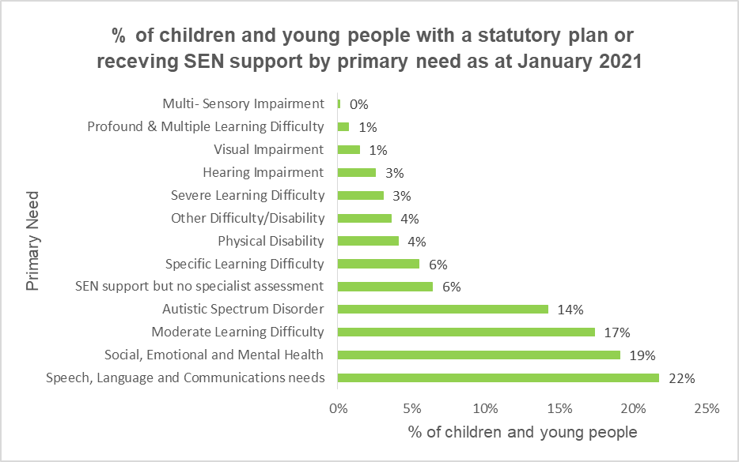

Schools and Settings

There are 141 schools:
- 113 Mainstream Primary
- 18 Mainstream Secondary
- 3 Nurseries
- 3 Pupil Referral Units (PRUs)
- 4 Special Schools

3 Independent/Private Schools
3 colleges

Specialist Provision

There are a range of specialist provisions across the Wakefield district. These are Special schools and others are specialist resource provisions or units which are part of a mainstream school or a stand-alone provision:

Hearing Impairment:
- 1 primary – Rookeries Resource
- 1 secondary – Castleford Resource

Visual Impairment:
- 1 secondary Resource – Crofton Resource

Autism Spectrum Disorder (ASD)/Speech Language and communication
- 3 primary – Methodist, Newlands and Northfield Resources
- 3 secondary – St Thomas a Beckett, St Wilfrids and Featherstone (starting with Year 7) Resources

Social Emotional and Mental Health (SEMH)
- 3 Primary – Thornes, Woodlands and Moorthorpe Inclusion Resource
- 1 secondary – High Well special school

Severe Learning difficulties
- 1 primary – Kingsland special school (on 2 sites)
- 2 secondary – Highfields and Oakfield Park special schools

Pupil Referral Units (PRU):
- 1 Hospital PRU - This includes an Early Years Assessment Centre and a Key Stage 1 provision – Forest Wood Assessment Centre (ASD/SLCN)
- 1 Key Stage 2 and 3 – Priory PRU
- 1 Key Stage 4 – Springfield PRU

Alternative settings
Alternative settings are available when all other waves of interventions have been tried. Schools when exploring using alternative settings should ensure the setting best meets the needs of the child and the type of qualification delivered is appropriate to the child's need. Parental involvement and agreement should be sought in all decisions made.

3.0 Information, Advice, Guidance and the Local Offer

SEND Independent Advice and Support Service (SENDIASS)
Wakefield Early Support Advice Information Liaison (WESAIL) offers information covering a range of matters relating to Special Educational Needs and/or Disabilities (SEND) including education, health, social care, personalisation, personal budgets along with benefits and leisure.

WESAIL supports children, young people who have, or may have Special Educational Needs and/or Disabilities (SEND) aged 0-25 years who are living within the Wakefield District. Support is also available to their parents, carers, their wider family and those working with families.

WESAIL provide information to navigate systems and processes so that they can play an active role in decision making about matters relating to their or their children's health, education, social care to support and empower them in meeting their child's needs and promoting self-advocacy.

WESAIL provide information, advice, support and signposting according to need by telephone or through events and workshops. Where needed, they can also support on an individual or targeted basis. They share details of events on the Local Offer, their Facebook page and provide information through the Information Network.

Contact WESAIL on WESAIL@barnardos.org.uk or 01924 304152. More information is also available on the Local Offer Website http://wakefield.mylocaloffer.org/wakefield-early-support-advice-information-and-liaison-service-wesail

Wakefield Local Offer
WESAIL is also responsible for updating the Local Offer and engaging with children, young people, families and stakeholders in its ongoing development and review.

The Local Offer sets out on in one place services and support available for children and young people, aged 0-25 years, with special educational needs and/or disability (SEND) and their families from education, health and social care services.

It also includes appropriate charities, community and voluntary sector services where what they offer is specific to children and young people with additional needs or is able to meet their needs as well as those of other children and young people.

Wakefield's Local Offer is more than just a website
- Barnardo’s also produce a newsletter which features key services, support, activities, events and news about what is available in the local area.
- They hold Local Offer Live events with providers who are part of the Wakefield Local Offer to give young people, families and the people who work with them the opportunity see what is on offer and to speak to the providers and ask questions.
- They use social media with up to minute information and announcements about the Local offer including relevant consultation exercises, engagement opportunities, Listening Events and events like Local Offer Live.

http://wakefield.mylocaloffer.org
wakefieldlocaloffer@barnardos.org.uk

4.0 Increasing Access to the Curriculum

Schools are responsible for providing a broad and balanced curriculum for all children and young people, to include the wider curriculum (including after school clubs) for children and young people with SEND.

Schools must also make reasonable adjustments, including the provision of auxiliary aids and equipment required by disabled children and young people, to prevent them being put at a substantial disadvantage. These duties require thought to be given in advance in terms of what disabled children and young people might require and what adjustments might need to be made to prevent that disadvantage. Schools also have wider duties to prevent discrimination, to promote equality and to foster good relations.

Wakefield Council will:
- Support schools to improve access to the curriculum for pupils with learning difficulties and disabilities by offering specialist advice and guidance about responding to individual needs of pupils
- Provide guidance on removing barriers to learning and the development of a graduated approach that will help all schools to meet the needs of their pupils.
- Delivering training to staff

Further, detailed, information about the full range of services offered by the Council to schools is provided in Appendix 2.

5.0 Improving the Physical Environment

Schools must consider the needs of individual pupils or groups when planning improvements to the environment. In addition they have a duty to consider reasonable adjustments for individual disabled pupils and disabled pupils generally. However, schools are not obliged to anticipate and make adjustments for every imaginable disability and need only consider general reasonable adjustments.

A school accessibility checklist has been produced by Wakefield Council at Appendix 1. The checklist covers all areas that schools need to consider for all pupils but especially those with SEND.

There is a requirement on schools to notify the Council of access needs, and parents need to identify on school admission forms that their child has physical access requirements. There will be a presumption against agreeing a school place until discussions (or formal consultation if an Education Health Care Plan is in place) have taken place with the school about its capacity to accommodate the needs of the relevant pupil. Although both the school and Council will use their ‘best endeavours’ to enable a placement according to parental preference, it is not always possible.

Consideration should be given to whether adaptations at the school provide the best value for money as well as meeting the pupils ‘needs’. There may be another school locally that is already accessible and can adequately suit the needs of the child.

Wakefield Council will:
- One of the aims of the schools capital programme is to improve the standard of physical accessibility alongside planned capital investment for the purpose of increasing the extent to which disabled pupils are able to take advantage of education and benefits, facilities or services provided or offered by the schools.

- Where there is a new build, extension or refurbishment, it is expected that works will incorporate any access facilities needed for existing pupils, as well as, in accordance with its statutory responsibilities, anticipate the needs of future pupils (e.g. level access, hygiene/changing provision).

- The Council is committed to developing the range of provision available across the district and recognises that investment in buildings supports improved access to a full curriculum for children and young people with special educational needs and disabilities and will utilise the SEN funding allocation to help achieve this goal.

- Councils do not receive dedicated schools access funding for adaptation, improvement or alteration in schools. Therefore central funding for access improvements related to pupils joining or transferring to an individual school will be considered by the Council as priorities on a case by case basis, as they arise.

- There is an expectation that small capital adaptations will be funded from the school’s own revenue budget: Examples of school funded schemes include but are not restricted to:
  - level access to the main entrance and public/pupil areas of the site
  - Ongoing improvements to signage and the sensory environment
  - Appropriate works to support contrasting colour schemes, floor coverings, lighting, highlighting of steps and changes of level. Schools can seek support from SENSS Physical Disabilities’ Team when considering such adaptations to ensure they meet the requirements of individual pupils and general accessibility.

- For more complex and costly works there will need to be a minuted meeting on site with all parties present e.g. SENSS Physical Disabilities’ Team, STPD, Occupational Therapy, Physiotherapy School representatives, School Capital Development officers as well as a relevant Project Manager to understand the necessary works and how they may be supported and managed.

- Once the Council has funded an adaptation, its upkeep and maintenance is then the school’s responsibility.

- If a pupil moves and the school no longer needs a particular facility (e.g. a hygiene or physiotherapy room) the Governing Body must consult the council about any change or removal; if removed and subsequently the facility is needed again, this re-instatement will then be the financial responsibility of the school’s Governing Body.

Adaptations in Academies:
- Academy Schools are independent of the Council and are funded directly by Central Government.
Advice from Education Funding Agency is that councils should discuss the placement of a pupil with additional needs with an Academy prior to the issue of an Education Health and Care Plan and that the issue of costs and funding should form part of that discussion. The Council will work with Academies where capital funding is a significant barrier to placing a pupil.

6.0 Improving Access to Information

Schools have a duty to ensure that all written information normally provided to its pupils is available to disabled pupils, within a reasonable timeframe.
School websites must be reviewed annually. The school’s SEND Information Report must be published on their website.

In addition, the Council will:
- Further develop and improve our Local Offer through consultation and engagement with children and young people with SEND and their families.
- Liaise with partners in schools, social care and health professionals, to ensure that there is a consistent and equitable method of securing technological aids, e.g. Alternative and Augmentative Communication Aids
- Continue to develop our annual Local Offer Live event for young people and their families
- Continue to work across schools and settings to make information available through alternative methods and formats in partnership with our sensory specialist provisions
- Continue to offer impartial information, guidance and support through independent partners e.g. Barnardo’s WESAIL.

7.0 Implementation and Review

This strategy covers period June 2019 – March 2022. The Council will support schools in implementing the strategy and will continue to work with key partners through the SEND Strategic Partnership Board.

The SEND Strategic Partnership Board will oversee the delivery of the Strategy as part of their overall strategic role. This group has representation from education, social care, health, the voluntary sector and parents/carers.

The SEND Strategic Partnership Board will also review the strategy annually, to ensure it remains fit for purpose.

8.0 Feedback and Complaints

We would be pleased to receive your comments and suggestions about this strategy. If you have any feedback please email SEND@wakefield.gov.uk.

We would welcome suggestions about ways of improving this document and examples of good practice.

We will be reviewing this document by May 2020 and will be adopting a co-design approach with Council services, schools, children/young people and their parents/carers.

In case of a complaint about the implementation of this strategy, you can do so by following the Council’s complaints procedure. Every school, academy and setting has their own complaints procedure.

Date of Review: May 2022

Appendices

Appendix 1 Schools Accessibility Checklist

Appendix 2 Special Educational Needs and Disabilities Support Services Information

