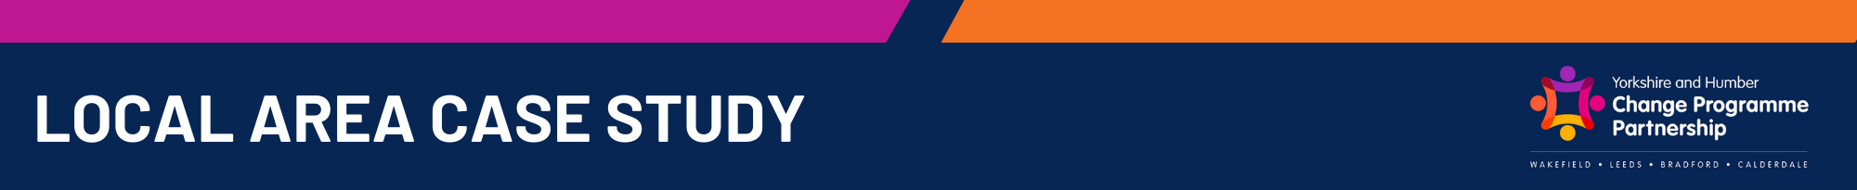
Following the step-out period, the pupil moved into a two-week reintegration phase based in the school’s IRP. The focus was on:
Self-Regulation and Emotional Literacy
- Daily modelling and co-regulation from a trained adult
- Individualised strategies (visual timetables, sensory supports, breaks)
- Zones of Regulation language used consistently
- ELSA strategies
Pupil Voice-Led Planning
The reintegration timetable was designed with the pupil rather than for the pupil. This included choosing:
- The order in which he rejoined specific lessons
- Preferred social times to start with
- The familiar adults he felt safest working with
This approach increased engagement, predictability, and ownership.
To create safe, manageable expectations, the school implemented a step-up timetable over eight weeks. The school has an Inclusive Resource Provision (IRP) on site where access is determined via an assessment panel.
Key features of step-out included:
- Gradual increase of time spent in school and in structured learning
- Prioritised regulation-based activities
- Predictable routines with consistent staffing
- Clear communication with the family to rebuild trust
- Frequent reviews involving the SENDCo, class teacher, and parent
The aim was to stabilise behaviour, rebuild relationships and prepare the pupil for an eventual full reintegration.

Reintegration Approach (Phase 1): Pupil-Led, Structured Return
Initial Intervention: 8-Week Step-Out Timetable
The pupil is a Year 3 child with an Education, Health and Care Plan (EHCP) for Social, Emotional, and Mental Health (SEMH) needs and is currently on the diagnostic pathway for Autism Spectrum Disorder (ASD). Prior to the intervention described in this case study, the pupil experienced significant dysregulation, resulting in 16-day fixed-term suspensions and multiple parental complaints from his peers. The school recognised the need for an intensive, highly structured reintegration plan to prevent Permanent Exclusion (PEX) and support the pupil’s long-term stability in mainstream education.

Background and Context

Family Engagement
Four months following reintegration, the pupil:
- Is fully integrated into mainstream lessons with peers
- Accesses adult support in line with EHCP provision
- Attends school full time with minimal disruption
- Continues to use self-regulation strategies independently
- Has daily check-ins with a key adult for emotional regulation, utilising the staff on site in the IRP and mainstream school staff
- Is making academic progress more in line with expectations
- Remains successfully in mainstream education
The model of support is maintained to ensure long-term sustainability and prevent further exclusions.
Current Position: 4 Months Post-Reintegration

Reintegration Approach (Phase 2): Return to Mainstream Classroom
After showing sustained stability in the IRP, the pupil phased back into the mainstream environment.
Key elements included:
- Graded transitions into whole-class lessons
- Daily pre-brief and post-brief with a key adult
- Seating plan adjustments to support sensory and social needs
- Visual aids and predictable routines to reduce cognitive load
- Flexibility for movement breaks and access to the resource base when needed
Adult Support
- A trained adult provided intensive, 1:1 support
- Consistent staffing ensured trust and reduced anxiety
- Staff used relational and trauma-informed practice throughout
Reintegration Approach (Phase 1): Pupil-Led, Structured Return

The school has worked closely with the family throughout:
- Weekly communication and shared targets
- Clear expectations around joint working and consistency
- Collaborative problem-solving meetings with the SENDCo
- Parental involvement in reviewing the reintegration plan
This partnership has been crucial in rebuilding relationships and supporting the pupil’s stability.
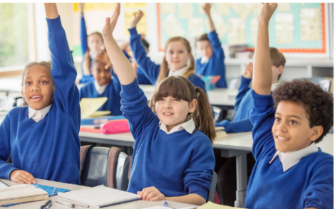

- Reintegration successful and sustained over four months
- Pupil remains in mainstream with peers
- Marked increase in self-regulation skills
- Strong home–school partnership developed
- Reduced risk of PEX
- Staff now using this model as a template for similar cases

Pupil Voice
Headteacher
- “The reintegration model shows the impact of a relational, needs-led approach. The pupil has demonstrated resilience and growth, and our staff have shown the power of consistency.”
SENDCo
- “Co-produced planning, pupil choice and predictable routines were key. His EHCP provision was used proactively to enable inclusion, not just to manage crisis.”
Staff Voice
- “I like knowing what’s happening next.”
- “It helps when I can have quiet time first.”
- “I like being back with my friends.”

- “The structured approach has really helped him feel safe. For the first time he looks forward to school.”
- “We feel included in decisions now, and communication is much better.”

Pupil Voice
Parent Voice

