Insights into the impact of COVID-19 on children and young people with SEND in Wakefield

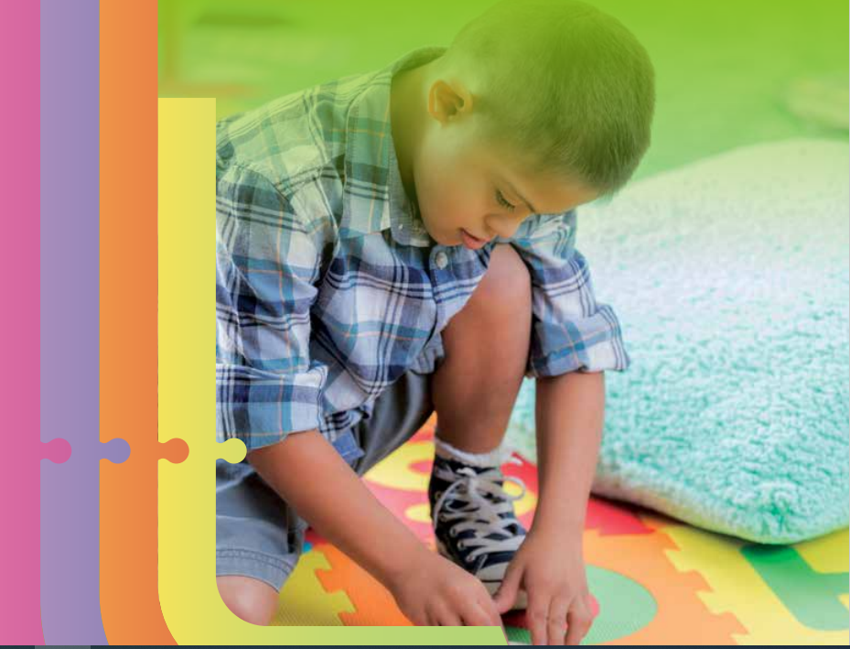

Introduction
This document produced by the multi-agency SEND Strategic Partnership Board provides a brief overview of the impact of the pandemic on the SEND cohort in Wakefield. It details the key issues informed by local information, key actions taken, along with future plans.

In addition, the report reflects on learning and best practice from other areas.

A key priority detailed in our SEND Strategy is a SEND Covid Recovery Plan.

‘SEND Covid-19 recovery plan - partnership working to deal with the short, medium and long-term impacts of the pandemic and ensuring the positive changes are embedded in new service delivery models.’

In Wakefield we are very proud of how partners have come together to respond to the impact of the pandemic and supported children and families with SEND. However, we acknowledge that despite our best efforts, all the creativity and innovation we were able to put in place it has still been an extremely difficult time for many children, young people with SEND and their families who have had gaps in their learning, support, and opportunities. We want to ensure our future actions enable us to reduce long-term impact as much as possible for this cohort.

Local Information
General
A blended and on-line offer has really worked well for some children and young people who have found it difficult to engage previously.
Many families struggled when they no longer had access to their usual support networks.
Anxieties increased across parents, children, and young people. We have seen an increase in children with emotionally based school avoidance.
Frequent changes to routines, bubbles and structures caused difficulties for some of our children and young people particularly those with ASD.
Work placements have been challenging for our young people during the pandemic although several young people on internships have still managed to secure jobs.
Transition to new schools and colleges has been more difficult for a number of children and young people with SEND due to covid restrictions having an impact on visits etc.
The inability to conduct hands-on or face-to face interventions with children has impacted on progress for some children and young people.

Information Regarding the Key Challenges from Wakefield Parent Carer Forum
- The increase in “staycations” due to the pandemic has made it more difficult for some families to access facilities – many children and young people with SEND don’t enjoy busy environments. The added noise creates sensory issues and additional anxiety which then prevents the family from accessing the facilities.
- Children unable to attend school during lockdown some with poor or no access to the internet for online learning
- Children’s mental health and anxiety levels deteriorated due to social isolation and changing their daily routines
- No access to usual support networks and community groups
- Loss of paid employment due to lockdown, and shielding vulnerable children resulting in financial hardship and additional stress/anxiety for parent/carers
- Moving to virtual/online life which many of our families struggled to adjust to

Regional and National Research and Reports

To inform our plans in addition to local information from partners we have considered a range of wider research and learning; a few examples of these are detailed below

Lessons Learnt From Lockdown: The highs and lows of the pandemic's impact on disabled children and young people
Between February and March 2021, as part of the Making Participation Work programme which is funded by the Department for Education and jointly delivered by Council for Disabled Children and KIDS, the Council for Disabled Children commissioned Kaizen to deliver an England wide consultation with children and young people with SEND.

Over 600 children and young people, 128 parents and 110 professionals contributed their views and experiences to this report - this report is the largest consultation to date with children and young people with special educational needs and disabilities to explore the impact of the COVID-19 pandemic on their lives, and to hear directly from children and young people to understand what support they need moving forward.
Lessons Learnt From Lockdown: The highs and lows of the pandemic's impact on disabled children and young people | Council For Disabled Children
Conclusions: The experiences that children, young people, parents and carers have highlighted through this report clearly communicates the difficulties, pain, anxiety and stress of the last year. For many families it has been an incredibly challenging period. However, in the stories about what has helped people get through this period there is a glimpse of a possible future where there is a bit more time to relax, consolidate, be flexible, take time with loved ones and explore interests. Where young people can be in learning environments with smaller class sizes, less sensory overload, more one to one support or the option to engage online when that suits an individual young person. We can begin to see and explore possibilities for an alternative vision where we have learnt the lessons from this experience and commit to keeping those elements that can work, to create a better future for children and young people with SEND.

SEND: Ofsted old issues, new issues and next steps
This report reflects on the reforms and their impact. It also considers what has been working well in the SEND system over time and areas where the reforms have not had the desired impact. It looks at SEND at the start of 2020, when the pandemic began: the number of children and young people who are part of the ‘SEND system’, their outcomes and experiences at different ages, and their experiences of receiving services. This sets the context for the findings from Ofsted’s visits to local areas, where we found out about the experiences of children and young people through the pandemic.
https://www.gov.uk/government/publications/send-old-issues-new-issues-next-steps/send-old-issues-new-issues-next-steps
Through our research visits to local areas, schools, early years settings, children’s services providers and further education and skills providers in the autumn term 2020, we found that children and young people with SEND were often not receiving education. Some important healthcare, such as physiotherapy, had also ceased. This left children and young people immobile and sometimes in pain. A lack of speech and language therapy, or communication devices not being available, left them unable to communicate properly. Social care and health-funded respite provision for families had also not been available. Parents and carers told us of their frustration and exhaustion, and sometimes of their despair. A few had found that the relative calm of being at home through the first lockdown had been beneficial for their children. However, this was more unusual.

When schools and colleges opened fully to all pupils in September 2020, not all those with SEND returned. Those who did return were sometimes given a narrower curriculum than usual.

By the time of the third national lockdown in spring 2021, we heard even greater concerns from parents and carers. For many, life had become more difficult over time. Children and young people, particularly those who had moved to a new school or college in September 2020, were feeling isolated and lonely. The issues that were raised in the autumn term visits to local areas – a lack of health and care provision, inconsistent provision from schools, long waiting times for assessments – continued. Many parents expressed concerns about the now-evident impact of these issues on their children and on their own physical and mental health.

Throughout the pandemic, local areas have had to adapt their ways of working frequently and significantly to continue to provide services for children and young people with SEND. The success with which they adapted appeared to be closely related to the quality of their work with families before the pandemic. It also depended on the extent to which they had implemented the 2014 reforms in a way that created the right relationships, systems and structures. Some areas quickly managed to adapt; others struggled.

- Missing out on education – in some cases, missing vast amounts – means that these children and young people will be further behind their peers.
- Missed support for physical health, communication needs and mental health has had a seriously detrimental, and in some cases potentially permanent, impact.
- Some children and young people with SEND have been out of sight of safeguarding professionals.
- Preparation for adulthood, including for education, employment and training, has been adversely affected.
- Delays in identifying needs have meant that some children and young people’s needs may not have been properly assessed or even noticed.

Speaking up for the covid generation
New report from ICAN on the impact of COVID-19 on speaking and understanding. Full report available here.
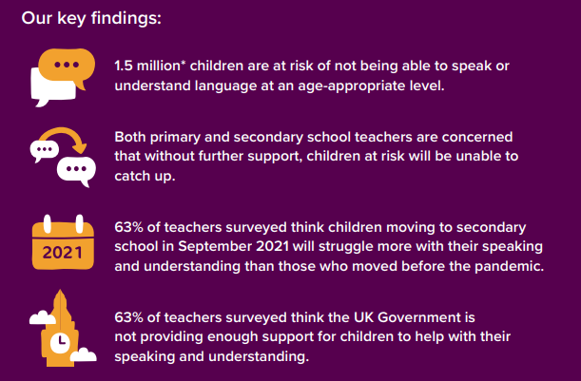

Special Educational Needs and Disabilities (SEND): Some children with diagnosed SEND such as Autism, Intellectual Disability or Cerebral Palsy may find speaking and understanding language far more difficult. Time away from school because of lockdown has meant that some of these children’s speaking and understanding skills have been impacted. Many have lost out on speech and language therapy and their families have been stretched beyond all reasonable expectations - the Disabled Children’s Partnership (DCP) found that 70% of families are still not experiencing pre-pandemic levels of support.
Left Stranded Report – Impact on Autistic People and their Families
We know the coronavirus (COVID-19) pandemic has had a significant impact on autistic people and their families’ lives. Research was commissioned to examine the impact of the pandemic, detailed in the Left Stranded report.
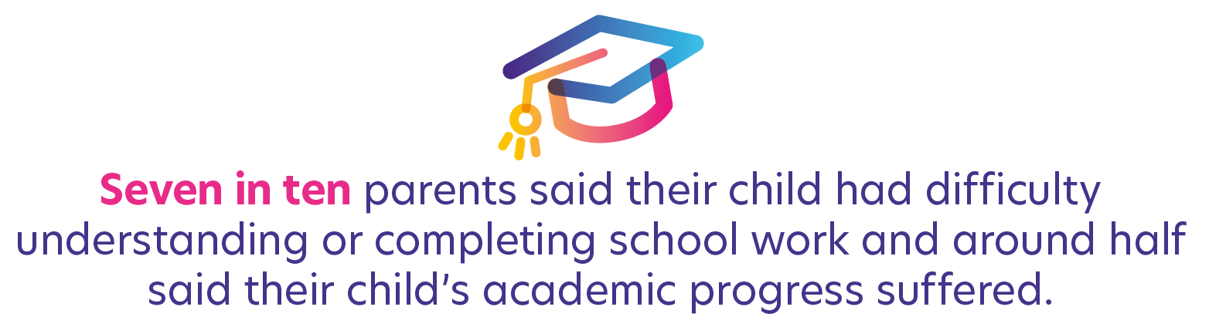

Our Approach to the Challenges of the Pandemic in Wakefield
Key Actions Included:

Prioritising Vaccinations for Key Staff
We targeted vaccinations for those staff who were essential to keep services operating for children and young people with the most complex needs.

This included special school staff, short breaks staff, residential staff, portage staff etc. This enabled all our special schools and respite provision to remain open throughout the pandemic although sometimes a reduced service had to be offered. We also supported parents who employ carers through direct payments by prioritising those carers for vaccination.

Flexible Approach to Support
For Wakefield as in other areas it was a massive learning curve but for our children open to the Complex Care Needs Team we got creative depending on needs………..a few examples are below:

- Complex Needs Team Bulletin – weekly then monthly – signposting to support, home learning activities, hints and tips etc
- Subscription to Netflix/ now tv/ Disney channel
- Regular (often daily) phone calls from complex care to check in with family
- Laundry service
- Support from OT’s / Physios available via phone, purchase of specialist equipment
- Foodbank – referral / delivery
- Voucher for just eat / takeaway
- Craft supplies / play dough / bubbles (entertainment packs)
- Fun learning resources/ activity packs for whole family
- Pamper packs
- Books/ resources to be provided
- Trampolines/garden equipment/games
- Tablets
- Rosettes for children and young people

Meetings with our Parent Carer Forum
Increased liaison with the Parent Carer Forum including fortnightly multi-agency meetings with Local Authority and Health colleagues, working together co-production, co-design, joint problem solving, listening to any ‘noise’ in the system. Identifying and addressing any emerging concerns at the earliest opportunity and providing consistent messages. The frequency of these meetings has continued.

Additional funding provided by the Local Authority and Clinical Commissioning Group to the Parent Carer Forum to provide wellbeing support to families.

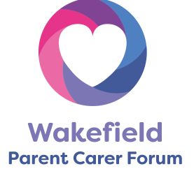
Wakefield Parent and Carer Forum – Supporting Parents
- Weekly Virtual coffee mornings to help reduce isolation
- Additional support from the Parent Carer Forum to support families including:
- Activity and wellbeing sessions for families
- Guest speakers
- Weekly virtual meditation sessions
- Wellbeing boxes
- Doorstep catch ups to check in on the most vulnerable families
- Children’s summer activity packs to encourage meaningful family time including outdoor activities
- Pamper packs for parent/carers to help with wellbeing & encourage “me” time

- Webinars with guest speakers covering hot topics requested by parent/carers
- Online Bingo with daily numbers to reduce social isolation and promote regular interaction with others
- Play your cards right – to encourage parental engagement within our Facebook Chat Group
- Wellbeing quotes posted weekly to parent/carers to let them know they weren’t alone, and they could reach out if they needed support
- Feeding parent/carer concerns into Wakefield Council/Wakefield CCG, and signposting to other services where needed – food bank etc

Wider Voluntary Sector
Additional funding provided to the voluntary sector to enable the voluntary sector to provide support e.g., additional support provided for Home-Start.

Supporting School Attendance
- Monitored daily
- Follow up emails sent to targeted schools
- Worked with special schools on staffing and prioritising pupils
- SENART Manager contacted Independent Schools to support the attendance of all pupils and to offer support during initial lockdowns. The feedback during this process was extremely positive.
- Cluster meetings for each of the 6 areas to discuss attendance/ safeguarding vulnerable pupils and multi-agency support including those with EHCP/ SEND these were weekly, then fortnightly as CYP were mainly back in and reduced to monthly when appropriate.

Additional Resources for Schools/Settings/Young People and Parents
A range of new resources were developed for schools and settings by our Education Psychology Team along with our Education Improvement Teachers. These included:

- High quality support and resources for schools to support the successful return of pupils.
  - COVID-19: Advice for Schools – Transition and Back to School;
  - COVID-19: Advice for Schools – Loss and Bereavement;
  - Support for Children and Young People: A Guide for Parents and Carers – Loss and Bereavement;
  - Return to Schools: Recovery Curriculum.

Recognising the challenges and time pressures in schools, a brief webinar was produced on staff wellbeing, which can be accessed at any time;
Staff Wellbeing in Education - Wakefield Education Psychology 16 mins - YouTube.

- These resources were used by our Education Improvement Teachers to produce a range of ‘Top Tips’ resources some examples are below:
  - Should I talk to my child about COVID-19?
  - Managing anxiety about going back to school
  - Managing loss
  - How to find out what my child is thinking and feeling
  - Coping techniques and strategies that are helpful for worry and anxiety
  - Managing change and transitions
  - Helping your child manage separation anxiety at home and preparing to go back to school
  - Reflecting on lockdown and looking after yourself
- WISENDSS sent out visuals/ social stories and individual support materials.
- Well-being Directory produced for all schools to support staff to signpost families to organisations for additional support on a wide range of well-being issues and identified organisations that could support school staff themselves.

Short Breaks
- Creative short breaks support for family’s support has remained available and increased for families needing extra support throughout the pandemic.

- Below are some examples and quotes by parents:
- Arts and Crafts supplied for a 9-year-old boy with physical needs and his younger sister. Quote from parent: The idea is marvellous and kept the kids occupied for ages giving me and my wife some relief
- Sewing and Arts and Crafts supplied for a family with 2 teenagers with ASD Quote from parent: Been really useful to balance the children’s needs and have time with them individually
- Books on planets, solar system and the world provided to an 8-year-old boy with ASD. Quote from parent: The book was a nice surprise and it made his day, he loves it! He has been reading it non-stop which has provided me with a chance to sit down
- Quote from parent: Your support has been amazing. You have always gone above and beyond to help support our family.
Emails are promptly answered often out of office hours. If you can’t answer a question you find out the answer. You have been there for our family and helped me get through my bad days. I am struggling to put into words the impact the service has had on our family.
- Utilised virtual and video support to offer sessions for children and young people.
- The Local Authority and Clinical Commissioning Group worked together on some joint packages of care.
- Kept our overnight respite care provision open over the pandemic, reducing capacity and re-directing resources rather than closing provision.
- Short Breaks team ensured that targeted and specialist groups were provided throughout the school holidays. An example was the specialist groups run at Easter 2020 at Oakfield Park, where staff from WISENDSS volunteered to work during the holidays so that the school staff could have their time off.

Additional Support Over Schools Holidays
Over the summer Wakefield Council worked with over thirty voluntary and community organisations, local schools and childcare providers as part of our locally branded WF Happy Healthy Holidays programme to provide a summer of free activities and food for children (aged 5-16) eligible for income – related free school meals throughout the district. The programme reduced inactivity and isolation experienced by many children across the Wakefield district during the school holidays, as well as providing children with healthy meals and nutritional education.

A range of activities took place, such as: forest schools, dance, pottery, climbing wall, fire fighter course, football, family picnic days, cricket, archery, arts and crafts, cooking and much more. More information is available on our website: https://www.wakefield.gov.uk/schools-and-children/happy-healthy-holidays

Adapted Ways of Working and Closer Links with Schools/Settings
- Daily updates from Service Director Education and Inclusion for all settings providing updates, links to guidance, signposting to support etc.
- Weekly webinars for Head Teachers with public health in attendance along with guests providing key updates.
- Fortnightly meetings with our Special Schools.
- Wakefield Inclusion SEND Support Services (WISENDSS) implemented weekly contact with SENDCOs in schools to ensure support and safeguarding of vulnerable children and young people. They conducted risk assessments around the EHCPs and identified how outcomes could be achieved.
- School Admissions – moved both primary and secondary Fair Access Meeting to virtual. Meetings held on Zoom with HTs and all documents sent electronically via VLE. This has increased engagement with schools and attendance.
- Education Psychology Service continued to provide support throughout the pandemic, including in relation to mental health and wellbeing. During the first lockdown, in addition to producing a range of resources, the team maintained regular contact with schools. In a number of trusts, the EPs worked in conjunction with school staff to provide support for the parents of children with SEND. Since September 2020, all EPS teams have carried out visits to schools safely, in addition to offering virtual meetings.

Further Education
We have been able to work with our further education providers who have been able to offer non accredited courses to support re-integration for those hard to reach young people. Staff have been able to structure courses and deliver instruction more flexibly and creatively without the pressure of attaining key qualifications. This has further empowered young people to better prepare themselves for the year ahead, counter negative perceptions as well as with support identify a clear pathway for the future.
Further to this, blended learning has enabled systematic integration of online and face-to-face engagement to support and enhance meaningful interaction between young people, teachers and resources. Young people have benefited of both online education and in-person instruction, where they have had the advantage of working semi-independently and at their own pace online, in addition to still having access to the personal attention of a Tutor and all the assistance, knowledge, resources and an integrated learning experience. The blended-learning situations, have inadvertently compelled young people with SEND to use digital and online technologies enabling them to naturally acquire more technological literacy, improve performance and independence as well as attain greater confidence using new technologies, which is very essential in this modern age.

Home to School Transport
Returned pupils with SEND to taxi transport/mileage who had previously been trained to travel independently but had concerns about public transport due to the pandemic. Utilised any spare transport runs to transport the most vulnerable pupils to school. Offered personal transport budgets to parents and carers.

SEND Health Community Services
Continued to provide services throughout the pandemic RAG ratings July 2021
Service | Provider | RAG | Details
Physio | MYHT | Partially | Unable to offer Hydrotherapy at present. Group numbers limited, some being delivered virtually. Otherwise fully operational. Activity @ 109% compared to 19/20 activity.
OT | MYHT | Fully | Activity @ 113% April 19/20, service changes continue moving forward - I.E online resource for training on sensory, previously delivered via parent ed.
SaLT | MYHT | Partially | Activity @ 92% 19/20, unable to offer some groups or drop in sessions as pre Covid. Otherwise fully operational.
ASD | MYHT | Fully | Will continue with remote assessments where appropriate. Fully operational
ADHD | MYHT | Fully | Fully operational

We Took Some of Our Offer Online……..
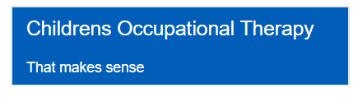
A series of videos to help understand and support children’s sensory processing needs. https://www.midyorks.nhs.uk/that-makes-sense

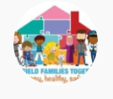 Wakefield Portage Service
Wakefield Portage Service - YouTube
Training Materials for Families: Provided the Wakefield Parent and Carer Forum with a range of free training to share with parents and carers.

Free School Meals
Moved to on-line applications for parents to speed up the process. We previously only offered paper applications but worked with ICT and parents now complete an on-line e-form. This is a permanent move.
Communications and Partnerships
- Agreed and published joint letter/updates on the Local Offer
- Produced and circulated letter for parents and carers – supporting them as ‘exceptional’ cases to leaving the home
- Sign posting on the Local Offer
- Newsletters from partners
- Facebook updates

Take 5
Offered to families if while out and about. ‘If you feel over-whelmed, anxious or need to step away from a busy area we have the 'Take 5' initiative where businesses, and other locations in the district, offer a quiet space for people, with staff trained for assistance’.

Next Steps/Additional Support

Additional Support for Parents
Launch of the Night Owls Service (jointly commissioned across WY&H)
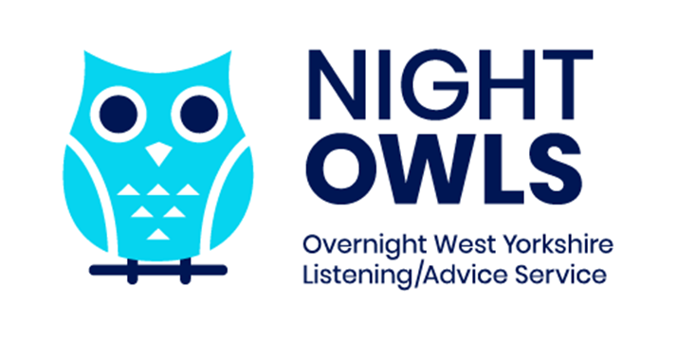
Vaccinations Next Steps
- Supporting the 12 to 15 year old cohort who now qualify for a vaccine to obtain one, putting additional support in place, special clinics are arranged early in September 21 offering additional time for appointments.
- Roll out of boosters for key staff supporting our SEND cohort.

Wakefield Parent and Carer Forum
Wakefield Parent Carer Forum have placed orders for a wide range of SEND related books suitable for parent/carers and their children. A full list of the books available to borrow will be available soon, including details on how the service will run on their website.

- Weekly face to face Coffee Mornings to be hosted at our unit to encourage parent/carers to meet in small groups to reduce social isolation and increase peer support.
- Lego Club – will be held monthly for parent/carers and their children including siblings to encourage quality family time, reduce social isolation & gain new friendships with families in similar situations.
- Adult Craft Sessions – monthly at our unit to support parent/carer wellbeing, reduce stress/anxiety, gain new friendships & opportunities for peer support. Learning new skills in a welcoming safe environment.
- More Letting Go of Stress Courses – 2 courses completed so far, with excellent feedback from parent/carers. This is a short course aimed at providing parent/carers with the skills needed to successfully manage the day-to-day stresses they are facing. The skills can be easily transferred and put into practice in their daily lives within their caring roles.
- Termly parental engagement events in co-production with Wakefield Council & Wakefield CCG – covering the most requested issues parent/carers are facing and to gather feedback, the impact of the pandemic will be a key feature.

New Service for Children and Young People
The Neurodiverse Inclusive Support Team (NIST) is a small multi-disciplinary team which operates across the Wakefield district. The Neurodiverse Inclusive Support Team (NIST) services are delivered in existing CAMHS venues, residential children’s homes and within the child’s home or school. The team will Deliver: consultation, assessment, care, treatment, and parent / carer support within a clinical and community setting. The team will work with young people who are identified through work undertaken by key partner agencies.

The Neurodiverse Inclusive Support Team (NIST) will work closely together with partner agencies to deliver emotional and mental health support to children / young people and families the referral would need to determine the emotional health and wellbeing difficulty that required specialist intervention from a CAMHS team.

Commissioning Services
We will incorporate requirements around covid recovery into services commissioned for the SEND cohort. We will work within the ICS footprint to improve services for children and young people with SEND.

Preparing for Adulthood
- We will continue to build more opportunities to support young people with SEND into employment.
- We will review our training in internships to incorporate teaching the skills young people will need to access jobs which involve some elements of home working in the future.
- Decisions re post 16/19 support will continue to consider the impact of covid on their opportunities.

Travel Training
We have reinstated training for young people to develop the skills to become independent travellers. Those who had previously accessed training but who have been impacted by not travelling during the pandemic will be targeted initially before new candidates are taken on.

Gathering Feedback from Parents and Carers
Termly events have been planned for 2021/22 to meet with parents and carers to gather feedback, the impact of the pandemic will be a key feature.

Support and Training for Settings on Emotionally Based School Avoidance

- Support materials produced for schools, parents and young people by the Education Psychology Service
- Training to be offered to settings

Multi-agency Approach to Anxiety Impacting on Attendance
This issue has escalated since the pandemic we are collating details of the current support available across all partners to identify and then explore resolving any gaps.

Partnership Working
The strengthening of partnership work and regular meetings with key partners will continue. This will include Wakefield Families Together, fortnightly meetings with Wakefield Parent and Carer Forum, regular meetings with special school Head Teachers.
Barnardo's Wesail
- A commitment to a blended approach to all aspects of our service providing meetings, interactions, and communications in both face to face and virtual formats and flexibility in working arrangements to maximise time, efficiency
- Provide a range of initial means of contact to match what works best for families and professionals be it via text; email; chat; duty mobile; landline
virtual meetings; chat facilities; blended; in person
- Add more elements to the “News and views” Local offer newsletters in easy read format and directed at children and young people
- Create Elective Home Education and Education other than at School section on our websites in collaboration with Wakefield exclusions team to support those who have identified success with home-schooling and a reduction in anxieties
- Utilise data analysis and analytics from our websites and social media to continually evaluate and improve the best ways to communicate and interact with service users, learning how and when they seek support
- Signpost to “Relationship matters” support for those who have experienced the strain of lockdowns and “Reducing parental conflict” modules along with expanding the wellbeing support and content on our websites
- Seek to provide further wellbeing-based resources to families in the future
- New service users will receive a virtual “All about me” from their allocated worker to begin the process of a trusted relationship

