**Wakefield Local Area SEND Partnership**

**You Said We Did**

**April 2022 – March 2023**

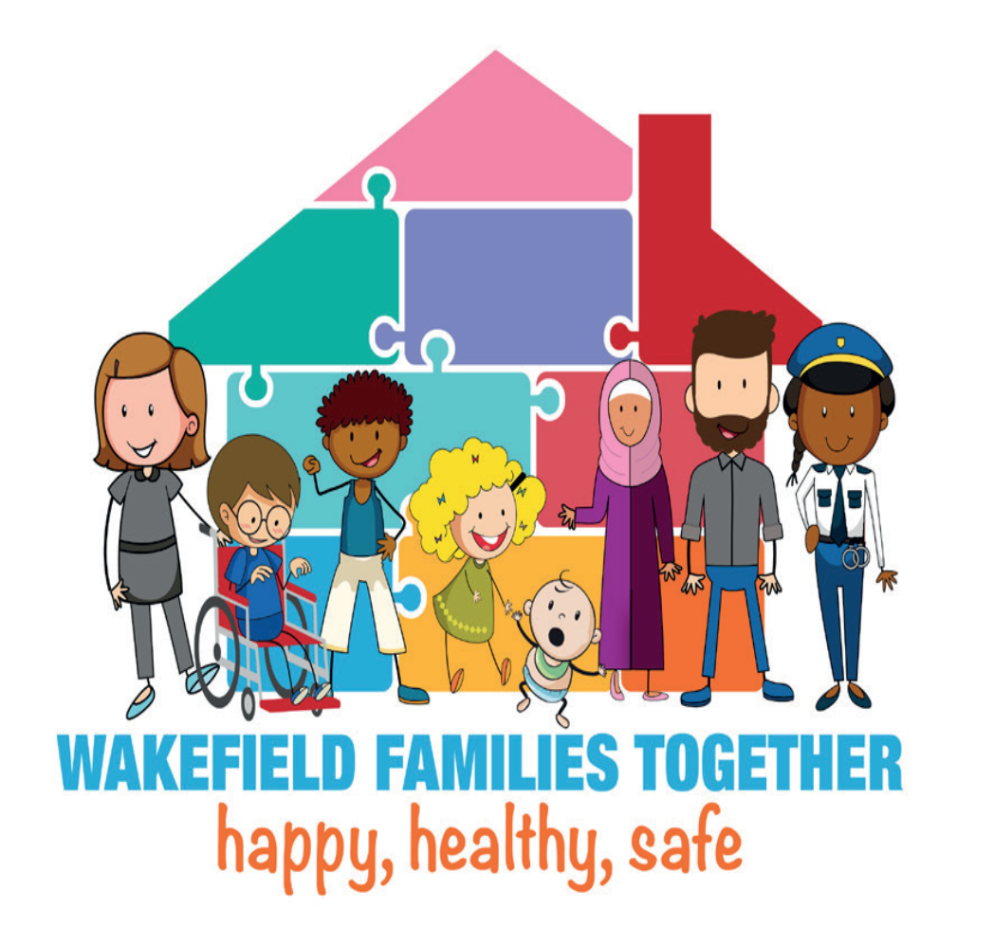

**What You Said about Wakefield’s Local Offer and Services**

**All information and feedback in this document are for the period April 2022 to March 2023.**

| **You Said** | **We Did** |
| --- | --- |
| We would like more information on how to get a Personal Budget | We have asked Wakefield Council’s Social Care team to review and update this information. |
| Parent/carers asked for soft play sessions for children with SEND. | We secured funding to provide SEND soft play sessions, started in March 2022. |
| Parent/carers would like Makaton training to help them support their children. | We provided parent/carers the opportunity the train Makaton Level 1 in May and June 2022. |
| Parent/carers wanted drop-in session with different services. | We arranged meetings with different services to speak to parent/carers i.e., Educational Psychology, SENART. |
| Adults, Learning Disabilities & Mental Health were made aware that the accessibility of our written communication with young people through could be improved and aligned better with schools and colleges. | Adults, Learning Disabilities & Mental Health have now purchased and have access to Board Makers software. The software produces symbols and is like that used in schools and colleges. It and will allow us to produce accessible and easy read information, to improve communication and engagement with young people. |
| A link is needed between college and schools to help with transition. | 5-day officer is supporting the Flex team in college which is proving to be effective |
| We would like advice and support on Tourettes / tics | We contacted Tourettes Action who have provided information for our Winter newsletter  We posted about Tourettes Action on the Local Offer Facebook page |
| We don’t find the word ‘here’ as a hyperlink accessible | We will be reviewing our wording and hyperlinks ready for the new website |
| We are happy for the WESAIL and Local Offer Facebook pages to be joined. We would like the new page to be called WESAIL and Wakefield Local Offer | We have created the new page. In line with Family Action and Facebook guidance the new page is called Wakefield WESAIL and Local Offer. |
| We would like to have an email or text telling us our Max Card is about to expire | We contacted the Information Network who updated their information on the Local Offer. They are unable to send out reminders, so ask for you to please check the expiry date on the back on the card. |
| We can’t find the Social Communication and Interaction form (for an autism referral) | Family Action added the form to the services section of the [Easy Read Autism Section of the Local Offer](https://wakefield.mylocaloffer.org/autism/services/). We posted about this on Facebook. |
| We think there is a gap in provision for teenagers | We focused our successful short breaks bid on this area which has increased provision. |
| We would like for soft play sessions for children with SEND to continue | SEND Soft Play is now weekly. |
| We would like to continue with monthly Lego Club | Lego Club now has two sessions monthly due to demand. |
| We would like drop-in sessions with different services | Drop-In sessions are now monthly with Special Educational Needs Assessment and Review Team (SENART) plus other services in the diary including Social Care, Educational Psychologists, Emotionally Based School Avoidance (EBSA). |
| We would like to know what training is being delivered in schools. | Training in schools – We hosted Autism Education Trust (AET) training sessions for parent carers delivered by Wakefield Inclusion Special Educational Needs and Disabilities Support Service (WISENDSS) to show what schools are being receiving |
| We would like craft sessions to be held more regularly to support mental health and wellbeing. | Craft sessions are now three per month. |
| We find the Autism Pathway confusing and would like it to be updated to make it parent carer friendly. | Autism Frequently Asked Questions (FAQs) will be created instead of the Pathway. It will be co-produced with parent carers. It will be added to the Local Offer website when ready. |
| The ‘Let’s Talk About SEND’ event was the most valuable event parents and carers have attended all year. | Let’s Talk About SEND event is now an annual event. |
| You would like more information on mental health. | We have posted about mental health on our Facebook page. We will be updating information about mental health on the Local Offer website. |
| You would like more information on Preparation for Adulthood (PfA). | We have shared the PfA drop in sessions on our Facebook page and in our newsletter.  We will be sharing more information and services on PfA in future newsletters. |
| You would like more information on Short Breaks. | We have put information on Short Breaks in our Spring Local Offer Newsletter. |
| More support has been requested earlier | Submitted a successful bid to Supporting Families: Special Educational Needs and Disabilities Pilot Project which focuses on early help. |
| It would be good to have some groups that siblings could attend together for those with and without SEND. | Incorporated siblings’ groups into our year 2 successful short breaks innovation bid. |
| You asked for information on support available for deaf people | We shared this information in our Spring Local Offer Newsletter. |
| You said that sometimes the postcode search on the Local Offer website doesn’t give results | We are working with the website hosts to resolve this issue. |
| You said you felt that discussions were held too late, there was not enough time to explore options for your child moving into a Post 16 provision and they wouldn’t gain meaningful employment. | We held a SEND Careers event specifically for all young people in Year 9 and above. The event was a great success and it has been agreed to have an annual event. |
| We would like to know what our appointment at the Sexual health Clinic will be like | Sexual Health Service (Spectrum) developed easy read, personalised booklets with photos to show what the appointment at the clinic will include, with options to fill in information beforehand to support the visit |
| We would like bespoke Relationship and Sex Education lessons at our school | The school worked with the Sexual Health Service RSE Team (Spectrum) to put together and deliver targeted sessions for SEND |