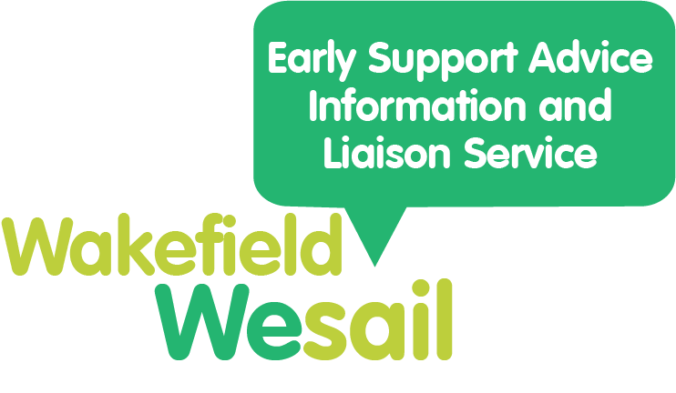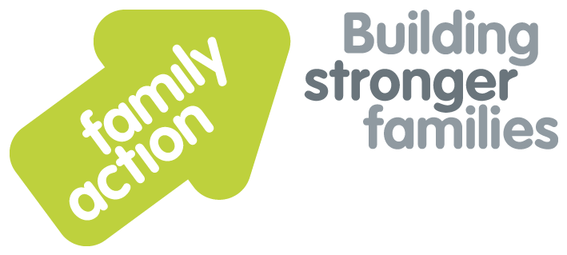

**You Said We Did**

 Here are the comments you have made from October 2022 – December 2022.

**You Said** is what you have told us needs improving.

**We Did** is what we are doing about that.

|  |  |
| --- | --- |
| **You Said** | **We Did** |
| We would like to have an email or text telling us our Max Card is about to expire | We have passed this on to the Information Network |
| We don’t find the word ‘here’ as a hyperlink accessible | We will be reviewing our wording and hyperlinks ready for the new website |
| We can’t find the Social Communication and Interaction form (for an autism referral) | Family Action added the form to the services section of the [Easy Read Autism Spectrum](https://wakefield.mylocaloffer.org/autism-spectrum-disorder/services/) section of the Local Offer. We posted about this on Facebook. |
| We would like to know more about personal budgets | Family Action have asked Wakefield Council’s Social Care teams to review and update information on personal budgets. |
| We would like for soft play sessions for children with SEND to continue | SEND Soft Play is now weekly. |
| We would like to continue with monthly Lego Club | Lego Club now has 2 sessions monthly due to demand. |
| We would like drop-in sessions with different services. | Drop-In sessions are now monthly with Special Educational Needs Assessment and Review Team (SENART) plus other services in the diary including Social Care, Educational Psychologists, Emotionally Based School Avoidance (EBSA). |
| We would like to know what training was being delivered in schools. | Training in schools – We hosted Autism Education Trust (AET) training sessions for parent/carers delivered by Wakefield Inclusion Special Educational Needs and Disabilities Support Service (WISENDSS) to show what schools are being delivered. |
| We would like craft sessions to be held more regularly to support mental health and wellbeing. | Craft sessions are now 3 per month. |
| We find the Autism Pathway confusing and would like it to be updated to make it parent / carer friendly. | Autism Frequently Asked Questions (FAQs) will be created instead of the Pathway. It will be written in co-production with parent/carers. It will be added to the Local Offer website when ready. |
| The ‘Let’s Talk About SEND’ event was the most valuable event parents and carers have attended all year. | Let’s Talk About SEND event is now an annual event. |