Wakefield SEND Local Offer
Easy Read - Service Application Form
If you need help filling in this form, please email wakefieldlocaloffer@family-action.org.uk or leave a message on 01924 965588.
 | Name of service:
 | Basic description:  This is what your service does. It will appear in search results. The description needs to be short.
 | Address:
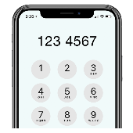 | Phone number:
 | Email:
 | Website:
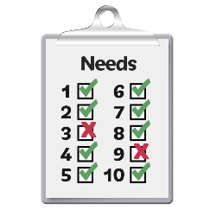 | Area of need:  ☐ Select all  ☐ ADD/ADHD  ☐ ASD  ☐ Behavioural Issues  ☐ Continence issues  ☐ Eating and drinking support  ☐ Hearing Impairment  ☐ Learning disability/difficulty  ☐ Medical needs  ☐ Mental health needs  ☐ Mobility/physical difficulties  ☐ Social and communication difficulties  ☐ Visual impairment
 | Age range:  ☐ Select all  ☐ 0-5  ☐ 5-11  ☐ 11-16  ☐ 16-25
 | When:  ☐ Select all  ☐ School Holidays  ☐ Term Time  ☐ Weekdays  ☐ Weekends
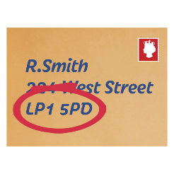 | Postcode:  This is to tell people what area your service covers.  ☐ Select all  ☐ LS26  ☐ Online  ☐ Out of Area  ☐ S71  ☐ S72  ☐ S75  ☐ WF1  ☐ WF10  ☐ WF11  ☐ WF2  ☐ WF3  ☐ WF4  ☐ WF5  ☐ WF6  ☐ WF7  ☐ WF8  ☐ WF9
 | Category:  ☐ Select all  ☐ Early years and childcare  ☐ Education  ☐ Finance, benefits and grants  ☐ Health, wellbeing and mental health  ☐ Information and advice  ☐ Preparing for adulthood  ☐ Short breaks  ☐ Things to do  ☐ Travel and Transport
 | Accessibility information for the venue:
 | How do people access the service/activity:  Please note referral and or eligibility criteria. If your service requires a referral form, please attach that to the application.
 | Cost to join/attend the service/activity:
 | Who can attend:  Please note who can attend the service (e.g., family, siblings, drop off and leave, who can stay) and if sessions need booking in advance.
 | When is the service/activity available:
 | Contact name for service/activity:
 | Social Media links:

For information on how we use your data, please visit https://www.family-action.org.uk/services-privacy-notice/

