

Wakefield District Health & Care Partnership

Adult Autism Strategy

April 2023 – March 2025

**Our ambition is to improve public understanding and acceptance of autism, and that autistic people feel more included in their communities and less lonely and/or isolated.**

**Contents**

1. Introduction 4

2. Our Vision 5

3. What is autism? 5

4. The National Policy Framework 7

5. Local Context 9

6. How we have Developed the Strategy 12

7. Our Key Priorities 13

8. Engagement, support and recommendations 15

9. Governance 28

**FOREWORD**

As the Place Leads for Wakefield District Health and Care Partnership we are delighted to share with you our Adult Autism Strategy for the Wakefield district, which describes how we will deliver the vision for autistic people.

Wakefield District Health and Care Partnership works to improve the health and wellbeing of local people, by reducing health inequalities, providing continuity of care and improving our services. Our priorities, overseen by the Health and Wellbeing Board, are based on what we know makes the biggest difference to improving people’s health:

* Giving every child the best start in life
* A healthy standard of living for all
* Sustainable communities
* Preventing ill health

The Adult Autism Strategy encompasses these key priorities and embraces a partnership working approach to removing historical barriers that have prevented joined-up patient care across primary, community, mental health, social care and acute services. We are committed to applying these integrated care principles to the delivery of autism services for adults in Wakefield following a recent engagement highlighting that this is important to everyone.

Jo Webster Councillor Maureen Cummings

Corporate Director Portfolio Holder, Communities, Poverty and Health

Adults & Health

Wakefield Council

# 1. Introduction

The National Strategy for autistic children, young people and adults: 2021 to 2026 includes developments that will impact on what we need to deliver at place in order to meet statutory guidance. This includes roll out of the Oliver McGowan training for learning disabilities and autism and the introduction of health checks for autistic adults. A crucial part of our work in 2022-2024 is supporting an all-age Autism and ADHD deep dive across West Yorkshire. This two-year project that brings together partners and people who use services across the integrated care service to identify areas to work on collaboratively. Development of this strategy allows us to meet these national and regional challenges in a co-ordinated way as well as reflecting the improvements that local people want to see made to our services.

It is estimated that over 695,000 people in the UK may be on the autistic spectrum: that’s around 1 in every 100 people. There isn't an official register or record of people on the autistic spectrum so it's hard to know exactly how many people have autism. Nationally referrals for adult autism assessments are on the rise and the current average monthly referral rates to the Wakefield adults autism assessment pathway have increased by 67% since 19/20.

The strategy has been strongly influenced by the views of autistic adults, their families and those who support them. The ideas and priorities contained in this strategy have evolved from conversations and engagement events that have taken place over the last 12 months. As our commitment to co-produce this strategy, Wakefield Council seconded a neurodiverse individual to co-facilitate the engagement and consultation. Survey’s, questionnaires and conversation sessions were used to gather people’s views about what was working, what was not working so well and what we needed to do to address the challenges.

By working alongside autistic people, we hope to develop services which meet their needs. We will continue with this approach, building on the feedback we have already received, and will continue to make sure that the development and implementation of our Autism Strategy reflects the views of autistic people and their families.

A bi-monthly autism steering group has been set up to oversee development of action plans based on the priorities within this strategy. A range of quantitative and qualitative measures will be used to demonstrate the impact of projects. The autism steering group will report progress into the Learning Disability and Autism Partnership Board.

# 2. Our Vision

Autistic people are an important part of the Wakefield community. Our vision for the future is for autistic adults to:

* Live life to the full
* Feel accepted
* Be understood
* Make the most of their talents and abilities
* Be treated as individuals and with respect and dignity

# 3. What is autism?

Autism is a congenital, lifelong development condition that affects how a person communicates with, relates to, and understands people, social cues and the environment around them. Autism is a spectrum condition because a person may experience differing levels of traits associated with autism. People from any nationality, religion, race or sex can be autistic, although at present there appear to be more males than females diagnosed with the condition. The reasons for this are not yet fully understood.

*Difficulty with social communication*

Autistic people have difficulty with verbal and non-verbal communication, such as gestures, facial expressions and tone of voice. Some might not speak or may have limited speech. Some are very articulate but find it difficult to engage in a two-way conversation or may lack a depth of understanding of the conversation. Some people may understand what a person says to them but may prefer to use another form of communication in response.

Many people with autism display delays in processing information and/or repetitive behaviours, such as Echolalia and ‘hand flapping’.

*Difficulty with social interaction*

Autistic people find it difficult to recognise and understand other people’s emotions and can find it challenging to manage their own emotions. This can make it hard for autistic people to establish relationships, leading to social isolation, increased risk of poor mental health and conflict with others.

Autistic people may also struggle to understand the ‘rules’ of social interaction, resulting in perceived inappropriate behaviours, such as staring, standing too close, or touching another individual. These behaviours may also lead to conflict.

*Difficulty with social imagination*

Autistic people have difficulty understanding and predicting other people’s intentions and behaviours and imagining situations. They also often display a lack of ‘Theory of Mind’, meaning that an autistic person is often unable to perceive that other people’s thoughts and intentions may differ from their own.

Due to the traits associated with Autism, people on the spectrum are more likely to rely on routines to help them understand the environment around them and ‘predict’ other people’s behaviours. This can lead to perceived inflexibility and result in challenging behaviours when these routines are disturbed.

**Diagram 1 – Triad of Impairments**

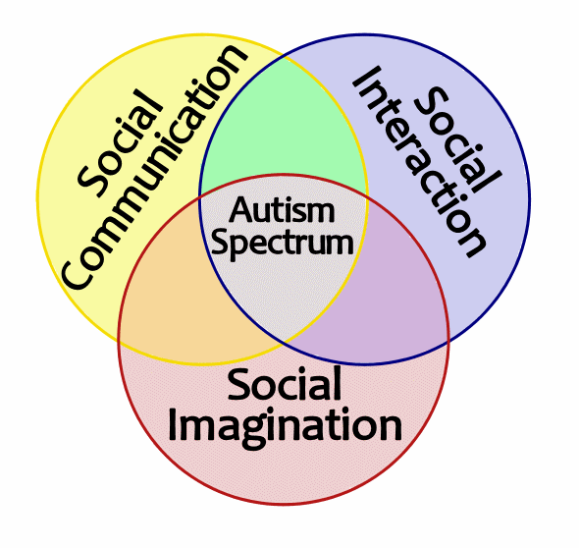

*Other difficulties*

Autistic people may also experience hypersensitivity or lack of sensitivity to sound, touch, taste, smell, lights or colours. This can have an impact on how people cope with different environments. They are also more likely to have associated mental and physical disorders and are more predisposed to self-harm and suicidal thoughts and actions.

*‘’If you’ve met one person with autism, you’ve met one person with autism’’ Stephen Shore*

However, despite these commonalities it is important to note that autistic people are individuals, and each will experience differing autistic behaviours, impacting their lives in differing ways.

It is estimated that over 695,000 people in the UK may be on the autistic spectrum: that’s around 1 in every 100 people. There isn't an official register or record of people on the autistic spectrum so it's hard to know exactly how many people have autism. Estimates of the prevalence of autism are generally made on studies, although information about people accessing services and support may also be used.

# 4. The National Policy Framework

There is a range of legislation and guidance which provides a framework for services aimed at supporting autistic people, underpinned by the Autism Act 2009 and strengthened by the 2021 National Strategy for autistic children, young people and adults: 2021 to 2026.

*Transitioning from childhood to adulthood*

Local authorities have a duty under both the Children and Families Act 2014 and the Care Act 2014 to carry out an assessment for all children with Autism and an EHC Plan going into further education or training. Where a Transition Plan is required, it will be tailored to the needs and wishes of each individual and should be reviewed and updated each year.

*Improving opportunities for adults with autism*

The Autism Act (2009), which only applies to adults, was enacted over ten years ago to address the multiple social disadvantages and health and care inequalities that the autistic population have faced. Since then, the government have published two adult autism strategies, resulting in greater awareness of autism across society and significant improvements in the priority placed on autism across-government.

‘Fulfilling and Rewarding Lives’, published in 2010, provided further direction, and ‘Think Autism’, published in April 2014, shared research into the views of people with autism and their families on how progress has been made in implementing the 2009 Autism Act.

In 2021 the Government published a new national autism strategy. This strategy builds on and replaces the preceding adult autism strategy; it extends the scope of the strategy to children and young people for the first time, recognising the importance of ensuring that they are diagnosed and receive the right support as early as possible across their lifetime.

This new strategy aligns with the existing statutory guidance on implementing the Autism Act for local authorities and NHS organisations. This sets out local authorities and NHS organisations’ duties to support autistic adults and remains in force. This means that local systems should continue to deliver on existing requirements, including having active Autism Partnership Boards in local areas.

*Diagnosis*

There are NICE guidelines in place for adults who did not get an autism diagnosis in childhood. Autism; recognition, referral, diagnosis and management of adults on the autism spectrum: NICE Clinical Guideline 142 (2012), covers the care provided by primary, community, secondary, tertiary and other health and social care professionals who have direct contact with and make decisions concerning the care of adults with autism.

*‘’autism is not a disability, it’s a different ability’’ Stuart Duncan*

# 

# 5. Local Context

The number of referrals for adult Autism assessments in 2021-22 ranged from 22 to 39 per month, with 31 being the average. The accepted referrals rate is much higher in children’s referrals than in adults. The adult Service has adopted a clinical triage approach to referrals. The conversion rate of assessment to diagnosis is similar across children and adults.

There has been an increase in the number of referrals across West Yorkshire since pre-pandemic.

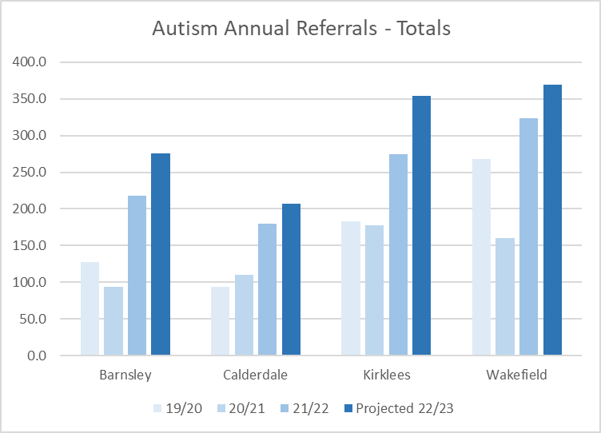

The table below shows the percentage of people across the three age bands diagnosed with Autism in 2019 and known to Wakefield Council. The true number of residents who have an Autistic Spectrum Disorder is greater, as not all families will choose to have a social care assessment for their child. However, it is reasonable to assume that the age representation of this is not skewed in any way.

. [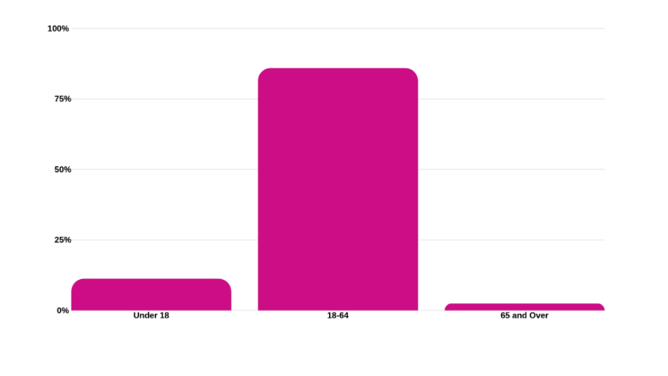](http://www.wakefieldjsna.co.uk/site/wp-content/uploads/2019/06/Autism-Prevalence-by-Age-Band.png)

Source: Wakefield Council Social Care

The Autism Service in Wakefield follows a health intervention pathway post-diagnosis. This provides individuals with access to a range of psychological, occupational therapy, speech and language therapy and health care support. There is a social worker dedicated to the service who will provide information, advise and signposting as well as a care act assessment for those individuals with eligible social care needs.

For those autistic adults with social care needs, they could be supported across a range of adult social care services such as learning disability, transitions, community teams and mental health. Wakefield Council does not have a specialist autism team.

Work is being undertaken across the West Yorkshire Integrated Care System to review services and support for people with autism. Within Wakefield, this will be taken forward through the Wakefield Learning Disability and Autism Partnership Board.

A crucial part of our work in 2022-2024 is supporting an all-age Autism and ADHD deep dive across West Yorkshire. This two-year project that brings together partners and people who use services across the integrated care service to identify areas to work on collaboratively.

We will be working with people with lived experience and our partners across all sectors to:

* Understand the current experience of users and families of Autism services.
* Map existing Autism provision, capture data and information.
* Assess initiatives and ways of working to see if these could improve how the system works and the impact on individuals and families. Identify projected future gaps and issues to address and explore options to proactively address future projected need/areas of work.

The deep dive will use the information and data captured along with people’s views and experiences to produce a report and recommendation to present to the Regional Mental Health, Learning Disability and Autism Partnership Board. This deep dive offers the opportunity to benchmark services across the region and gather evidence about any gaps.

Currently services for Autism are designed and delivered in each of our places, and the deep dive will provide the learning to help our places do this in more sustainable ways or to consider whether there are opportunities to collaborate across West Yorkshire in providing specialist support, that interfaces with strengthened primary care and local authority provision within each place.

Wakefield Adult Autism Strategy will evolve in line with the findings of this deep dive.

In addition to the West Yorkshire project, the Regional ADASS led LD, MH & Autism Network is undertaking work around autism strategy and implementation plans, through a task & finish group. Wakefield will be participating in this work.

*“People on the autism spectrum don’t think the same way you do. In my life, people who made a difference were those who didn’t see labels, who believed in building on what was there. These were people who didn’t try to drag me into their world, but came into mine instead.” ~ Temple Grandin*

# 6. How we have Developed the Strategy

This strategy has been developed in partnership with autistic people, their families, and practitioners. It is informed by questionnaires, surveys, and co-designed engagement conversations where we asked adults what needs to change to make the necessary changes.

Adults with autism shared their experiences with Autism Plus through a survey in 2020. Appendix 2 summarises the feedback we have received on the Autism Plus survey.

We have used the findings from this survey to formulate conversation sessions with a number of key stakeholders to share information and listen to autistic adults. These conversations and survey findings outline how we intend to respond to these issues as part of the strategy.

As our commitment to co-produce this strategy, Wakefield Council seconded a neurodiverse individual to co-facilitate our engagement and consultation. These can be seen at appendix 3. This engagement was to gather people’s views initially and for them to have the opportunity to offer their opinions about what was working, what was not working so well and what we needed to do to address the challenges. It was following this stage that a broad set of principles and outcomes were agreed on which would be applied throughout the entirety of the development and delivery of the strategy.

This engagement involved a comprehensive public consultation process was conducted during the autumn of 2022 and provided an ideal opportunity for the people of Wakefield to put forward their initial views on a series of themes, ranging from inclusion, education, employment, health and accessing community facilities.

67 people in total completed the questionnaire used in the consultation. A copy of the questionnaire from this consultation can be seen in appendix 4 to this strategy.

We recognise we need to continue to engage with autistic people. Together-UK will facilitate continued engagement with autistic people through Wakefield Autism Voice for Everyone (WAVE), a dedicated support group in Wakefield for autistic people, to help us to develop services and the Autism Strategy as well as understand if we have made a difference to autistic people with the delivery of this strategy.

As part of the two-year project to improve the lives of neurodivergent people in West Yorkshire we are bringing together Autistic people along with parents and carers to help understand where, how, and why Autistic people might be disadvantaged. One aim is to understand experiences of the Autism assessment process better, any learning from this will be reflected in a review of this strategy.

# 7. Our Key Priorities

Our priority areas are related to the need to build on the areas of strength and develop the areas of significant weakness. These areas have been defined in the strategy and are based on the National Strategy, engagement with autistic people and the outcome of discussions with professionals across the local authority, health and provider sector.

**Priority 1: People in Wakefield understand autism**

* We want to make sure more people across the district of Wakefield understand autism so that autistic people:

feel more included and less lonely

are treated better by people in their community.

* We want more organisations, businesses and services to understand autistic people.

**Priority 2:** **Autistic people get help in their communities**

* We want to reduce the number of autistic people in mental health hospitals.
* We only want autistic people to be in these hospitals if they really need to be.
* We want autistic people to get help with their mental health in their local area, so they don't have to go to hospital.
* We want to make social care and help with housing better for autistic people

**Priority 3:** **There is help for autistic people to find jobs**

* We want to help autistic people who have jobs, to keep them.
* We want to improve the help autistic people can get to find and stay in jobs.
* We want to improve help for autistic people who can’t work, so they can live well.

**Priority 4: Health and care services support autistic people**

* We want autistic people to live healthier lives and live longer.
* We want to get better at recognising autism in young children, so they can get the help they need from an early age.
* They say that people should only wait up to 13 weeks before they see a healthcare worker, to see if they are autistic. Too many people are waiting longer than 13 weeks and we want to stop that happening.

**Priority 5:****There is help for autistic children and young people at school**

* We want autistic children and young people to get the help they need at school and colleges.
* We want to make sure teachers and education staff understand how to help autistic children and young people.
* We want to make sure there is no bullying of autistic children and young people at school.
* We want to help autistic young people as they become adults, so that they:

can live in their communities

can find work

can get higher education, for example in university, if they want to

are less likely to have mental health problems.

**Priority 6: There is help for autistic people in the justice system**

* We want to make sure justice system staff understand autistic people and know how to help them. We want the justice system to support autistic people and make autistic people feel safe.
* We want the justice system to treat autistic people in the same way as other people.

# 8. Engagement, support and recommendations

A series of Engagement Surveys and Conversations have provided valuable feedback from autistic people, families, citizens, providers and partners about the areas we need to prioritise in our Autism Strategy and has provided the opportunity to co-produce our plans and continue to gather feedback and views from autistic people and families.

These conversations have provided insight into the services and support currently available within Wakefield and areas for further development or improvement.

We have heard many positive stories, some individuals continue to struggle to get the support they need.

Some autistic people are not accessing GPs, they would rather sit at home and be ill, as don’t know what to expect

I may come across confident and OK, but inside I’m not. Inside I am asking myself what do I need to do now? What do I need to do next? What do I need to say? How do I say this? I am constantly trying to figure out what the next step is, what the reaction might be

People are vulnerable, you don’t stop being vulnerable just because you turn 18

**People in Wakefield understand autism**

**What you told us**

* There needs to be an Autism awareness programme for health and social care staff, criminal justice staff, job centre staff and all professionals working with the public
* Work with Employers to encourage inclusion through autism awareness training and awareness of government financial incentives
* Information about both the Autism Alert Card and the Sunflower lanyard should be included in autism awareness training
* Services need to ensure their environments, facilities, and support meet the needs of autistic people
* It is essential to have special interests and not be shunned for that
* There are many myths about what autism is
* We are not Rainman
* You can have autism as an older adult
* You can have autism as a woman

**What we are already doing in Wakefield**

* An Autism Awareness Leaflet has been developed and distributed to all Wakefield Council employees
* We worked with autistic people to produce a myth buster
* Leisure services offer a range of support programmes for children, adults and families
* Wakefield Autism, Voices for Everyone, are a small support group that meet in Wakefield
* Wakefield Live Well Team, social prescribing is able to offer support and advise
* A training package including strength-based training is currently being reviewed and will be offered to Social Workers, offering a preventative approach.
* Oliver McGowen Training is being considered across West Yorkshire
* West Yorkshire Police offer autism awareness training to all employees
* Mid Yorkshire Hospital NHS Trust are in the process of autism accreditation
* South West Yorkshire NHS Trust ADHD & Autism Assessment Service is the first to receive Royal College of Psychiatrists accreditation for community health services in the UK
* South West Yorkshire NHS Trust has produced an friendly autism-friendly environment checklist
* Several provider services provide training for their staff through care skills academy and BILD
* Services are encouraged to review environments to ensure autism friendly and accessible

**How we will achieve this objective**

* Once published, we will work to the code of practice to ensure the Oliver McGowen training package is made widely available and reviewed each year.
* Continue to develop strong links with all professions and organisations to increase understanding and skills to support autistic adults.
* Ensure that autism training and learning opportunities are publicised to health and social care staff and other stakeholders, including autistic adults, their families, and carers.
* Develop links with local employers to develop a ,more comprehensive understanding and awareness of autism
* Monitor CQC registered services in Wakefield to ensure staff receive learning and training around autism
* Leisure services offer a supported access day to their facilities for autistic people to see and try out the facilities
* Leisure services to consider producing a range of posters and short films involving autistic adults to highlight access to leisure facilities
* Consider commissioning an outreach connection service to support familiarity, confidence, and a buddy to access services for the first time alone – a low-level befriending scheme
* Staff new to health and social care to spend time as part of their work induction with autistic adults, like the WAVE group, to support better awareness and understanding.
* Hold a one-stop shop event with a wide range of information, services, and resources
* Educate People that autistic adults exist and what that looks like

**Autistic people get help in their communities**

**What you told us**

* You did not always have access to advocates
* You would like to see the autism partnership board reinstated
* You cannot always get an assessment if you do not meet the criteria
* Information is not always accessible to autistic adults, and current resources are not easy to navigate
* You would like one source of information for adults
* Services are not available for autistic adults to meet peers and develop relationships
* Workers in community services were not informed about autism
* Autistic people want to be included, especially in decisions that affect them
* There is not much support for people who receive a diagnosis later in life
* There is not much support for people who do not have a formal diagnosis

**What we are already doing in Wakefield**

* Wakefield Council commissions and work in partnership with voluntary and other third-sector organisations to develop services that improve community accessibility for autistic adults
* This strategy has enabled a project group to be formed, which will support the implementation plan
* Wakefield commission advocacy support for those autistic people who do not have family or friends who can advocate for them
* Together-UK is a commissioned advocacy service that also provide support to the Wakefield Autism Support Group (WAVE)
* West Yorkshire ICS are undertaking a neurodiversity review, of which Wakefield is part
* Autistic people were commissioned to provide Top 10 Tips to make it easier for autistic people to attend GP surgery
* Autistic people registered on Homesearch can approach the housing needs service for support if where they live isn’t meeting their needs
* Wakefield Autism Leisure Club is a sports club for children and young people
* There is a friendship and relationship service called Luv2meetU for adults with learning disabilities and autistic adults
* South West Yorkshire Foundation Trust has developed an autism-friendly environment checklist for assistancethis is endorsed by the National Autistic Society
* The Wakefield Learning Disability & Autism Partnership Board meets regularly and invites and encourages autistic representation
* Wakefield Council’s Connect to Support website has information regards the autism pathway and diagnosis
* Autistic people have presented at the Co-production event to share top tips on involving people in services

**How will we achieve this objective**

* Review the Learning Disability & Autism Partnership Board to support the development of autism awareness and understanding in organisations and staff who provide social and leisure activities. Work with the Partnership Board, partners, and other organisations, to explore ways for local autism social and support groups to be further developed, possibly through a dedicated Autism Partnership Board
* Ensure that autistic adults, eligible for adult social care, have their social needs assessed and supported.
* Explore using assistive technology to help autistic adults become more socially independent.
* Develop a voluntary sector hub which will offer support, signposting and opportunities for social interaction for autistic adults through a buddy scheme
* Support community resources to identify a champion for hidden disabilities, to support raising awareness
* Consider an autism charter for businesses, where businesses can display, they are autism friendly
* Hold a one-stop shop event for services, community, public and autistic people and families
* Ensure that people with lived experience are involved more in services
* Consider commissioning WAVE as mystery shoppers around GP and primary healthcare services
* Adult social care consideration of a dedicated autism care management team or autistic champions in wider community hubs

**There is help for autistic people to find jobs**

**What you told us**

* You did not get the support you needed to find employment
* You would like responsive and supportive Employment Services
* You faced prejudice in the workplace from potential employers and employers were reluctant to employ autistic adults
* Your employers were not aware of the needs of autistic adults and did not make reasonable adjustments
* There were not enough job opportunities, volunteering opportunities or training courses for autistic adults
* There need to be better links between education and employment, with bespoke employment advice and greater work experience opportunities for young adults to access across Wakefield
* Autistic people have as much right to a fulfilling and successful career as anyone else

**What we are already doing in Wakefield**

* Wakefield Council are developing a Supported Employment Service, which will offer a range of services to enable autistic adults to be supported in employment
* Various local groups offer support with the completion of application forms, getting job-ready and advice for career decisions
* The Department for Work and Pensions currently has several disability employment advisors based at local job centres who can assist autistic adults in finding work
* Autism Plus run multiple programs designed to support people into employment and awareness sessions for anyone looking to employ autistic people
* There are a number of supported internships through project search available for young people
* Access to work scheme is available to offer training and support for individuals starting in work or in work to assist employers in providing reasonable adjustments
* Ring-fenced apprenticeship employment opportunities across leisure and street scene

**How we will achieve this objective**

* Ensure that autistic adults get information about employment programmes and benefits advice.
* Ensure that services address employment issues for autistic adults. This includes transition reviews and person-centred planning in schools.
* Work with mental health services to ensure that employment for autistic adults is planned for.
* Ensure that the Supported Employment Service supports adults who have autism into employment and continues to develop their staff ‘s autism awareness.
* Work with partners in Wakefield to lead by example in the employment of autistic adults
* Expand the current supported internships to include more employment opportunities
* Engage with colleagues in the Job Centre to use reasonable adjustments for individual appointments and autistic friendly environments
* Engage with employers to support them with reasonable adjustments allowing autistic adults to be employed
* Seek to expand volunteering opportunities and support the voluntary sector to retain autistic volunteers

**Health and care services support autistic people**

**What you told us**

* Many adults who have autistic spectrum disorders often have multiple health concerns
* There needs to be improvements in our joined-up working to minimise people being sent to different departments and having to tell their story many times.
* There is a high number of adults with ASD who also have mental health needs, but only half receive the support they require
* You were not always aware of what services were available
* If you have autism and a learning disability, services seem to be available, but if you have just autism, you fall through a gap
* You needed support to access healthcare services
* Non face-to-faceNon-face-to-face GP surgeries were difficult for you to manage
* GPs need a better understanding of autism to help them with autistic patients and to help diagnose Autism
* There needs to be support for people before they reach a crisis point

**What we are already doing in Wakefield**

* The Mid Yorkshire Hospital NHS Trust employs a Learning Disability and Autism Liaison Nurse who supports autistic adults when being admitted to the hospital, outpatients, enhanced care and with reasonable adjustments
* There is a new liaison nurse to support children
* The Trust offers electronic flagging; this flag states ‘autism’, and agreement is made for all newly diagnosed children to be flagged by the ASD assessment pathway
* A Complex Needs Delivery Group has been recently established, which involves members from WAVE; information from this is taken to the Mid Yorkshire Hospital NHS Trust Senior Leadership
* Wakefield Healthwatch is the independent consumer champion for health and social care.
* Wakefield Council commission and work alongside voluntary and private organisations that offer support with understanding healthcare and accessing services.
* The Autism & ADHD Service is multi-disciplinary, with access to psychology, occupational therapy and social work
* 8 support sessions are offered post-diagnosis, including information, advice and sign-posting where an individual does not have eligible adult social care needs in line with the Care Act
* There is no current waiting list for an autism assessment, and this is well managed through a triage process

**What we are already doing in Wakefield**

* GPs have access to guidance to support them when considering making a referral to the ADHD & Autism Service
* NHSE have published guidance for the development of a dynamic risk register for autism, Wakefield have produced plans to implement this guidance
* Care (education) and treatment reviews are in place to support people at risk of hospital admission, or to support those already in hospital to ensure people don’t remain there longer the necessary
* Changes to the LeDeR national policy that is already in place for learning disability and autism, this change now ensures a review the deaths of autistic adults (where there is no learning disability)
* Autistic people have access to MY Hospital Passport

**How we will achieve this objective**

* Ensure that all health service staff are aware of their need to have knowledge and understanding of autism and are provided with opportunities to access learning resources.
* Encourage commissioners and providers to explore how health services can be supported to make the necessary adjustments to enable autistic adults to access all health services.
* Work with mental health services to improve the response to autistic adults who may also have mental health difficulties.
* Ensure that the pathway from diagnosis to post diagnosis support is clear and communicated to autistic adults, health professionals and health organisations.
* Improve our partnership working to enable services to share information
* Work with NHSE to introduce health checks for autistic people
* Put in place a pathway for flagging of newly diagnosed adults
* Work with West Yorkshire autism and ADHD review to improve the assessment pathway, pre and post diagnostic support
* Develop the autistic adult DSR (dynamic risk register) in line with the recently published CTR and DSR policy refresh
* Invite Autistic Champions across all the social care management teams
* Review the guidance for GPs on the autism assessment pathway
* Work with GPs to ensure a wider understanding of autism and how to support people who present as needing an assessment
* Produce a leaflet for people who feel they may be autistic, in terms of how to approach the conversation with their GP, how to prepare and what to expect

**There is help for autistic children and young people at school**

**What you told us**

* Education offers a safety net; its once people leave education, there is a need for support
* Post-16 education staff do not have the same level of awareness or understanding of autism
* There is a lack of timely information for post-education options
* Autistic adults are not given the right support to help them succeed
* Young autistic people want the same information their peers receive
* There are not enough training courses that lead to employment for autistic adults
* Aspirations of children and young adults should be raised with an expectation that children and young adults with autism will move from education into work or tocontinue onto higher education
* There needs to be more focus on life skills, independence and friendships

**What we are already doing in Wakefield**

* Wakefield Council commissions services that support families with their everyday needs including

navigating care services, benefits, and signposting to other services

* SEND engage with children 0-25 years and their families to enable their voice to be heard
* The inclusion service is not diagnosis led and is included in the ASD pathway to support

communication

* The service has recently signed up as an Autism Education Trust Partner to deliver accredited training

across the schools

* Direct Payments can be offered to carers, and they are supported to use these flexibly to empower the

adults they support and enable them to have an improved balance of home life and caring

responsibilities

* Carers Assessments identify creative ways of helping carers to continue in their caring role
* Children’s services have a joint autism strategy group with health
* Post-16 education worked with autistic young adults to produce literature about post-16 options

**What we are already doing in Wakefield**

* There is a coordinator dedicated to preparing for adulthood
* There is an engagement officer dedicated to NEET (not in education, employment or training)
* Wakefield college offer supported internships
* Wakefield Carers offers good support for parents, families and carers
* Adult social care transition team offer early support from age 16yrs
* Advisory inclusion teachers who have a specialism in autism and communication and interaction

needs, support schools and professionals with the right strategies to support autistic children

**How we will achieve this objective**

* Improve our data collection to identify carers/families of autistic adults
* We will work in partnership with our health colleagues to ensure that the work to improve pre and post diagnosis support services will consider carers’ needs for ongoing information, advice, and support.
* Work in partnership with Children’s Services to ensure that young carers and siblings of autistic adults are supported.
* Continue to develop Wakefield Partnership Board and support it to contribute to the work of the implementation of the strategy
* Continue to develop and improve support through a smoother transition with a focus on preparing for adulthood

**There is help for autistic people in the justice system**

**What you told us**

* Low level support such as neighbourhood policing teams and hate crime were not always supportive and understanding of autism
* Criminal Justice service staff were not always aware of your autism or understood your needs
* No autism pathways within prison
* Prison environment does not meet sensory needs
* Within the Prison system and on release information can get lost, diagnosis is not always known
* You felt that staff in safeguarding situations did not always understand your autism and any needs you have

**What we are already doing in Wakefield**

* West Yorkshire Police have invested time and money in training their staff in autism awareness.
* Autistic adults in Wakefield have access to the autism awareness card, and this has been made more accessible to anyone requiring it
* This strategy has been co-produced to ensure that the things that matter to you have been included
* Voluntary organisations commissioned by Wakefield Council maintain good links with West Yorkshire Police
* West Yorkshire Police have relaunched their own Police Disability Association for police officers and staff with disabilities or caring responsibilities.
* Wakefield has a Hate Crime Officer available to support people , and this officer attends the Learning Disability & Autism Partnership Board
* If an individual identifies they have autism in custody, appropriate support is made available
* Custody suites intend introducing ‘sensory items’ to into the suites and receive input on neurodiversity within a training settings
* West Yorkshire Police are working on piloting an autism alert card in Leeds that will then be rolled out across the force
* Autistic male criminals are referred to HMP Wakefield Prison Mulberry Unit, dedicated to supporting autistic people, Wakefield Prison is the first category A prison to have autism accreditation.
* There is a learning disability and autism nurse within the Prison

*‘’the greatest prison people live in is the fear of what other people think.’’ David Icke*

**How we will achieve this objective**

* Work with the Safeguarding Adults Board to ensure that autism is embedded in any training.
* Develop the local Safer Places schemes and ensure autistic adults to use this if they wish.
* Continue to work in partnership to promote autism training opportunities to those working in the criminal justice system within Wakefield.
* Work to develop a clear pathway and support for autistic adults in the criminal justice system.
* Improve communication with services, including custody, probation services, neighbourhood police, environmental health, anti-social behaviour and hate crime for a more consistent approach
* Consider a charter of standards
* Support the role out of the Autism Alert card in Wakefield, with the possibility of a phone app too
* Schedule regular coffee mornings in local community centres so police and autistic people can have the opportunity to talk together
* Consider another Police Conference with a focus on autisma to raise awareness and explore reasonable adjustments

# 9. Governance

Figure 1

Appendix 1: Autism Strategy – local data



Appendix 2: Autism Plus Survey



Appendix 3: Autism Strategy – Conversation briefs



Appendix 4: Autism strategy – Engagement Survey Feedback Summary

