News, updates, and more

REACH NEWSLETTER | 27 Nov

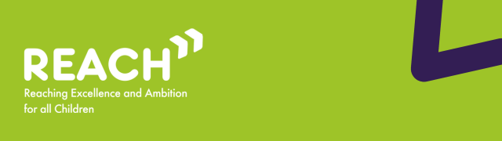

Welcome to the November edition of the REACh newsletter.
In this edition, you can find:
- Reminder: what is the Change Programme and what is it trying to achieve?;
- Updates and latest activity from across the Change Programme Partnerships;
- Yorkshire and Humber SEND Youth Alliance: Children and Young People’s Change Programme Report;
- Spotlight on the REACh support offer: learning from the journey of ELSEC pathfinders;
- MAPS and Parental Engagement Practice Notes;
- Research, reports and events
Best wishes,
Luke Evason-Browning
Council for Disabled Children

Reminder: what is the Change Programme and what is it trying to achieve?
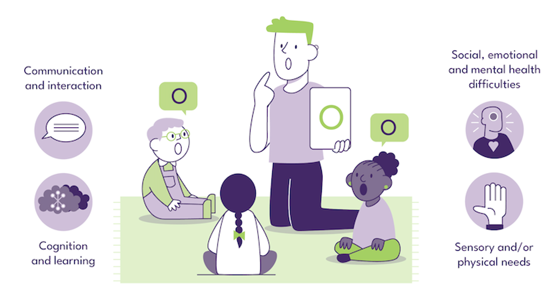
The Change Programme involves 32 local areas undertaking a ‘test and learn’ approach to changes across their local system, collaborating in Change Programme Partnerships (CPPs) in each of the 9 regions of England. Originally set up to test reforms set out in the SEND and Alternative Provision Improvement Plan, in its current phase, the Change Programme is working with these local areas to test a range of programmes collectively to strengthen the inclusion support offered to mainstream settings.
Building on earlier phases, the programme now covers continued work on the use of Alternative Provision through a 3-tier model of interventions and extending the Early Language Support for Every Child pathfinders that are enabling earlier identification and intervention for speech, language and communication needs. In the extension, the Change Programme has strengthened links with two other existing initiatives from the DfE: Alternative Provision Specialist Taskforces (APST) and the Programme for Inclusion of Neurodiversity in Schools (PINS) so that more of the local areas can test these models. Change Programme local areas also have the opportunity to test Assistive Technology ‘lending libraries’ that give schools the ability to test the effectiveness of these tools for their students so that they can make best use of funds to meet need.
The Change Programme involves working collaboratively with local areas and alongside partners from health, education and social care, as well as parent carers, children and young people, recognising that the insights and expertise of all of these groups are key to creating any new system. The Change Programme also works in parallel with other DfE programmes and wider work that is happening in the SEND sector, such as the Family Help reforms and Ofsted’s curriculum and assessment review, acknowledging the significant potential that these changes and initiatives have to be complementary to the activity on the Change Programme as well as the learnings from it.
The Reaching Excellence and Ambition for all Children (REACh) consortium are the DfE’s delivery partner for the Change Programme. The REACh consortium are made up of PA Consulting, IMPOWER, Council for Disabled Children and Olive Academies. REACh support local areas to implement and learn from nationally and locally developed initiatives, whilst also capturing learning from these initiatives and disseminating this to other Change Programme Partnerships as well as the DfE.

Updates and latest activity from across the Change Programme Partnerships
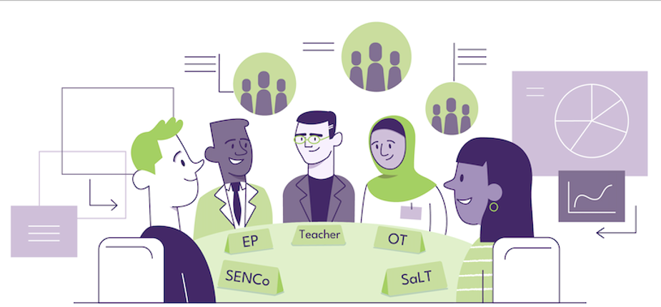
Improved Early Intervention and Access
Local areas participating in the Change Programme have highlighted that universal and targeted support offers are increasingly enabling children - particularly those for whom access to services is more complex or who have experienced long waiting lists - to access help earlier. For example, Leicester has reported improved outcomes for children accessing the Early Language Support for Every Child (ELSEC) programme, following a reassessment of priorities for children facing significant health inequalities. In particular Leicester noted that children living in areas of high deprivation who have experienced long waits for services are now receiving more timely review and intervention, reducing the risk of escalation of needs and adverse educational impact.
Growth of Partnerships Between Mainstream Settings and Specialist Support
Local Areas are seeing stronger collaboration between mainstream settings and specialist services, driven by linked provisions, investment in workforce training, sharing of resources, and co-development of inclusive approaches. Leeds is implementing cluster-based therapist work across schools and recently launched the Inclusive Mainstream Practice (IMP) Toolkit on 5th November, providing practical guidance to support inclusive teaching in mainstream settings.
Innovative Approaches to Supporting Inclusion
Local areas on the Change Programme continue to develop and trial innovative approaches to inclusion. Shropshire has introduced a Primary Inclusion Development Fund, enabling primary schools to submit requests for funding to enhance their mainstream provision. Meanwhile, Central Bedfordshire has delivered Emotionally Based School Non-Attendance (EBSNA) training to over 20% of schools so far.

Feature

Yorkshire and Humber SEND Youth Alliance: Children and Young People’s Change Programme Report

On behalf of the Yorkshire & Humber SEND Youth Alliance, the Children & Young People’s Change Programme Report brings together the real, lived experiences of 82 young people across West Yorkshire. Co-produced with peer researchers, the report highlights not only the challenges facing SEND young people in education but also the strengths and hopes they carry forward.
Key findings in the report reveal serious systemic issues: limited awareness of educational rights; inconsistent and ineffective support; bullying and discrimination in schools; and a lack of preparation for adulthood and independent life. These findings come directly from young people’s voices, captured and elevated through participatory research.
Moreover, the report doesn’t just dwell on the systematic issues. There are powerful stories of resilience and belonging: in some colleges and smaller schools, young people found safe, inclusive environments; supportive staff and mentors helped young people feel valued and respected; and practical learning opportunities like budgeting, cooking classes, and creative subjects boosted confidence and independence
Read more

Spotlight on the REACh support offer: learning from the journey of ELSEC pathfinders
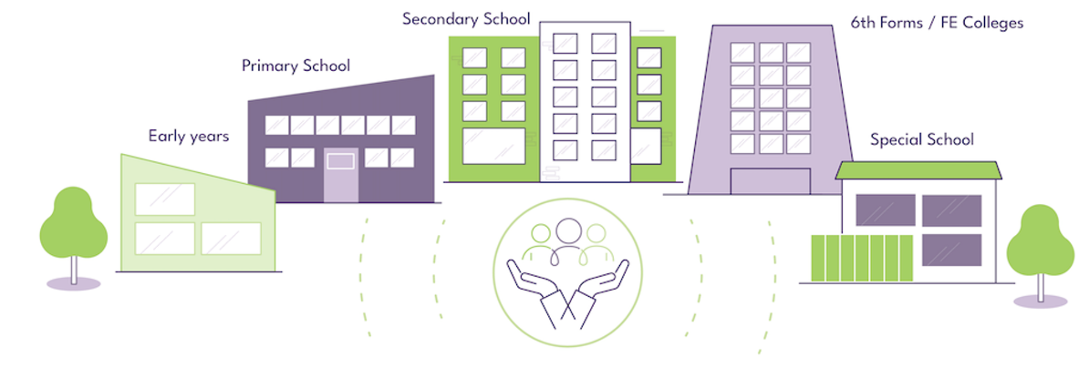
In November, the REACh team hosted a webinar led by three of the Early Language Support for Every Child (ELSEC) pathfinders, who shared their experiences and lessons from the implementation of the programme in their local area.
What is ELSEC?
Launched in 2023, the ELSEC programme provides support for speech, language and communication needs within primary and early years settings. The programme is jointly funded by the Department for Education (DfE) and NHS England and is one of the reform areas being tested as part of the SEND and AP Change Programme. ELSEC aims to address the rising pressure on specialist speech and language services and challenges in the specialist workforce, and to provide earlier intervention for children with speech, language and communication needs.
ELSEC pathfinders provide specialist speech and language support to primary and early years settings to:
- improve communication-friendly environments within educational settings,
- screen and support children with identified needs,
- train and upskill setting staff,
- engage with and support parent, carers and families.
While these goals are shared across all areas, each pathfinder has adapted the model and approach to meet the needs of their local area.
What the pathfinders told us – key challenges and enablers
1) Understanding the local context
All three pathfinders spoke about the impact of deprivation and rising levels of speech, language and communication needs as key challenges. Each presentation gave a data-informed overview of the specificities of their local context – such as delivery in rural areas, levels of literacy amongst the adult population, or numbers of families with English as an Additional Language - and described how they had shaped their programme to respond to local needs.
Across the board, pathfinders emphasised that data-informed planning has been a crucial step in shaping delivery models that truly work for local children, families and educational settings.
2) Workforce development and recruitment
One of ELSEC’s core aims is to address workforce and recruitment challenges in the speech and language field and promote sustainability through innovative workforce structures. Most pathfinders have created non-clinical Speech and Language Assistant or Higher-Level Teaching Assistant positions who are trained by clinical staff to deliver interventions in primary and early years settings.
During the webinar, the pathfinders described how they structured their teams and shared insights into their recruitment and onboarding processes, highlighting the importance of collaborative and multiagency working and access to high-quality training, supervision, and CPD for non-clinical delivery staff.
3) Collaborative working
As a programme that aims to deliver specialist early intervention in non-healthcare settings for both children and their families, strong collaborative working is key to the success of ELSEC. Pathfinder areas discussed the importance of effective stakeholder engagement at all levels and described their efforts to embed collaborative governance and strategic oversight structures, build relationships with settings, and engage parents and carers. While these processes are complex and ongoing, pathfinders highlighted clear communication, flexibility, and accountability across teams as being enablers of effective practice.

Spotlight on Learning

MAPS and Parental Engagement Practice Notes

We are pleased to share the REACh Consortium’s Multi-Agency Panels (MAPs) and Parental Engagement Practice Notes. These Practice Notes have been created by the REACh consortium in partnership with the Department for Education. The Practice Notes contain emerging insights and learning from the Change Programme and should not be regarded as official government policy or guidance.
These Practice Notes offer a range of learning and insights from the Change Programme, including:
- Panel membership is a major commitment and flexibility is required to maximise input from professionals
- Making the most of the Designated Social Care Officer role (DSCO) in decision making
- Panels need to be well-managed, with clarity between all members on the scope and purpose of input to decisions
- Parent involvement in Panels needs to be clearly scoped and well supported, ideally in partnership with the Parent Carer Forum
- Communication with parents and ensuring access to non-statutory support needs as much attention as decisions themselves
- The importance of partnering with parents and carers at all levels of decision-making
To read more about Multi-Agency Panels and Parental Engagement, or to read about other Change Programme learning and insights from the REACh Consortium, please click the link below.
read more

Research, reports and events


  SEND Regional Engagement Events with the Department for Education
  Ahead of the publication of the Schools White Paper early next year, the Department for Education is committed to testing the proposals to reform the SEND system with the people who matter most – young people and families – alongside teachers and other experts.
  The Department for Education, alongside expert advisors Dame Christine Lenehan and Tom Rees, and in partnership with the Council for Disabled Children, will be hosting a series of SEND Engagement events across the country, to listen to and understand the full range of views and experiences from a wide range of perspectives. Creating an opportunity to discuss and understand views on the core principles for SEND reform and ensure that our reforms are grounded in lived experience.
  Each event is for parents, carers, school staff and SEND professionals, and other key interested stakeholders to come together. We strongly welcome and encourage participation from across the SEND community and all those with an interest in these issues.
  Please visit the Council for Disabled Children’s website for the latest information and to book onto these events.

Curriculum and Assessment Review Final Report
The conclusions and recommendations of the independent review of the curriculum, assessment and qualifications system in England, have now been published by the Department for Education and you can read them here.

Children and young people's Speech and Language Therapy Improvement Forums - Register now!
The Office of the (Chief Allied Health Professions Officer) CAHPO has commissioned NHS Elect to co-produce and implement a Speech and Language Therapy (SaLT) pathway transformation toolkit, for children and young people’s community health services. This toolkit will support regions, ICBs and providers with key outcomes to reduce waiting times and address unwarranted variation in access. Visit the SaLT Transformation Programme Future NHS workspace for updates as this work progresses.
The improvement forums is a national series aimed at connecting professionals and partners across each region and nationally, providing a platform for active participation and delivery with the support of a network. There are three planned forum sessions in 2025/26 (click on the hyperlink for each session to register):
- Tuesday 2 December 2025, 10:00–12:00
- Thursday 26 February 2026, 09:30–11:30
- Wednesday 25 March 2026, 10:00–12:00

Thank you

Thank you for reading this edition of the REACh newsletter. We will be back next month with more insights and information from the Change Programme.
If you would like to be first to hear about this or you know of anyone who would benefit from receiving updates about the Change Programme, please subscribe here.

