
Wakefield SHORT BReaks
Annual Report
2024 - 2025

Contents

Context…………………………………………………………………………………….……2

Public Sector Equality Duty…………………………………………………………………...3

Assessments……………………………………………………………………………………4

Short Breaks Panel…………………………………………………………………………….4

Specialist Short Breaks Team………………………………………………………………...5

Specialist Short Breaks………………………………………………………………………..5

Compliments and Complaints…………………………………………………………………8

Feedback………………………………………………………………………………………...9

What have we achieved in 2024/25…………………………………………………………10

Future Plans……………………………………………………………………………………11

Context

Wakefield is committed to ensuring that all children and young people, including those with special educational needs and/or disabilities (SEND), are happy, healthy, safe, and supported to achieve their full potential.
The local authority has a statutory duty to provide short breaks for children and young people with SEND, as outlined in the following legislation:
- Children Act 1989
- Breaks for Carers of Disabled Children Regulations 2011
- Chronically Sick and Disabled Persons Act 1970
- Children Act 2004
- Children and Families Act 2014
- Equality Act 2010
- NHS Act 2006 (as amended by the Health and Social Care Act 2012)
- Care Act 2014 (particularly in relation to transition to adult social care)
Short breaks are designed to give children and young people with SEND opportunities to enjoy experiences similar to those of their peers – both at home and within their communities. These services help them to participate fully in family life and the wider community.
Short breaks also play a vital role in supporting family carers, enabling them to continue providing care by offering regular respite and reducing the pressures associated with caring responsibilities. For many children and young people with SEND, these services are accessed through universal provision available to all families.
Wakefield offers a range of short breaks for children and young people with special educational needs and/or disabilities (SEND), delivered through Universal, Targeted, and Specialist provision:

- Universal Provision
These are services and activities available to all children and young people, including those with SEND. Examples include mainstream groups and facilities such as Brownies, bowling alleys, parks, and open spaces.
- Targeted Provision
These services are specifically designed to meet the needs of children and young people with SEND. They may include disability-specific sports clubs, swimming sessions, and youth groups tailored to support children with additional needs.
- Specialist Provision
This level of support is for children and young people with complex needs that cannot be met through universal or targeted services. It includes provision requiring specialist medical equipment, personal care, or support from highly trained staff. Examples include overnight residential care, nursing support, and groups with high staff-to-child ratios and personal assistants.

Public Sector Equality Duty

All work undertaken in relation to short breaks considers the ‘Public Sector Equality Duty’ or ‘PSED’ under section 149 of the Equality Act 2010. This applies to everything done by local authorities, including its short break provision.
The ‘PSED’ mandates ‘due regard’ to a series of needs, being the need to:
- Eliminate discrimination.
- Advance equality of opportunity; and
- Foster good relations between different groups.
Short breaks play a vital role in meeting the diverse needs of disabled children and young people. They contribute to:
- Reducing barriers to participation by improving access to mainstream leisure activities, clubs, and community spaces.
- Promoting equality of opportunity, helping disabled children enjoy experiences comparable to those of their non-disabled peers.
- Enhancing visibility and inclusion, increasing interaction between disabled and non-disabled individuals—including short break staff—which helps reduce stigma and foster positive community relationships.
To be effective, specialist and targeted short breaks must complement broader efforts to make universal services more inclusive, ensuring disabled children are fully integrated into their communities.
In line with the Public Sector Equality Duty (PSED), local authorities must give due regard to these needs when setting budgets and making commissioning decisions. This includes actively considering how short breaks provision can support equality, eliminate discrimination, and foster good relations between different groups.

Assessments

Access to specialist short breaks in Wakefield is based on an assessment of need. These assessments are carried out by the following teams:
- Complex Care Needs Team
- Locality Social Workers
- Early Help Team
- Short Breaks Assessment Team
Reassessments may be conducted by the Complex Care Needs Team, Locality Social Workers, or the Short Breaks Assessment Team. These can occur as part of a scheduled review cycle or be initiated at the request of a parent/carer or professional when there has been a significant change in one or more of the following areas of need:
- The child’s needs and development
- The parent carer’s needs
- The family and home environment
This structured approach ensures that support is tailored to the evolving needs of the child and their family, and that resources are allocated appropriately and fairly.

Short Breaks Panel

The current Short Breaks Panel was established in November 2019 with the remit to oversee the short breaks process and to:
- Reach decisions on requests for specialist short breaks.
- Review specialist short breaks packages.
- Quality assure the short breaks assessments completed by the Short Breaks Assessment Team and Complex Care Needs Team.
It is a multi-agency panel chaired by a Service Manager which meets every 2 weeks.

Specialist Short Breaks Team

The Specialist Short Breaks Team is led by the Specialist Short Breaks Manager, supported by:
- 1.5 full-time equivalent (FTE) Short Breaks Coordinators
- 2.0 FTE Short Breaks Support Officers
The team plays a central role in the delivery and oversight of specialist short breaks across Wakefield. Its key responsibilities include:
- Coordinating assessments for presentation at the fortnightly Short Breaks Panel.
- Attending, contributing to, and minuting Panel meetings.
- Communicating Panel decisions to parent/carers.
- Liaising with short breaks providers to ensure timely implementation of agreed support following Panel approval.
- Ensuring all short breaks providers—both internal and external—meet required minimum quality standards.
- Planning and delivering holiday group provision for children and young people with SEND.
- Setting up and managing direct payments to families, including monitoring appropriate use of funds.
- Participating in regular contract management meetings with providers, offering support and challenge where necessary.
- Maintaining ongoing communication with parent/carers to address any issues or concerns related to short break provision, including where arrangements are not meeting the child’s needs.
- Liaise with parent/carer(s) regarding all aspects of short break provision, including where provision is not working for whatever reason.

Specialist Short Breaks

The following specialist short breaks support is available for children and young people in the Wakefield District:
- Managed Account – the Council manages the support on behalf of the family, finds the provider and pays the provider directly. The provider can deliver:
  - Individual support in the home for personal care, social and leisure, waking and sleeping nights.
  - Individual support in the community for social and leisure.
  - Term Time and Non-Term Time specialist groups (except Christmas holidays).
- Direct Payment – the family manages all or part of their short breaks support.
- Residential Provision.
Many providers offer more than one type of support which can include personal support, group social/leisure in the community, individual social/leisure in the community, daytime support in the home, overnight support inside the home or overnight support outside the home. In addition to our internal providers, we commission external providers whose information can be found on Local Offer website: Wakefield SEND Local Offer | Wakefield SEND Local Offer (mylocaloffer.org)

Performance
In 2024-25 there were 571 children and young people who received specialist short breaks support. This represents a 24% increase on the number of children and young people who accessed the service in 2023-24. However, it should be noted that the method of data collection has changed over time and this has an impact on the capacity to make comparisons. The children and young people in receipt of the short breaks service are predominantly male and white British.
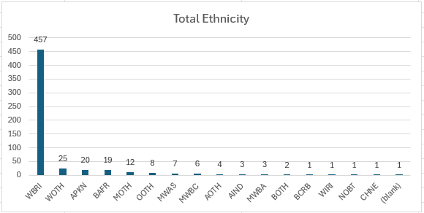
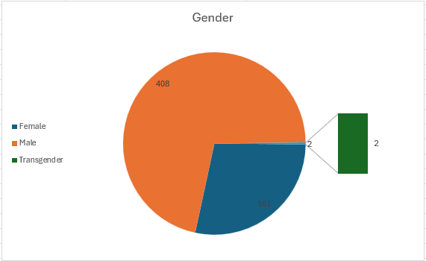
Most of the children and young people who received short breaks in 2024 – 25 were in Key Stage 3 and aged between 11 – 14 years. This represents a change from recent years where the biggest group was children in KS2. Additionally, the biggest group are boys.
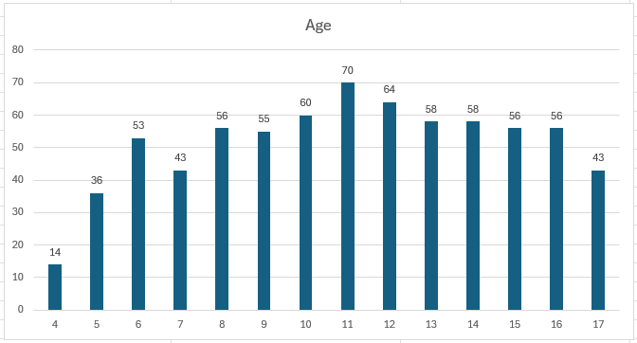

The charts below indicate the areas where the children and young people in receipt of short breaks reside within the Wakefield district. As much as possible, we use this information to inform the planning of our targeted and specialist short breaks to try to ensure that children and young people are able to access opportunities within their local areas.
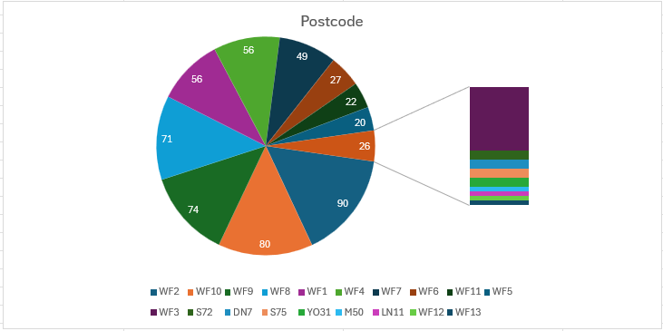

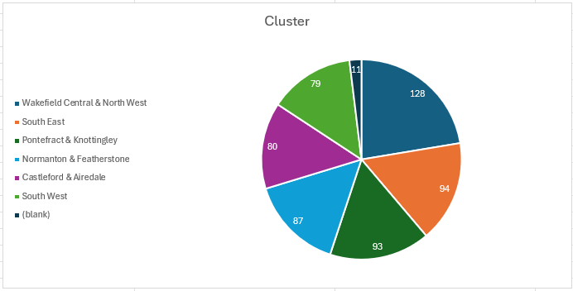

Specialist Short Breaks
The table below is the summary of short breaks provision children and young people have received in 2024-25. The figures from previous years are included for comparison.
Provision* | 2020 - 2021 | 2021 - 2022 | 2022 - 2023 | 2023 - 2024 | 2024 - 2025
Managed Account: Personal Care | 12 | 13 | 13 | 22 | 32
Managed Account: Social and Leisure | 164 | 184 | 177 | 204 | 295
Managed Account: Specialist Groups | 102 | 154 | 164 | 221 | 286
Direct Payments | 77 | 71 | 72 | 82 | 130
Residential | 81 | 71 | 68 | 67 | 67

* some children and young people access more than one service as part of their support package

A total of 106 children and young people ceased support in 2024-25:

Turned 18 Years Old | 29
No longer needed to access Short Breaks support | 15
Package ceased – no longer engaging | 25
Moved out of district | 2
Other | 35

Compliments and Complaints

Wakefield is committed to delivering high-quality short breaks that meet the needs of children and young people with SEND, support their families, and engage a skilled and responsive provider network. We strive for excellence in all aspects of service delivery.
To achieve this, we actively seek and value feedback from both service users and providers. We listen carefully to what they tell us and use this insight to inform service development, improve practice, and ensure that provision remains relevant, inclusive, and effective.
One formal complaint was received in 2024/25 which was partially upheld.

Complaint and feedback themes:
The Specialist Short Breaks Team have been proactive in dealing with issues when they arise but listed below are main themes of issues that families have raised:

- Poor communication and organisation from external provider managers
- Unsuitable carers provided by external agencies
Each concern or issue is addressed fully with the provider and improvements monitored.
Compliments
These are a selection of quoted compliments received from parents. They evidence that the service is very much valued by families and children and young people alike. We also get compliments from providers and occasionally, members of the public.

‘Just to let you know that my daughter came back very, very happy and enthusiastic and ....tired. I don't know what she did, but I can tell from her face that she enjoyed it a lot. Staff from transport was amazing as well. I am not so sure who I need to say thank you to but please send all my gratitude to everyone and a big thank you.’

‘I would like to pay a compliment regarding two staff members who brought two younger boys into walnut tree at Wakefield play soft on Friday. When they entered the soft play one of the children was over stimulated with the noise and environment, one carer took action immediately and acted very professionally and with empathy laid on the floor with the child until he felt secure enough to stand up and leave the building. It was heartwarming to see how the child kept hugging the carer as they were leaving the building the carer stated, "it's okay, we will take you away from all the noise". As I was out with my own child it was amazing to see how caring and attentive your staff are in the community. As a parent I would be more than happy to leave my child in the care of your staff as they did an excellent job.’

‘We just want to say a big thank you for the short breaks our daughter has had. She's been to the group twice now and seems to have enjoyed it. I was nervous about her going by transport with an escort and wasn't sure what to expect. I just wanted to let you know how lovely the escort and driver were. The driver got out to introduce himself and even asked what music Liv liked so he could play it in the car for her. Everyone had a great time so thank you for all the help in sorting this out for us all. It has really made a difference for us as a family.’

‘The girls enjoyed it a lot and I am very grateful. The escort and lady who drove the bus were absolutely lovely. I had to ring when girls come home due to one of twins glasses (I thought they forgot to put them in bag) and I spoke with the manager. She talked very nicely about the girls and she apologised for not eating enough – which happens a lot. The manager reassured me that all the staff are trained to deal with kids in this situation and she told me if I will ever have any questions or concerns to ring anytime. I had such a nice feeling and I am sure all the staff are amazing and they are doing fantastic job. Thank you again.’

‘What absolutely amazing staff they are including the lady running it. They are very experienced and have fab social skills with the family too. (The young person) in my time there, was regulated and happy. The whole room was calm and every staff member was engaging with different children. Excellent provision.’

Wakefield Parent Carer Forum and Short Breaks

For the third year in a row Wakefield’s Parent/Carer forum (PCF) was able to use funding from Wakefield’s successful bid for the DfE Short Breaks Innovation Fund to host Family Fun Days for families of children and young people with SEND.
These local SEND families were able to attend and take part in some exciting sessions to experience things they might not have been able to access previously. All the sessions had reasonable adjustments included as standard.
The PCF surveyed forum members to find out what things they would like to see as part of family fun days and built the sessions based on that feedback.
The PCF gathered feedback from each family after each event so that they could improve the content of what they delivered and continue to bring exciting opportunities to SEND families across the Wakefield district. Many of the members said they would be unable to access opportunities like these without the planning and support from Wakefield Parent Carer Forum.

What we have achieved in 2024-25

The number of providers on our framework has continued to grow so that we are able to offer a wider range of choices to parents to meet the needs of the children and young people. We have more holiday groups, more term time groups and more providers able to support young people in the home and community.

Happy Healthy Holidays Funding
We have been successful in accessing funding from the government’s Happy Healthy Holidays scheme which has meant that we have been able to provide more support to children and young people with SEND and their families over the summer holidays and offer free lunch for those who are eligible with free school meals.
In summer 2024 we were able to provide:
Number of:
Sessions | 314
CYP | 77

Comparison over three years:
 | Specialist CYP that accessed summer groups: | Targeted  CYP that accessed summer groups: | Total:
2022 | 154 | 56 | 210
2023 | 177 | 58 | 235
2024 | 195 | 77 | 272

EHCP Advice
From April 2024 until March 2025, 198 initial discussions took place.15 of those cases went ahead for full assessment with 143 either opting out or not responding within set timescales.
The detailed initial conversation provides comprehensive tailored advice to families. Following this, the majority decide that they do not feel it is necessary for them to progress to a full social care assessment as they are now aware of the wider support they can access without the need for an assessment. This is then recorded as EHC social care advice.

DfE Short Break Innovation Programme

Wakefield Council successfully secured Year Three funding from the Department for Education’s Short Breaks Innovation Programme, building on two previous years of successful delivery. This continued investment enabled the expansion of short breaks support for children and young people with SEND.
One notable initiative funded through this programme was the creation of a specialist group for home-educated young people with SEND, hosted in a nursing home in Pontefract. The group aimed to provide meaningful social opportunities for young people who may experience isolation due to not attending school. The nursing home setting offered a unique and enriching experience, fostering intergenerational interaction and community connection.
Due to space limitations, the group welcomed an average of 6–8 young people per week, engaging them in a wide range of activities including:
- Animal encounters with reptiles and birds of prey
- Circus skills workshops
- African drumming sessions
- Cooking and arts & crafts
- A six-week course at the local Fire Station covering basic first aid and firefighter skills
Feedback from young people, their families, and nursing home residents was overwhelmingly positive. The project helped participants build confidence, develop social skills, and form friendships with peers who share similar experiences. Importantly, it also supported progress toward re-engagement with formal education.

Short Breaks Survey
In autumn 2024, the Specialist Short Breaks Team conducted a survey to gather feedback from families accessing short breaks. The aim was to better understand their experiences and identify areas for improvement across the service.
Insights from the survey were used to inform targeted actions, including:
- Holiday club providers were asked to produce an introductory leaflet about their group to share with families of newly awarded children and young people, helping to ease transitions and build familiarity.
- Providers were also asked to complete a daily activity log for children and young people using WMDC transport, giving parents a summary of their child’s day, including activities and events.
- Feedback on preferred activities was shared with providers, enabling them to tailor their programmes to better reflect the interests and preferences of children, young people, and their families.
A new survey is planned for the 2025 to continue gathering valuable feedback and ensure services remain responsive to the needs of those who use them.

Future Plans

Wakefield is continuing to enhance its short breaks offer for children and young people with SEND through a number of key developments:

A holiday club service, previously delivered internally, will now be operated by an external provider. To ensure continuity for children and young people, the service will continue to run from the same building and adopt a similar model of delivery.

We are expanding our term-time group provision by increasing the number of places available through current providers who deliver weekend groups, helping to meet growing demand.

In partnership with Mid Yorkshire Health, we are working to strengthen the capacity of our short breaks providers by offering medical support and training, enabling them to better meet the complex needs of children and young people.
- Within the Short Breaks Team, data management processes are being reviewed and updated to digital systems to provide more efficient, timely and organised support.

A funding bid for Summer 2025 was submitted to support the continued delivery of a diverse range of short breaks, ensuring both targeted and specialist provision is available during the school holidays.

