Wakefield SEND Local Offer Annual Report 2022 – 2023 Family Action WESAIL

report complied by usha gough, local offer lead
CONTENTS
Introduction to SEND Local Offer 3
Contact Details 4
Key Developments and Progress 5
How did we get on with our targets from last year? 5
What have we improved this year? 6
Local Offer Website 7
Website Refresh Project Outcomes 7
Website data 8
What have people said about the website? 10
Local Offer Newsletter 12
What have people said about the newsletter? 12
What do people want to see in future newsletters? 13
Facebook 14
New Facebook Page 14
Facebook Data 14
Local Offer Inbox Contacts 15
Inbox data 15
You Said We Did 18
Audits 22
Website Refresh Project 22
Peer Review 22
Engagement and CoProduction 23
Social Value 24
Local Offer Champions 24
Regional Local Offer Network 24
Wakefield Libraries, Castles, and Museums 24
Future Developments 25
Target 1 25
Target 2 25
Abbreviations 26

Introduction to SEND Local Offer
The Special Educational Needs and / or Disabilities (SEND) Local Offer is a legal requirement. It tells you things and helps children and young people aged 0-25. You can find out more by reading the SEND Code of Practice.
Every Local Authority must say what help they expect to be available in their local area.
Lots of different people contribute to the Local Offer. These can be from education, health care, social care. Parents, carers, children, and young people also make important contributions.
You can find out more details on the Local Offer website.
This report is an overview of the Local Offer from 1st April 2022 – 31st March 2023.
During this time, the Local Offer service was provided on behalf of Wakefield Council by Family Action’s Wakefield Early Support, Advice Information Liaison (WESAIL) service.
There was one part-time person employed to work on the Local Offer. That person helped put information on the website, Facebook and in the newsletter.

Contact Details
You can contact the Local Offer by emailing wakefieldlocaloffer@family-action.org.uk
You can ring and leave a message on 01924 965588.
You can leave feedback on the website by clicking on the smiley face buttons. It is helpful to leave a comment to say what page you are on, as well as your feedback.
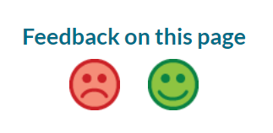

You can also press the blue button on our Facebook page.

Key Developments and Progress

How did we get on with our targets from last year?
Target 1. We will ensure there is a smooth transition of providers when the contract changes from Barnardo’s to Family Action.
We transferred all Local Offer information over to Family Action systems ready for the new financial year.
We met with the Operational Manager to help develop an understanding of the Local Offer, and shared relevant documents and files to support this.
The member of staff with responsibility for the Local Offer remained in post after a restructure to ensure continuity.
We received feedback via the SENDIASS Steering Group that the transition had appeared seamless and a good transition.

Target 2. We will develop and coproduce the Local Offer website, focusing on making information easier to read and access.
We worked with Wakefield Council, Wakefield and District Health Care Partnership (WDHCP), Wakefield Parent Carer Forum (WPCF) and the website hosts, Public Partnerships Ltd (PPL) to work on a project to redesign and launch a refreshed Local Offer website. We ran district-wide consultation for this and used other feedback gained from surveys etc. to feed into the development of the site.
We were able to keep the Easy Read format for some aspects of the site and ensured that education settings information was more concise and clearer – this was done in partnership with WPCF. The colour scheme was chosen by parents, carers, and professionals as part of the consultation, and has a better contrast for accessibility.
The new site was launched in December 2022.
We held regular meetings with key stakeholders before, during and after the launch to address and concerns, make amendments and to respond proactively to feedback about the site.

What have we improved this year?
This year, we have improved the look, accessibility, design, and functionality of the whole SEND Local Offer website. For example, education settings can now be searched for using filters chosen by WPCF, in response to parent and carer feedback.
We have also removed several pages that were no longer active or relevant, which has decluttered the feel of the site.
We have used feedback from our service users to put the most requested topics on the homepage.
We have made use of a scrolling banner function to add quick links to school search, short breaks and the WESAIL and Local Offer Facebook page.
We have continued to improve the Local Offer newsletter, News & Views, by having regular feedback opportunities. As a result of this feedback, we have provided requested information on dyslexia, Tourette’s, personal independence payments (PIP) and applying for secondary schools with an EHCP.
We have also created a Local Offer Operational Group that meets regularly to review the Local Offer.

Local Offer Website

Website Refresh Project Outcomes
In partnership with our services users and stakeholders, the new website has been redesigned and launched this year. The key highlights are:
In consultation with service users, the colour palette of the LO website has been changed and provides a greater contrast for accessibility.
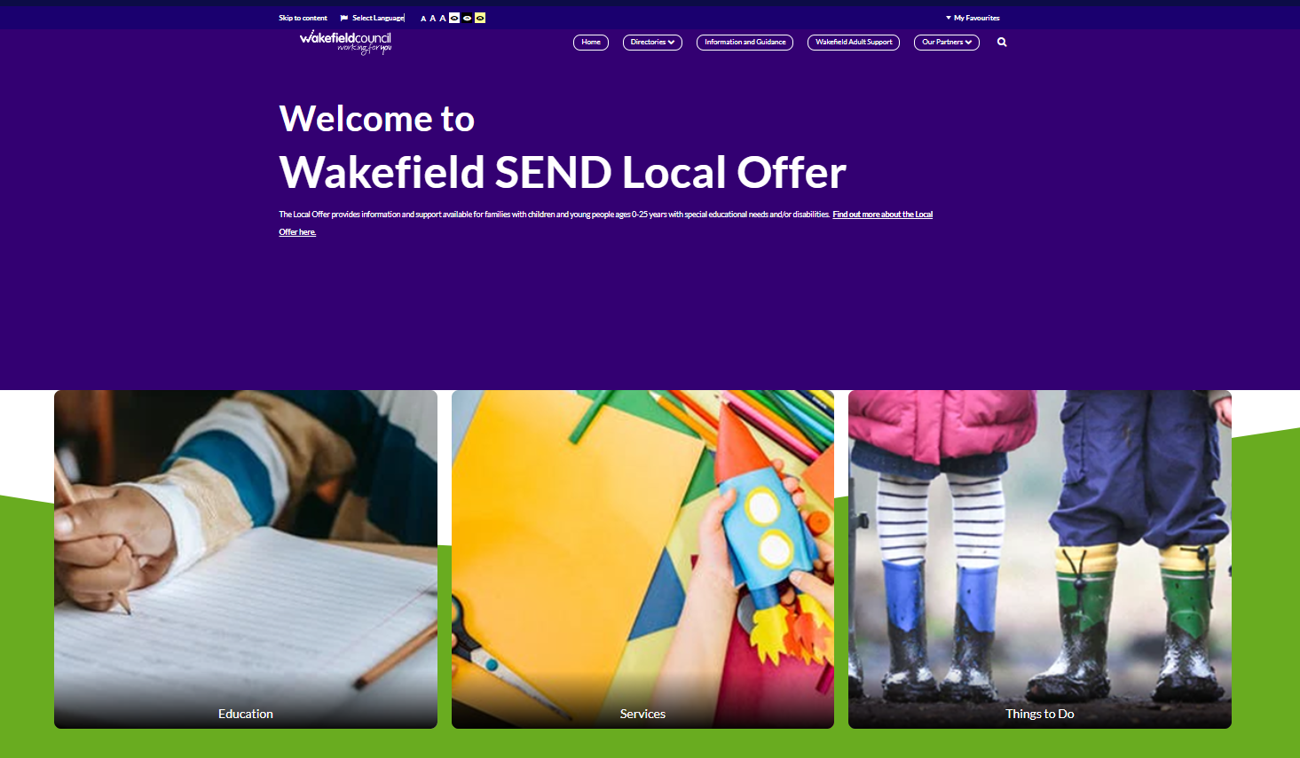
The most requested and needed information, as stated by our stakeholders, is displayed clearly on the homepage.
The pages detailing education settings, services, and things to do have now been split into three separate directories. We worked in partnership with key stakeholders to determine search categories and filters, for service users to find more easily what they are looking for. This has been particularly beneficial for the education providers search.
Key information from areas such as health, social care, finance, and key information from Wakefield Council is available on the Information and Guidance pages. This has been developed with our partners and is reviewed by the LO Operational Group.

Website data
The Local Offer website had a total of 58,811 visits between 1st April 2022 and 31st March 2023.
This is an increase of 13% on last year.

There were 130,590 pages viewed this year. This is down by 23% on last year. This could be because the new LO website has less pages, as it was streamlined during the refresh project.

There were 46,610 new users on the website this year. That is an increase of 36% on last year. The reason for this could be due to the launch of the new site.

The most popular pages on the Local Offer are:
WESAIL
EHCP
Children’s First Hubs
Information Network
Autism
SEN Support

The most searched terms on the Local Offer are:
Short breaks
WASP
Schools
Max Card
Autism
Information Network

What have people said about the website?
Very easy to navigate.
Re: LO web

Thank you so much for getting it done and getting back to me so quickly.
Re: amendment of EHCP page on LO

That is brilliant, thank you!
Re: promoting West Yorkshire Keyworker newsletter via LO web and FB

Simple and easy to use.
Re: Information Network form

I have just looked at my page and it looks great.... Thank you so much.
Re: Completing application for new service on the LO

That’s great, thank you for doing so quickly.
Re: Updating WASP page on LO

Easy to complete and not too lengthy.
Re: IN application form

Brilliant site
Re: LO website

Everything worked.
Re: LO website

Much better to be able to click individually on the areas rather than one long list.
Re: WESAIL section on the new LO website

Looks good.
Looks great – easy to get around.
Looks really good.
Re: Refreshed LO website

The LO website is looking much better following the updates.
Re: New LO website

This is such an improvement and easier to navigate.
Re: Lo web general

Thank you for sorting this so quickly, we really appreciate it.
Re: Amending school page on LO

Local Offer Newsletter
This year we have continued to use feedback from service users to inform the newsletter. For example, we have included the requested topics of Tourette’s, short breaks, and information on deaf services. Children and young people have been involved in image selection, and we have also had an article written by a parent / carer.

What have people said about the newsletter?
Each newsletter gets sent out with a survey, which is also shared through the Information Network as well as being put on social media and the Local Offer website.
This year, 96% of people who responded said they had received the newsletter via email. There is a mix of how service users hear about the newsletter, with most getting this via the Information Network.

Most respondents also said they found the newsletter easy to read, with 82% saying they felt it was easy to understand, and 14% saying it was mostly easy to understand.
Finally, 82% of people surveyed said that they would look at the Local Offer website for further information.
Further feedback was given as comments:

Great newsletter
Re: Winter LO newsletter 2022 – 2023

This is really excellent, so, so helpful for parents!
Re: Spring LO newsletter 2023

What do people want to see in future newsletters?

We have already begun to use this to shape the LO newsletter. For example, we have featured information on short breaks as well as how to search for education settings on the website (Spring newsletter 2023).
As part of the Local Offer Strategy Group for 2023 - 2024, there will be a survey regarding the most important newsletter topics. This will also be shared with service users to help prioritise articles over the next year.

Facebook

New Facebook Page
This year we ran a consultation on our social media pages. This was to determine how our service users felt about amalgamating the WESAIL Facebook page with the Local Offer Facebook page. The responses were positive and therefore we created and launched a new, single, Facebook page. As part of the consultation, service users chose the new name, Wakefield WESAIL and Local Offer, and identified topics they wanted to see posts on.

Facebook Data
At the end of the 2022 – 2023 year, the new Facebook page had 409 followers. The total reach of the new page from December 2022 to March 2023 was 2,038. This graph shows where most of our Facebook followers are based geographically:
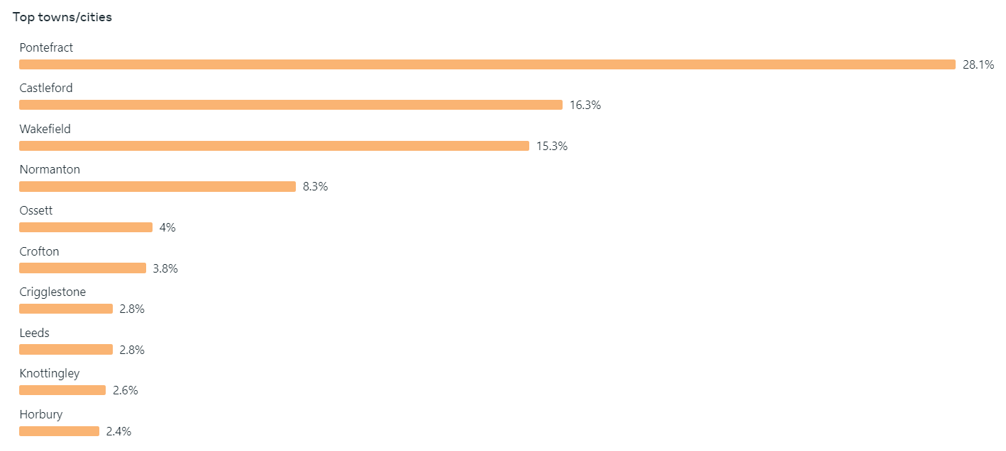
The most popular posts have been:
- Welcome to new Facebook page post / SEND Christmas event
- Engagement post on choosing a cover for the Winter 2022-2023 newsletter
- Autism friendly cinema screening at Cineworld
- SEND law training for parents / carers from IPSEA
- New autism support group (Autism Support Community, Featherstone)
- BBC article on “school refusal”
- Local Offer winter newsletter
- West Yorkshire ADHD support group
- SENCO and teacher checklist for creating an inclusive classroom from the AET
- Speech and Language drop in sessions

Local Offer Inbox Contacts

Inbox data
The total number of enquiries received via the Local Offer email and Facebook inboxes was 142 for this year. 66% of all enquiries were from parents and carers.

Most contacts (93.5%) were responded to within 72 hours. However, due to significant staff absence during the Autumn, a few of these were just outside this timeframe.

Appropriate contacts are those such as requesting for a page on the Local Offer to be updated, or finding out about where users can access summer playschemes. These appropriate contacts make up for 54% of all inbox enquiries. Inappropriate enquiries are those that the Local Offer cannot and do not deal with, such as requesting an EHCP review, or for their bathroom to be refitted.

It is worth noting that the number of inappropriate contacts has steadily decreased over the year. This is due to the new Local Offer website clearly displaying the acronym ‘SEND’ and explaining what this is / who the website is for on the homepage. The old website did not display the special needs part so clearly and therefore some members of the public saw it as a generic Wakefield Council information website.

Over the year, 18% of queries were passed on to the WESAIL inbox, as they were not appropriate for the Local Offer to respond to. For example, a parent wanted advice about her child with additional needs, as they were being suspended from school on a regular basis. Each time this type of query came through, the parent or carer was given clear information about how to contact WESAIL SENDIASS and what would happen.

The chart below shows the types of queries received via the LO inbox. The majority of these were to request information, signposting, and support.

You Said We Did
You Said We Did is where we respond to feedback about the Local Offer. Feedback is where you tell us what you think.
You can find out how we get feedback on the Local Offer website.
This year, more services have contributed their ‘You Said We Did’ via the SEND Strategic Partnership Board.
You Said is what you think.
We Did is what we are doing about it.
You Said | We Did
Can’t find the Social Communication and Interaction form (for an autism referral) | We added the form to the Services section of the Easy Read Autism part of the Local Offer.  We posted about this on Facebook.
We would like more information on how to get a Personal Budget | We have asked Wakefield Council’s Social Care team to review and update this information.
Parent/carers asked for soft play sessions for children with SEND. | We secured funding to provide SEND soft play sessions, started in March 2022.
Parent/carers would like Makaton training to help them support their children. | We provided parent/carers the opportunity the train Makaton Level 1 in May and June 2022.
Parent/carers wanted drop-in session with different services. | We arranged meetings with different services to speak to parent/carers i.e., Educational Psychology, SENART.
Adults, Learning Disabilities & Mental Health were made aware that the accessibility of our written communication with young people through could be improved and aligned better with schools and colleges. | Adults, Learning Disabilities & Mental Health have now purchased and have access to Board Makers software. The software produces symbols and is like that used in schools and colleges. It and will allow us to produce accessible and easy read information, to improve communication and engagement with young people.
A link is needed between college and schools to help with transition. | 5-day officer is supporting the Flex team in college which is proving to be effective.
We would like advice and support on Tourette’s / tics. | We contacted Tourettes Action who have provided information for our Winter newsletter  We posted about Tourettes Action on the Local Offer Facebook page
We don’t find the word ‘here’ as a hyperlink accessible | We will be reviewing our wording and hyperlinks ready for the new website
We are happy for the WESAIL and Local Offer Facebook pages to be joined. We would like the new page to be called WESAIL and Wakefield Local Offer | We have created the new page. In line with Family Action and Facebook guidance the new page is called Wakefield WESAIL and Local Offer.
We would like to have an email or text telling us our Max Card is about to expire | We contacted the Information Network who updated their information on the Local Offer. They are unable to send out reminders, so ask for you to please check the expiry date on the back on the card.
We can’t find the Social Communication and Interaction form (for an autism referral) | Family Action added the form to the services section of the Easy Read Autism Section of the Local Offer. We posted about this on Facebook.
We would like to know more about personal budgets | Family Action have asked Wakefield Council’s Social Care teams to review and update information on personal budgets.
We think there is a gap in provision for teenagers | We focused our successful short breaks bid on this area which has increased provision.
We would like for soft play sessions for children with SEND to continue | SEND Soft Play is now weekly.
We would like to continue with monthly Lego Club | Lego Club now has two sessions monthly due to demand.
We would like drop-in sessions with different services | Drop-In sessions are now monthly with Special Educational Needs Assessment and Review Team (SENART) plus other services in the diary including Social Care, Educational Psychologists, Emotionally Based School Avoidance (EBSA).
We would like to know what training is being delivered in schools. | Training in schools – We hosted Autism Education Trust (AET) training sessions for parent carers delivered by Wakefield Inclusion Special Educational Needs and Disabilities Support Service (WISENDSS) to show what schools are receiving.
We would like craft sessions to be held more regularly to support mental health and wellbeing. | Craft sessions are now three per month.
We find the Autism Pathway confusing and would like it to be updated to make it parent carer friendly. | Autism Frequently Asked Questions (FAQs) will be created instead of the Pathway. It will be co-produced with parent carers. It will be added to the Local Offer website when ready.
The ‘Let’s Talk About SEND’ event was the most valuable event parents and carers have attended all year. | Let’s Talk About SEND event is now an annual event.
You would like more information on mental health. | We have posted about mental health on our Facebook page. We will be updating information about mental health on the Local Offer website.
You would like more information on Preparation for Adulthood (PfA). | We have shared the PfA drop-in sessions on our Facebook page and in our newsletter.  We will be sharing more information and services on PfA in future newsletters.
You would like more information on Short Breaks. | We have put information on Short Breaks in our Spring Local Offer Newsletter.
More support has been requested earlier | Submitted a successful bid to Supporting Families: Special Educational Needs and Disabilities Pilot Project which focuses on early help.
It would be good to have some groups that siblings could attend together for those with and without SEND. | Incorporated siblings’ groups into our year 2 successful short breaks innovation bid.
You asked for information on support available for deaf people | We shared this information in our Spring Local Offer Newsletter.
You said that sometimes the postcode search on the Local Offer website doesn’t give results | We are working with the website hosts to resolve this issue.
You said you felt that discussions were held too late, there was not enough time to explore options for your child moving into a Post 16 provision and they wouldn’t gain meaningful employment. | We held a SEND Careers event specifically for all young people in Year 9 and above. The event was a great success and it has been agreed to have an annual event.
We would like to know what our appointment at the Sexual health Clinic will be like | Sexual Health Service (Spectrum) developed easy read, personalised booklets with photos to show what the appointment at the clinic will include, with options to fill in information beforehand to support the visit
We would like bespoke Relationship and Sex Education lessons at our school | The school worked with the Sexual Health Service RSE Team (Spectrum) to put together and deliver targeted sessions for SEND

Audits
An audit is where another service, professional or group look at some information and say what is good about it. They can also say what needs improving.
They might use a survey or report to help them do the audit.

Website Refresh Project
As part of the website refresh project, the whole LO site was audited. This documentation was shared with the LO Operational Group and PPL, to determine which pages needed deleting, transferring, and amending for the new site.

Peer Review
As part of the Yorkshire and Humber Regional Local Offer Network (YHRLON), we participated in a peer review of Local Offer websites. This is based on the Mott Macdonald framework, which the YHRLON group have developed over the past couple of years.
The main positives that came from the review were:
- Clear where to go to give feedback
- Out of area educational provisions are listed and included in the filter tab of types of provisions
- Clear information under PfA, additional support on social care and short breaks
- Lots of information on mediation and tribunals under EHCP information, appeals and disagreements
- Homepage leads to specific information without having to search via another site
- Site very easy to navigate through and it is interactive with the use of videos and images making it look bright and visually appealing
- Clear accessibility tab including an accessibility statement at the bottom of the page and a menu to select accessibility options
The main things to develop (with key stakeholders) are:
- Make ‘how to access social care services for pre-16’ easier to find
- Make information on requesting EHC assessment more accessible to parents and young people
- Simplify and make easier to find personal budgets information from the homepage
- Make involvement with service users more obvious

Engagement and CoProduction
Engagement and Coproduction Events 2022 - 2023
Number of events held | 49
Number of children and young people participating | 57
Number of parents / carers participating | 30
Number of professionals participating | 66

Some of the engagement and coproduction events that have been held this year include:
- The LO website refresh project, which involved partners from health, Wakefield Council and Wakefield Parent Carer Forum. This also included a district-wide consultation with service users. The impact of these events can be seen in the new LO website. Please see also: ‘Website Refresh Project Outcomes’.
- Yorkshire and Humber Regional Local Offer Network meetings, including the creation of a video about the Local Offer. This can be viewed by visiting https://wakefield.mylocaloffer.org/important-information/what-is-the-local-offer/
- Surveys regarding the newsletter, in terms of what is useful and what else service users would like to include in future editions. The impact of this can be seen in every newsletter published this year, as each includes requested topics, and involvement from services, parents and children and young people. Please see ‘Local Offer Newsletter’ for more information.
- Discussions with key partners around suitable content for the LO. The outcome of this can be seen on the new LO website. Several pages have been removed because of these discussions, and other, more relevant services added. This work is ongoing.

Social Value
The Local Offer has contributed social value in the following ways:

Local Offer Champions
We have supported with developments and auditing, as well as understanding of issues, gaps, and use of the new LO website.

Regional Local Offer Network
We have supported with the regional LO video, participation in peer reviews (this is auditing LO websites against the Mott McDonald framework to recognise strengths and areas for development as well as share good practice). Peer reviews took place during March 2023 (with follow up discussions to be in May / June 2023).
https://wakefield.mylocaloffer.org/important-information/what-is-the-local-offer/

Wakefield Libraries, Castles, and Museums
We have supported with SEND-friendly features of activity sessions as well as what to feature in accessible guides (they have called these Visual Stories).
https://www.wakefield.gov.uk/museums-and-castles

Future Developments

Target 1
We will continue to shape Local Offer information in collaboration with key partners. There will be a focus on adding and updating ‘Things to Do’ (as requested or suggested by our service users).
We will do this by making use of monthly surveys, to enable service users to make comments and suggestions, which will be used across Facebook, the newsletter, and the website.
We will invite other services, e.g., WPCF, to share this via their channels.
We will raise this at meetings such as the Local Offer Strategy Group.
We will also contact other services to work collaboratively on developing further information about activities and events that occur throughout the year. These will be signposted across all our channels.

Target 2
We will continue to shape the Local Offer website in collaboration with key partners by developing the Service and Information and Guidance pages.
We will do this by holding Local Offer Operational Group meetings at least 6 times per year. We will ensure that this group develops an understanding of how to request information to be added or updated on the website.
We will share new information and services with key partners, such as WPCF, to ensure suitability.
We will hold a Local Offer Strategy Group meeting at least twice per year, to audit, respond and develop the Local Offer, including looking at accessibility. We will invite representatives from the council, health, and parents /carers.

Abbreviations
ADHD – Attention Deficit Hyperactivity Disorder
AET – Autism Education Trust
CYP – Children and young people
EBSA – Emotional Based School Avoidance
EHCP – Education Health and Care Plan
FAQS – Frequently Asked Questions
IN – Information Network
IPSEA – Independent Provider of Special Education Advice
LO – Local Offer
PFA – Preparation for Adulthood
PIP – Personal Independence Payments
PPL – Public Partnerships Limited
SENART – Special Educational Needs Assessment and Review Team
SEN/D – Special Educational Needs and / or Disabilities
SENCO – Special Educational Needs Coordinator
WASP – Wakefield Awareness Support Project
WDHCP – Wakefield District Health Care Partnership
WESAIL – Wakefield Early Support Advice Information Liaison service
WISENDSS – Wakefield Inclusion Special Educational Needs and Disabilities Support Service
WPCF – Wakefield Parent Carer Forum
YHRLON – Yorkshire and Humber Regional Local Offer Network

