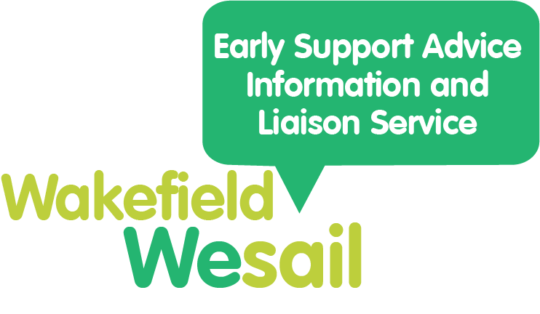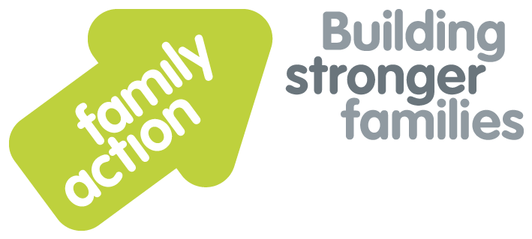

**You Said We Did**

 Here are the comments you have made from January 2023 – March 2023.

**You Said** is what you have told us needs improving.

**We Did** is what we are doing about that.

|  |  |
| --- | --- |
| **You Said** | **We Did** |
| You would like more information on mental health. | We have posted about mental health on our Facebook page. We will be updating information about mental health on the Local Offer website. |
| You would like more information on Preparation for Adulthood (PfA). | We have shared the PfA drop in sessions on our Facebook page and in our newsletter.  We will be sharing more information and services on PfA in future newsletters. |
| You would like more information on Short Breaks. | We have put information on Short Breaks in our Spring Local Offer Newsletter. |
| More support has been requested earlier | Submitted a successful bid to Supporting Families: Special Educational Needs and Disabilities Pilot Project which focuses on early help. |
| It would be good to have some groups that siblings could attend together for those with and without SEND. | Incorporated siblings’ groups into our year 2 successful short breaks innovation bid. |
| You asked for information on support available for deaf people | We shared this information in our Spring Local Offer Newsletter. |
| You said that sometimes the postcode search on the Local Offer website doesn’t give results | We have worked with the website hosts to resolve this issue. |

