REACH NEWSLETTER | 15 September 2025

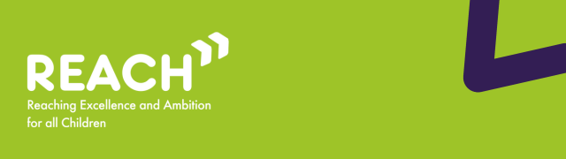

Welcome to the September edition of the REACh newsletter.
In this edition, you can find:
- Updates and latest activity from across the Change Programme Partnerships;
- Local Inclusion Support Offer (LISO): A Step Change in Inclusive Support;
- Feature: ’Lending Libraries:’ Thousands of children with SEND to benefit from assistive technology;
- Feature: What works in SEND report: ‘What does good look and feel like in co-production in SEND services?’;
- Feature: Emerging Insights from a call for evidence by Inclusion in Practice;
Best wishes,
Luke Evason-Browning
Council for Disabled Children

Reminder: What is the Change Programme and what is it trying to achieve?

The Change Programme involves 32 local areas undertaking a ‘test and learn’ approach to changes across their local system, collaborating in Change Programme Partnerships (CPPs) in each of the 9 regions of England. Originally set up to test reforms set out in the SEND and Alternative Provision Improvement Plan, in its current phase, the Change Programme is working with these local areas to test a range of programmes collectively to strengthen the inclusion support offered to mainstream settings.
Building on earlier phases, the programme now covers continued work on the use of Alternative Provision through a 3-tier model of interventions and extending the Early Language Support for Every Child pathfinders that are enabling earlier identification and intervention of speech, language and communication needs. In the extension, the Change Programme has strengthened links with two other existing initiatives from the DfE: Alternative Provision Specialist Taskforces (APST) and the Programme for Inclusion of Neurodiversity in Schools (PINS) so that more of the local areas can test these models. Change Programme local areas also have the opportunity to test Assistive Technology ‘lending libraries’ that give schools the ability to test the effectiveness of these tools for their students so that they can make best use of funds to meet need.
The Change Programme involves working collaboratively with local areas and alongside partners from health, education and social care, as well as parent carers, children and young people, recognising that the insights and expertise of all of these groups are key to creating any new system. The Change Programme also works in parallel with other DfE programmes and wider work that is happening in the SEND sector, such as the Family Help reforms and Ofsted’s curriculum and assessment review, acknowledging the significant potential that these changes and initiatives have to be complementary to the activity on the Change Programme as well as the learnings from it.
The Reaching Excellence and Ambition for all Children (REACh) consortium are the DfE’s delivery partner for the Change Programme. The REACh consortium are made up of PA Consulting, IMPOWER, Council for Disabled Children and Olive Academies. REACh support local areas to implement and learn from nationally and locally developed initiatives, whilst also capturing learning from these initiatives and disseminating this to other Change Programme Partnerships as well as the DfE.

Updates and latest activity from across the Change Programme Partnerships

With the return to school from the summer break, the Change Programme Partnerships have been planning and organising the support that they will deliver to children, young people and families for the remainder of the Change Programme. This now includes funding to sustain local initiatives until the end of the 2025/26 academic year.
The REACh team will continue to support Change Programme Partnerships to capture and share learning, as well as to plan for sustainability beyond the Change Programme, until our support comes to an end in March 2026.

Local Inclusion Support Offer (LISO): A Step Change in Inclusive Support

The Local Inclusion Support Offer (LISO) aims to provide a more accessible and inclusive offer for children and young people in their local area. This is supported by early findings from programmes that use the specialist workforce to upskill the education workforce, including Partnerships for Inclusion of Neurodiversity in Schools (PINS) and Early Language Support for Every Child (ELSEC).
The DfE will support areas to develop and test an ‘offer’ that will improve the capacity and capability in the system to better identify needs early on in mainstream settings and take a support first approach to meeting that need.
The LISO aims to deliver a more consistent, inclusive approach by prioritising early identification of need, effective use of specialist resources, and delivery of high-quality teaching across early years, primary and secondary settings. This approach involves local areas co-ordinating their existing services and specialists, enabling more collaborative and joined up working to identify and fill gaps in support.
An area’s LISO offer aims to bring a range of benefits, including:
- For children and young people: Faster access to the right support in the right place, and greater chances of remaining in mainstream settings, offering stability and reducing disruption to learning.
- For families: Clearer processes, greater confidence in the provision of SEND support at their child’s setting, and earlier support without a lengthy wait.
- For settings: More equipped to provide a more inclusive and accessible offer, with improved staff capability and confidence, and access to targeted or specialist support when needed.
The support offer in each local area will be shaped by local need and context, but as a minimum should comprise the following three core components:
- Training: Building and expanding on the training already available, setting staff will be upskilled in identifying and meeting a broad range of needs.
- Advice: Access to expert guidance and inclusive problem-solving approaches.
- Direct Delivery: Delivery of SEND support at both group and individual levels.
Crucially, the LISO represents a cultural shift towards embedding whole-setting inclusion, ensuring that every setting across the local area has access to high-quality, equitable support.
By testing and learning from this approach in the Change Programme local authorities, we will better understand how we can support and equip the workforce in early years and mainstream settings to provide a comprehensive, more inclusive and accessible offer for children and young people.

’Lending Libraries:’ Thousands of children with SEND to benefit from assistive technology

Thousands of disabled children and young people and children and young people with special educational needs (SEN) in England are set to receive enhanced classroom support due to a newly launched government pilot.
Announced on 27 June 2025 by the Department for Education and Minister Catherine McKinnell, the initiative will deploy up to £1.7 million across 32 local authorities, covering approximately 4,000 mainstream schools. The pilot aligns with broader SEND reform efforts intended to ensure schools can identify and support learners’ needs swiftly and effectively.
Central to the pilot are the ‘lending libraries’ of assistive technology, which will allow schools to trial a variety of devices before investing in them. Each library will stock technology including reading pens, speech-to-text dictation tools, and image-driven tablets for non-verbal pupils. This model allows schools to assess what truly works for their students, helping to avoid wasted spending. Early adopters have already reported strong results, with 86% of staff noting improved pupil behaviour and 89% observing increased confidence among disabled children and those with SEN.
Delivered in partnership with assistive technology specialists CENMAC, the pilot is scheduled for rollout in the 2025–26 academic year. Early next term, we will begin to see the impact these technologies will have on SEND pupils across England.

What works in SEND report: ‘What does good look and feel like in co-production in SEND services?’
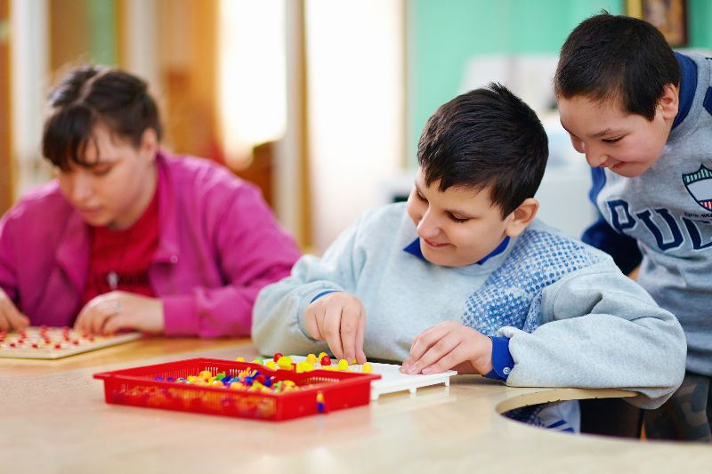
This new report from the What works in SEND (WWiS) programme aims to identify what good looks and feels like in co-produced services for disabled children and young people. It looks to inform future collaboration and innovation in SEND services, with further objectives including:
- Identifying facilitators of effective co-production.
- Identifying barriers to effective co-production.
- Providing examples of best practice in co-production, demonstrating how and why they are effective and conditions for effective implementation.
Exploring, evaluating and understanding the impact of co-production with children and young people and parent carers on the planning and reviewing of SEND services.
read more

Emerging Insights from a call for evidence by Inclusion in Practice
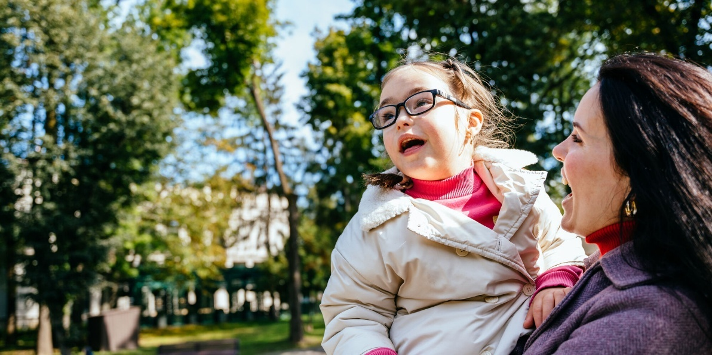
Following a national call for evidence to find examples of effective inclusive practice in mainstream schools, Inclusion in Practice and ImpactEd Group have published an emerging insights report.
The report details how several schools and trusts are successfully organising practice, professional development and resources to strengthen support for all children. Despite current challenges, the report identifies examples of promising inclusive practice already taking place in mainstream settings.
The report sets out five key emerging insights:
1. Knowing children well, early and often
2. High quality and evidence-informed teaching practice
3. Coherent, expert-targeted support
4. Strengthening inclusion through relationships and partnerships
5. Inclusion as a strategic and shared responsibility
Read more

Thank you
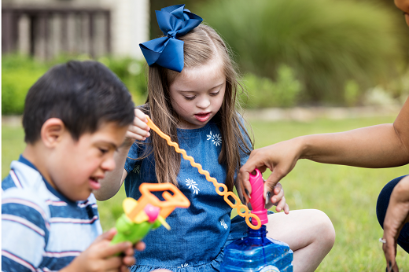
Thank you for reading this edition of the REACh newsletter. We will be back next month with more insights and information from the Change Programme.
If you would like to be first to hear about this or you know of anyone who would benefit from receiving updates about the Change Programme, please subscribe here.

