Wakefield SEND Local Offer

What is the SEND Local Offer?
The SEND Local Offer tells you things and helps children and young people aged 0 – 25.

It also helps parents, carers and professionals.
 |  | Every Local Authority must give what help they expect to be available in their local area.
Lots of different people contribute to the Local Offer.

These can be from education, health care, social care or be parents or young people.
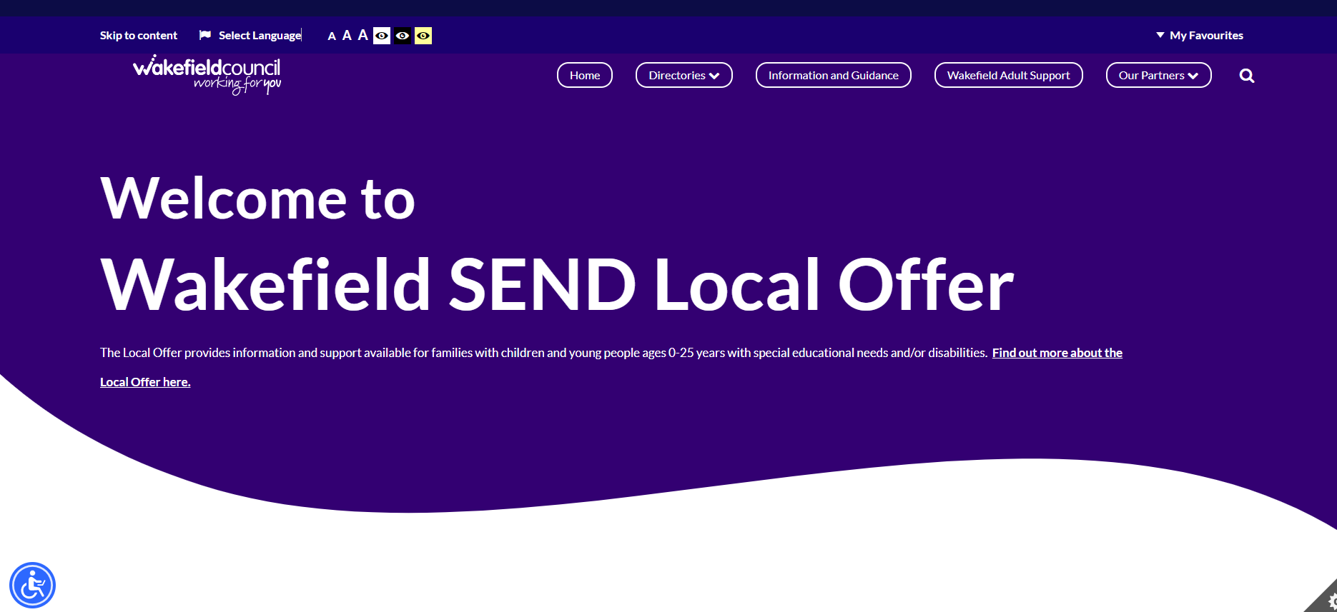 |  | The Wakefield SEND Local Offer website is where you can find all this information in one place.
What information does the SEND Local Offer have?
Education
- Education settings, e.g. schools
- Special provision
- SENDIASS
- EBSA
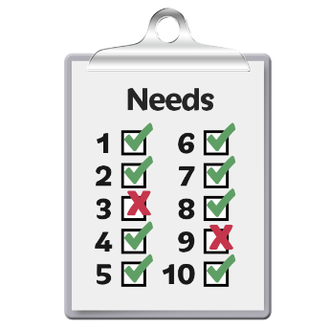 |  | Assessment Journey  - SEN Support  - ECHP  - Mediation, appeals and tribunals
Preparation for Adulthood
- Education and
employment
- Independent Living
- Health
Things to do
- Groups, charities, clubs
- Events
- SEND sessions
Money
- Financial support, grants,
- Benefits, discounts
- Personal budgets
Social Care
- Agencies, council provision
- Short breaks
Health
- Community services,
therapy, hospices
- Hospital services, NHS
(including physiotherapy, occupational therapy)
- CAHMs, speech and
language services
- Mental health
- Early Help
- Autism
- Feedback and response (You Said We Did)
How can I find information?
 | You can search using the search bar on the website.
You can look through the
directories to find an education provider, service or things to do.
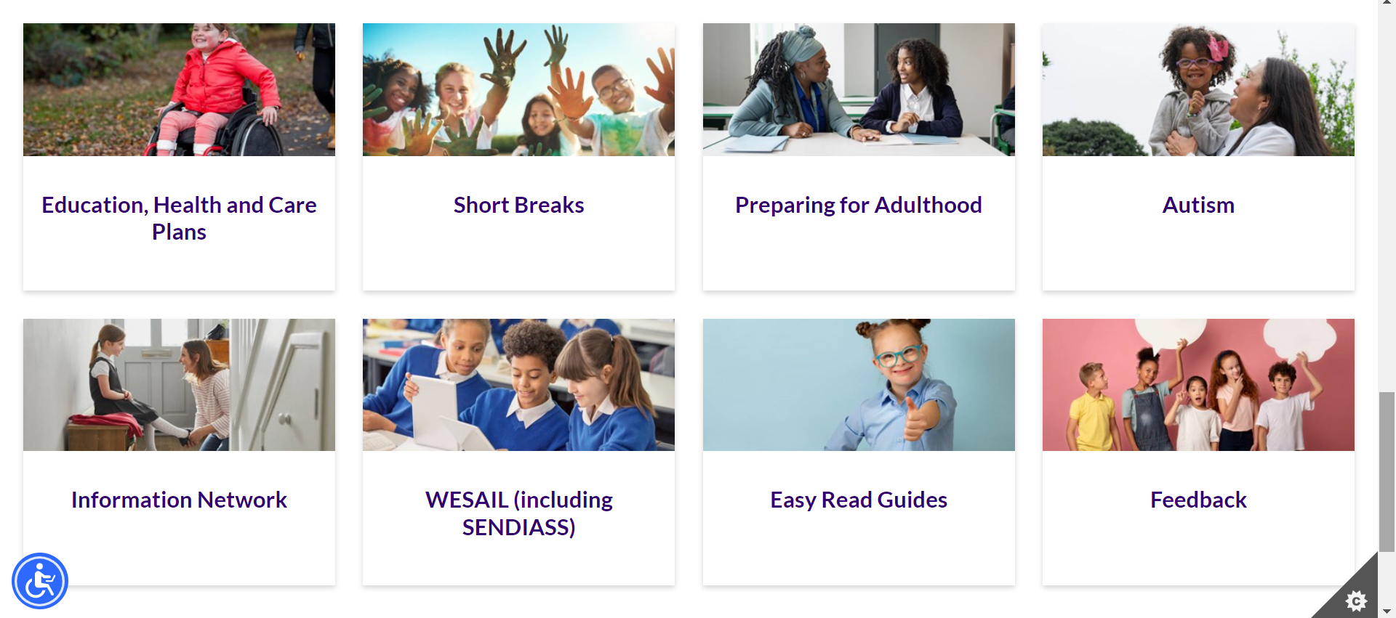 | You can scroll down the homepage to find key areas of information, e.g. autism, short breaks and EHCPs
You can look at the Information and Guidance section for
further topics, e.g., health
advice, Preparation for Adulthood, Newsletter, WESAIL and more.
How else can I get information?
A newsletter is made each term called ‘News & Views’.
It has articles about SEND
topics, updates from support groups as well as information that our service users ask for.

This newsletter is free to anyone who joins the Information Network (IN).

You can join the by completing the IN application form on the Local Offer website.

You can have the newsletter emailed or posted to you.
Are you on social media?
 | We have a Facebook page with the latest information.
 | We post several times each week with updates, useful links and information from different services.
 | We also post regular surveys so you can have your say.
Can I get involved?
 | Everyone can have their say about the SEND Local Offer.
If you would like to give ideas for how it can be improved, or other services you would like to see please contact:
wakefieldlocaloffer@family-action.org.uk

You can also tell us what you like and what works well!
 | You can find out more about feedback on the Local Offer website.
How can I contact you?
You can contact us by email:
wakefieldlocaloffer@family-action.org.uk

You can call and leave a
message on 01924 965588
You can write to us at:

Family Action WESAIL
Suite 6
Orion Office Express
Benton Office Park
5 Bennett Avenue
Horbury
Wakefield
WF4 5RA

Glossary
CAMHS – Child and Adolescent Mental Health Service

EBSA – Emotionally Based School Avoidance

EHCP – Educational Health Care Plan

IN – Information Network

NHS – National Health Service

SEND – Special Educational Needs and / or Disabilities.

Special Education Needs means you need help with learning.

A disability is a physical or mental condition that makes it hard to do things like walk, speak or see.

SENDIASS – Special Educational Needs and / or Disabilities Information Advice Support Service

WESAIL – Wakefield Early Support Advice and Information Liaison Service

If you need to ask any questions or for further advice, please email
wakefieldlocaloffer@family-action.org.uk

