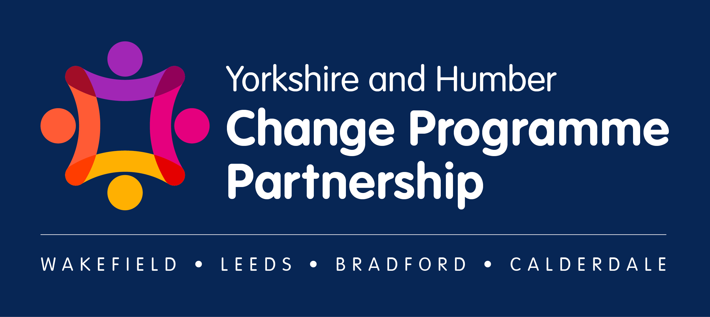

Yorkshire and Humber Change Programme Partnership (CCP) Highlight Report
Date of Report: | 03 November 2023
Reporting period: | 6/10/2023 – 3/11/2023
Progress Updates
- The Change Programme Partnership (CPP) first came together on the 6.10.23, and over the last 4-weeks have been collaborating to complete the Strategic Delivery Plan (SDP).
- Development of the Strategic Delivery Plan has happened across two in-person workshops, two-CPP working Groups, and activity outside of meetings to drive this work forward.
- The Strategic Delivery Plan (SDP) outlines how the Change Programme Partnership (CPP) will work together over the course of the Programme, in terms of:
- Key Stakeholders & Contacts
- Leadership Structures and Ways of Working
- Starting Positions and Funding Allocation
- Each Local Authority in the CPP and West Yorkshire ICB, have agreed to submit a first iteration of the Strategic Delivery Plan on the 6.11.23, which is the deadline set by the DfE.
- For Wakefield, Bradford, Calderdale and the West Yorkshire ICB, REACh (the DfE Delivery Partner) have facilitated local context calls, to understand the local context and starting points of these systems. A one-page summary has been drafted, agreed with lead contacts in the organisation and included in the ‘Starting Positions’ section of the SDP.
- Leeds local context section will be included in the second iteration anticipated to be submitted to the DfE the week commencing 13.11.23.
- Each Local Authority in the CPP has nominated someone to participate in the Community of Practice. This is facilitated by REACh and is one of the central mechanisms for sharing learning across regions involved in the SEND & AP Change Programme.
- Governance arrangements have been agreed as part of the SDP. The Steering Group membership has been established with formal virtual meetings taking place monthly and will remain under constant review through the embedding phase with recognition that extra ordinary meetings convened as required. Task and finish groups and workshops will be formed to undertake certain aspects of programme bringing in the required expertise depending on the particular focus. There are weekly programme meetings with Wakefield (the Lead Local Authority), the DfE and REACh.
- Agreement of this Highlight Report template and agreement to complete one after each CPP Steering Group. This will be circulated after each monthly meeting to a variety of audiences across the CPP.

Details of Meetings/Workshops/Task and Finish Groups
- Strategic Delivery Plan development workshops - ‘Task and Finish Groups’
Recognising tight timescales and half-term challenges, the SDP submitted on 6.11.23 had input from a representative group through two workshops and feedback via email:
  - Workshop 1 [25.10.23] – attendance included Calderdale, Leeds, Wakefield, School representative, post 16 representative, DfE and REACh
  - Workshop 2 [31.10.23] – attendance included Bradford, Wakefield and ICB representatives, Finance, DfE and REACh

- Local context calls
Detailed conversations have been held with each local area to understand local context and starting points. This has been used to develop a summary for the SDP and agreed by lead contacts in the Local Authority/ICB.
- Steering Group
The Steering Group has convened three times with the purpose of agreeing attendees and membership, discussing additional further representatives from Primary, Social Care and Children’s Social Care, PCF and Colleges. Finalising core membership and Leadership structures and finalising and agreeing the SDP.
  - Steering Group 1 – 8.9.23
  - Steering Group 2 - 6.10.23
  - Steering Group 3 - 3.11.23

- Weekly meeting with Wakefield lead contacts, DfE & REACh

  - 13.10.23 – 9-9:45am
  - 20.10.23 – 9-9:45am
  - 27.10.23 – 9-9:45am
  - 3.11.23 – 9-9:45am

- Wakefield Lead Local Authority Change Programme: Alignment Meeting/Session

  - 9.10.23 – 4-5pm

Programme Planned Activities for Next Month
- The SENDAP Leadership Partnership Structures outlined in local Terms of Reference, will be analysed against the Partnerships Guidance from the DfE in terms of good practice. To identify any gaps and discuss next steps with Local Authority leads to strengthen this further.
- Work to collaboratively develop/coproduce our Local Area Inclusion Plan (LAIP) in accordance with DfE guidance and templates.
- Comms plan and messaging for the CPP to be considered and finalised, to ensure regular and consistent communications with key stakeholders across the CPP. Including testing draft parent/carer comms with a parent carer forum and reviewing key messages for accessibility.
- Gaining access to Local and National Inclusion Dashboard developed by the DfE, beginning to test the use/usability and collecting initial feedback.
- Action planning around delivery of the wider reform programme over the medium-term future.
- Wakefield as the Lead Local Authorities - Change Programme: Alignment Meeting/Session on 30.11.23
- The next Steering Group to be held on 4.12.23
Key Learning
Partners in the Yorkshire and Humber Change Programme Partnership (CPP) have come together to have productive discussions and build on existing good relationships. The completion of the Strategic Delivery Plan is a positive outcome and demonstrates the strong commitment to move forward in a coherent way. Thanks were given to those who have taken part.
Risks, Barriers and Challenges
There is an on-going challenge to balance priorities and commitment, mitigations are in place to ensure capacity and support through specific task and finish groups and having delegated ownership to drive progress.
For further information please contact: acritchell@wakefield.gov.uk