When to Contact WESAIL Duty or the Local Offer
The Wakefield Early Support Advice Information Liaison (WESAIL) service a free service for children, young people, parents, carers and professionals. We offer confidential and impartial advice for on a range of matters relating to Special Educational Needs and or Disabilities (SEND).
As part of our contract, we provide the Special Educational Needs and or Disabilities (SENDIAS) service for Wakefield. We also do the SEND Local Offer in collaboration with our key partners.
Here is a guide on which part of the WESAIL service to contact.
WESAIL duty line | The Local Offer
wesail@family-action.org.uk | wakefieldlocaloffer@family-action.org.uk
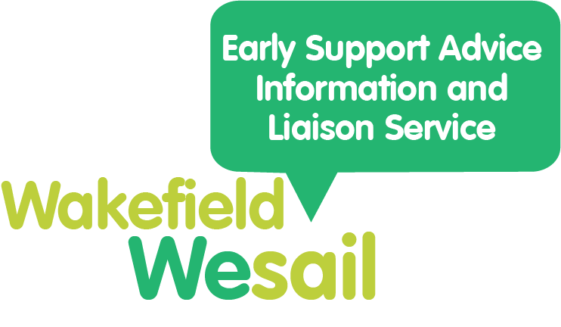
I need advice or information about education | I would like to ask about what is available on the Local Offer (education settings, services, things to do and information in and around Wakefield)
I need advice with legal matters around education (under the SEND Code of Practice) | I would like to add my service or activity to the Local Offer
I need support with reasonable adjustments for my child or young person | I would like contact details for a service or group
I would like advice on the EHCP process | I would like to provide feedback about the Local Offer
I would like information on annual reviews | I would like to suggest ideas for the Local Offer website, newsletter or Facebook page.
I would like advice on provisions within Wakefield | I would like to make amendments to information on the Local Offer
I would like advice on permanent exclusion, EBSA, mediations or tribunals. | I would like to know more about short breaks
I would like advice and signposting for my under 5 (please note eligibility criteria apply) | I would like to know what parent and carer support groups are available
I would like to know where to go for health or care support | I would like to know more about early help
 | I would like to know more about preparation for adulthood
 | I would like to know about personal budgets and direct payments
 | I want to read Wakefield’s SEND documents, such as reports, plans, pathways and strategies
 | I would like the Local Offer to share information about my service or group via the newsletter or Facebook

