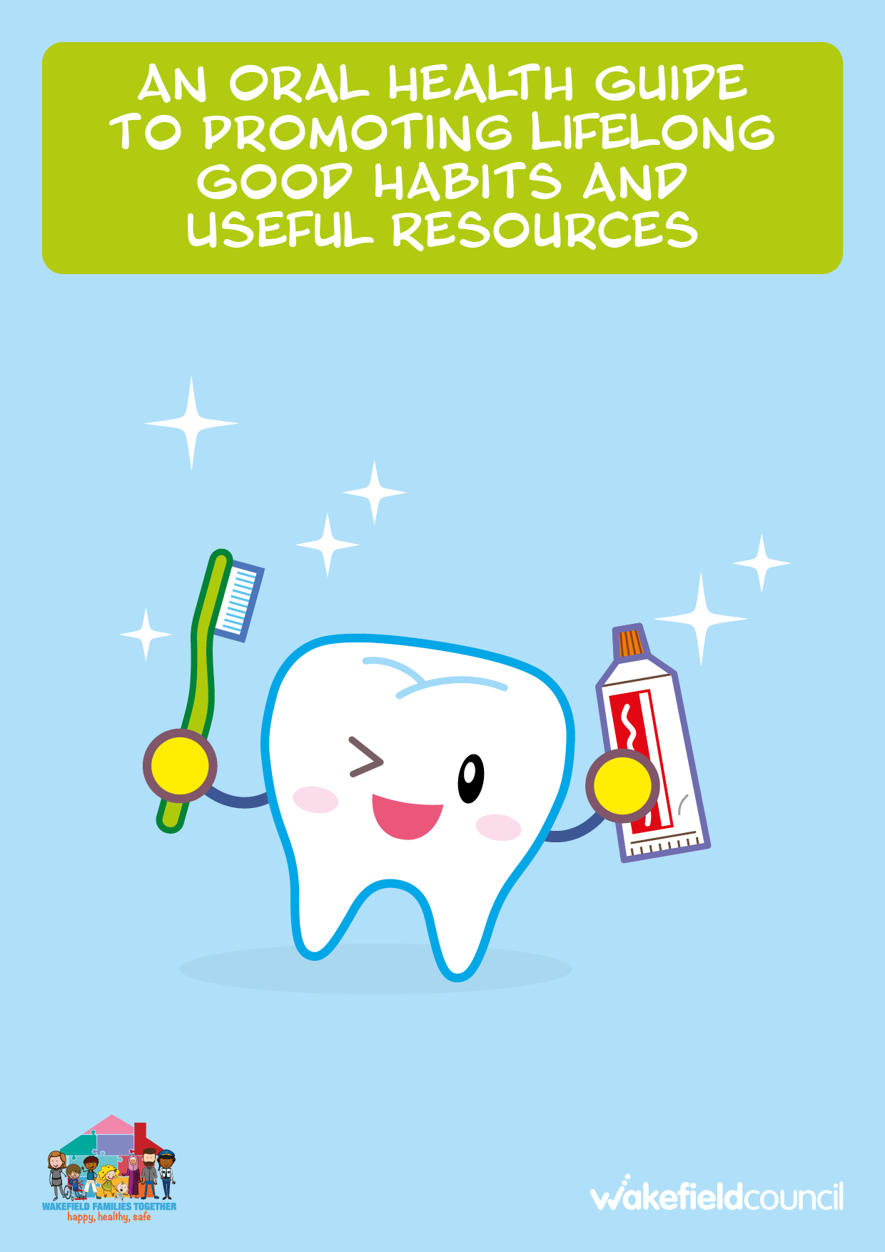

Contents
Introduction | Page 3
How to brush your child’s teeth | Page 4
Baby’s first year | Page 5-9
Toddlers and Pre-schoolers | Page 10-11
Infant School Age (4-7) | Page 12
Junior School Age (7-11) | Page 13
Secondary School Age (11-18) | Page 14
Busting Myths | Page 15-16
What to do if you or your child is scared of the dentist? | Page 17
Oral Health Resources | Page 18-21
Dental Health Resources in Wakefield | Page 22
Other useful Resources | Page 23

Introduction
Tooth decay is caused when bacteria in the mouth feeds on sugars from foods and drinks. This creates acid, which causes damaging holes in the teeth. Tooth decay may be prevented by:
- Reducing the amount and how often you eat sugary foods/drinks.
- Brushing teeth with fluoride toothpaste.
- Making regular trips to the dentist for check-ups and cleanings.
- Having fluoride vanish applied at the dentist

Taking care of your baby’s oral health should start when the first tooth starts to grow. Although these teeth fall out after a couple of years, they are extremely important as they hold space in the mouth for adult teeth to arrive. Bad oral health can cause numerous problems with your child’s health, such as eating, sleeping, communication, poor self-esteem or could be linked to even more serious chronic illnesses such as heart disease, diabetes, and respiratory diseases. Start creating tooth brushing habits with your children early so these habits will continue throughout their life. Having good oral health can protect your child’s teeth for their whole life.

This guide has been designed to help and encourage parents by providing access support to give a better understanding of positive oral health and why it is beneficial. It will provide parents and carers with knowledge and skills about their child’s oral health from birth to their teenage years, using useful information, tips, and resources to start building a routine with their child and achieve positive oral health goals.
Goal: The goal of this guide is to encourage parents to promote and role model positive oral health routines.

How to brush your child’s teeth
- Brush all surfaces of the teeth and gumline in small circles for about 2 minutes, just before bedtime and another time that fits with your routine.

- Children under 3 should use a smear of toothpaste containing no less than 1000ppm fluoride.

- Children aged 3 and over should use a pea-sized amount of toothpaste containing more than 1000ppm fluoride.

- Use a toothpaste containing 1350-1500ppm fluoride for maximum prevention. Most ‘own brand’ supermarket toothpastes are suitable and more affordable.

- Encourage the child to spit out the toothpaste.

- Do NOT rinse with water. Rinsing washes away the fluoride so it can’t do its job.

- The parent/carer should assist with brushing until the child is at least 7 years old.

- The parent/carer should sit the child on their knee or stand behind them and cradle their head while brushing.

- Here is video demonstrating how to brush your child’s teeth.

Baby’s first year
Parents and carers can ask any additional questions or find out extra information from your midwives, health visitors and nursery nurses.
Topic | Information | Useful Resources
Accessing dental care | - Free dental care will be provided to new mums for up to 12 months after birth.  - Adults should go to the dentist for a check-up at least once every 2 years.  - The dentist will advise on how often your child should have a check-up, but this will be at least once a year and often more frequently.  - Children should start going to the dentist with the rest of the family as soon as their first tooth erupts and before the age of one. By doing this, the dentist will become a familiar environment and your child will get to know the dentist. Dentists can provide advice and identify any oral health problems from an early age. | Enter your postcode to find a dentist Find a dentist - NHS (www.nhs.uk)  The Dental Check by One shows the importance of taking your child to the dentist before their first birthday and the benefits doing this may have.  Dental Check by One with Dr Ranj (CBeebies presenter)
Good oral health for good general health | - Good oral health is essential for general health and wellbeing.  - To care for your child’s oral health, it is important to know how to care for your own oral health.  - Children’s first teeth are just as important as adult teeth. Poor oral health behaviour will have a negative effect on both their teeth and gums.  - Tooth decay can cause pain and infection which may lead to sleepless nights, time off nursery/ childcare (for children) and time off work (for parents/carers).  - Therefore, if children have bad oral health, it can affect their ability to learn, thrive and develop. Good oral health contributes to school readiness and the prevention of school absence.  - Young children often need a general anaesthetic to have decayed teeth removed which can be an unpleasant experience and is not without risk.  - Baby teeth are important to guide the adult teeth into the right position. If they are lost early, the spaces for adult teeth can be lost, and they may come through crooked. | A practical guide to children’s teeth a guide for parents to take care of your child’s oral health throughout different stages of childhood.  A resource for parents, carers, and health professionals about looking after baby’s teeth in their first year
The Personal Child Health Record (red book) | - The ‘red book’ contains dental pages (Page 48) with useful information. You can ask your dentist to record it when your child visits the dentist. | Personal Child Health Record. Parents can keep a record of their child’s personal health, including oral health. Parents can take bring this book whenever they visit your midwife, dentist, school nurse and childminder for example.
Toothbrushing | - Start brushing your child’s teeth as soon as they start to come through.  - Brushing teeth removes plaque (a white sticky film, containing bacteria) which covers the teeth and gums). Brushing away the plaque keeps teeth and gums healthy.  - Use a baby toothbrush with a small smear of fluoride toothpaste.  - Don’t worry if you don’t manage to brush much at first, the important thing is to get your baby used to brushing their teeth as part of their daily routine. You can role model this behaviour by letting them watch you brush your own teeth.  - You should brush your child’s teeth for them rather than supervising.  - Make toothbrushing fun! | A video is provided on the NHS website showing parents how to brush their child’s teeth Looking after your baby's teeth - NHS (www.nhs.uk)  The Toothbrush Song from Hey Duggee (CBeebies)  How to care for the teeth of children aged 0-3 with Dr Ranj and Supertooth! (CBeebies presenter)  Growing up with Healthy Teeth video (from Henry)
Teething | - The first teeth that appear are usually the bottom front teeth around 5-7 months, followed by top front teeth. The baby should have 20 baby teeth by the time they are two and a half years old.  - Baby teeth sometimes come through with no pain or discomfort. Other times you may notice:  - Your baby’s gum is red and sore.  - One cheek is flushed.  - They are rubbing their ear.  - They are dribbling more than usual.  - They are gnawing and chewing on things a lot.  - They are more fretful than usual.  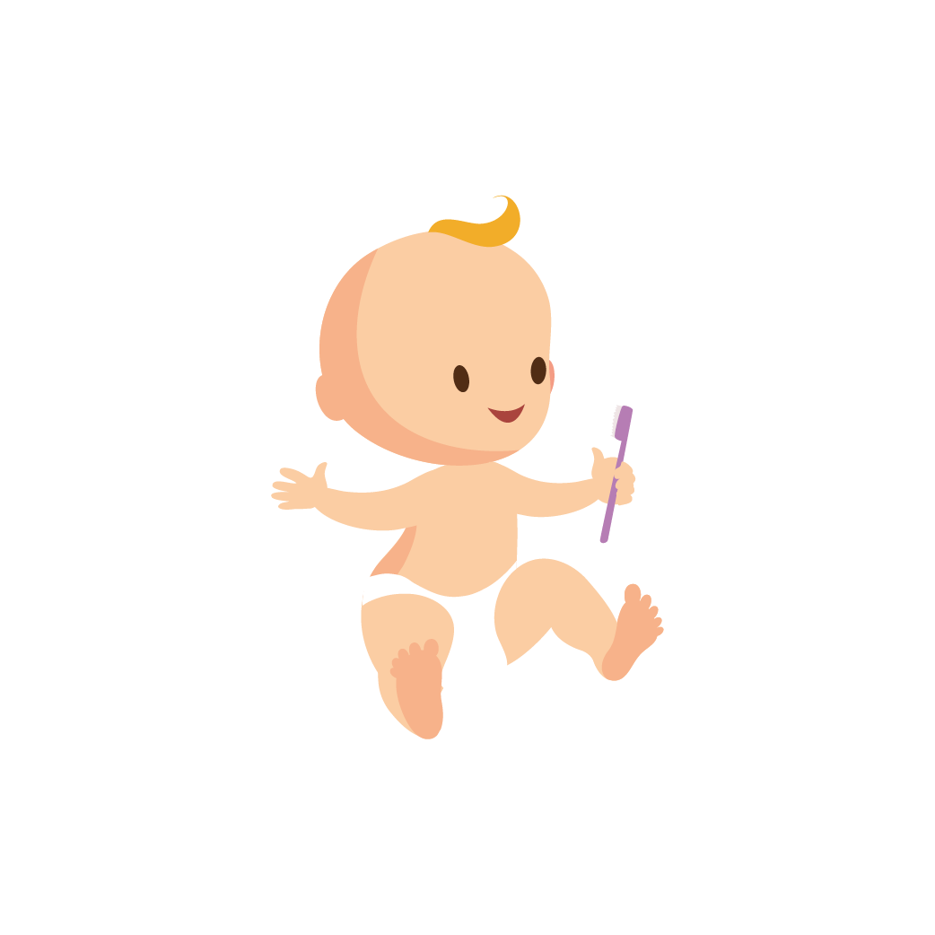  - Some people think teething can cause other symptoms, such as diarrhoea and fever, but there is no evidence to support this. Arrange for your baby to see a doctor if they seem unwell whilst teething.  - They may find it a relief to chew on something, such as a cold teething ring. Teething gels don’t usually help, but if you decide to use one, make sure it’s sugar free. Sugar free ibuprofen or paracetamol can be given to relieve teething symptoms in babies and young children aged 3 months or older. | Read tips on how to help your teething baby.  How to Soothe Your Teething Baby (pampers.co.uk)  Baby teething symptoms - NHS (www.nhs.uk)
Feeding baby and moving onto solids | - Plaque bacteria in the mouth feeds on sugar making acid which causes tooth decay. It is not just the amount of sugar, but how long and how often the teeth are in contact with sugar.  - The only safe drinks for teeth are plain milk and water.  - Breastmilk provides the best nutrition for babies and is the only food or drink they need for around the first 6 months of their life. Formula milk is the only suitable alternative for breastmilk.  - Breastfeeding for up to 12 months is associated with decreased risk of tooth decay.  - It is ok to use bottles for breastmilk, formula milk, or cooled boiled water.  - DO NOT put juices in bottles as this will bathe the teeth in sugar for long periods of time causing tooth decay.  - From 6 months old, you can offer babies drinks in non-valved free flowing cups (not a Sippy cup as this will require the child to suck like a bottle). Move from a bottle to a free-flow cup by 12 months.  - When your baby starts eating solid foods, encourage them to eat savoury food. Check if there’s sugar in pre prepared foods (including the savoury foods.) Rusks and baby drinks are not needed as part of a healthy diet and should be avoided.  - Avoid giving your baby biscuits, sweets, or dried fruit. However, if you chose to include them, they should only be eaten at mealtimes.  - You may see sugar written on food packaging using different words. Sucrose, glucose, dextrose, maltose, fructose and hydrolysed starch, invert sugar, syrup, honey, raw sugar, brown sugar, cane sugar, muscovado sugar and concentrated fruit juices are all sugars. Even if it is marketed as ‘natural’ or ‘organic sugar,’ it will be harmful to teeth.  - At bedtime or during the night, only give your child breastmilk, formula or cooled boiled water.  - If your child needs medicine, ask your pharmacist or GP is there’s a sugar free option. | Sugar: the facts  The benefits of breastfeeding - Baby Friendly Initiative (unicef.org.uk) – explains why breastfeeding is important for mum and baby. Includes resources to help mums who are breastfeeding.  Breastfeeding and dental health - GOV.UK (www.gov.uk) - Summary of the link between breastfeeding and positive oral health.  Wakefield - Families and Babies (FAB) – Supports mums with breastfeeding.  Healthy Eating Right from the Start video (from Henry).  The Food Scanner app from Change4Life can help you check how much sugar your family is having.  What To Feed Your Baby | Around 6 months | Weaning | Start for Life (www.nhs.uk)
Dummies and thumb sucking | - Using dummies or thumb sucking can cause the top and bottom front teeth to move and make space for the dummy/ thumb making a gap. Your child’s speech development can also be affected.  - It is fine to give your baby a dummy but avoid using them after 12 months.  - Discourage your child from running around, talking, or making sounds with a dummy or their thumb in their mouth and don’t dip dummies in anything sweet, such as sugar or jam.  - Never suck on your child’s dummy to clean it as you will spread germs between you and your baby. Keep plenty of spares instead. | Dummies - Better Health Channel – Information on dummies and the problems they can cause after the first year of your baby’s life.  Thumb sucking - Better Health Channel- Information on thumb sucking and the problems it can cause to your baby’s oral health.  How to Ditch the Dummy - Childcare.co.uk Fun ways to take the dummy away.

Toddlers and pre-schoolers
Parents and carers can ask any additional questions or find out any extra information from Health Visitors, nursery nurses and early year practitioners.
Topic | Information | Useful Resources
Toothbrushing | - See page 3 for ‘how to brush your child’s teeth.’  - Persevere even if the child is uncooperative. Brushing with fluoride toothpaste is more important than good toothbrushing techniques  - Each family member should have their own toothbrush to stop the spread of germs.  - Make toothbrushing fun using books, timers, reward charts etc.  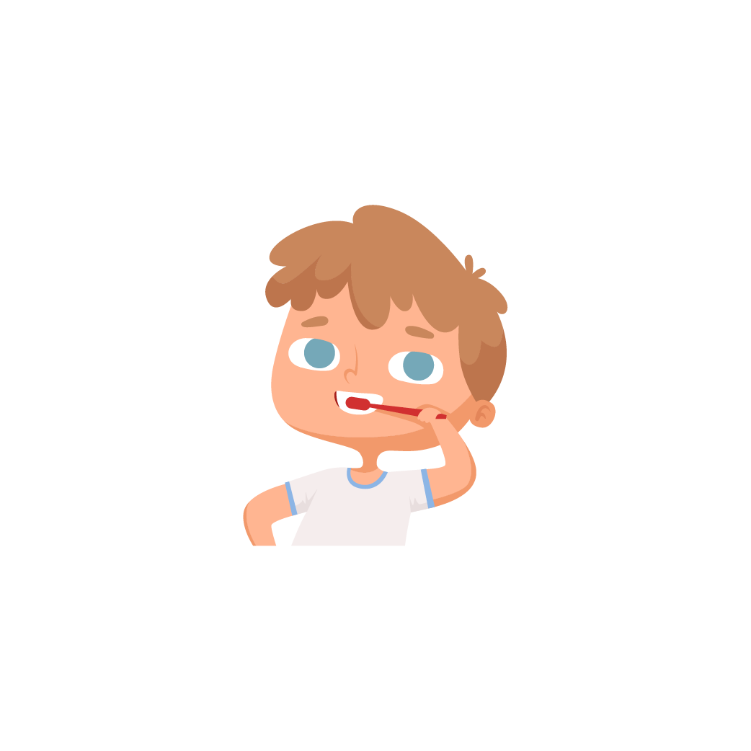  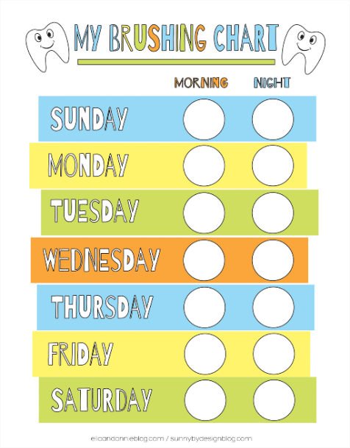 | Tooth Brushing Song by Blippi | 2-Minutes Brush Your Teeth for Kids - Bing video- Children are encouraged to brush their teeth for the length of the 2-minute song. Throughout the song, children are shown how to brush their teeth.  CBeebies | Something Special | Mr Tumble's Brush Your Teeth Song - Bing video  The Toothbrush Song from Hey Duggee (CBeebies).  How to care for the teeth of children aged 3-6 with Dr Ranj and Supertooth! (CBeebies presenter).  Growing up with Healthy Teeth video (from Henry).  A healthy mouth in children | Chalfont St Peter Dental Practice (chalfontdentist.co.uk):  Shine Time | Games | Health for Kids  Looking After My Teeth | Staying Healthy | Health for Kids  Brush DJ
Diet | Reduce the amount and how often your child eats food and drinks that contain sugar.  - Dilute, fizzy drinks, softs drinks and fruit juices sweetened with sugar do not need to be included in your child’s daily diet. If you do choose to give your child juice, dilute it to 1-part juice to 10 parks water and only give it with meals, not in between.  - Limit the amount of fruit juice and/or smoothies your child drinks to a maximum of 150 ml (one potion) a day and drink it with meals to reduce risk of tooth decay.  - Always ask for sugar free medicines. | Sugar: the facts  Healthy Eating Right from the Start video (from Henry)  The Food Scanner app from Change4Life can help you check how much sugar your family is having.  CBeebies | Something Special | Mr Tumble's Eat Our Greens Song! - Bing video  Encouraging Healthy Eating - Nurseries (kidsplaychildcare.co.uk)
Visiting the dentist | - NHS dental treatment is free for children under 18 or under 19 in qualifying full-time education  - Going to the dentist regularly helps children become familiar with the dental environment and enables the dentist to pick up on any problems as early as possible. | CBeebies: Topsy and Tim - Visit The Dentist - Bing video  Look here to find out who is entitled to free NHS dental treatment  Mr Tumble the Dentist - Bing video

Infant School age (4-7 years)
Parents and Carers can find out any additional information or any extra questions from teaching staff and school nurses.
Topic | Information | Useful Resources
Looking after teeth and gums | - Oral health is part of the National Curriculum in Key stage 1 Science and in Relationship’s education, sexual education (RSE) and health education.  - Tooth decay can cause pain, infection and sleepless nights which leads to time off nursery/school and time off work for parents. In Wakefield, each 5-year-old child has on average 0.7 teeth that are decayed (2015).  - Tooth decay is the most common reason for hospital admissions in the 6–10-year-old age group. | How to care for the teeth of children aged 3-6 with Dr Ranj and Supertooth! - Bing video  Shine Time | Games | Health for Kids  Looking After My Teeth | Staying Healthy | Health for Kids
Toothbrushing | - See page 3 for ‘how to brush your child’s teeth’ guide. | How do I brush my child's teeth? (6 months to 7 years) | NHS - YouTube
Diet and visiting the dentist | - Information from the toddlers and pre-schoolers is the same for 4–7-year-olds.  - The best food and drink for healthy teeth:  - Water  - Sliced carrots, peppers, and apples (scrapes away plaque and bacteria).  - Cheese.  - Low fat milk and yogurt (calcium)  - Oranges, strawberries, and kiwis (Vitamin C)  - Leafy greens and broccoli (Calcium and other nutrients)  - Eggs (Vitamin D and protein)  - Nuts and seeds (oils and fats that act as a forcefield against bacteria) | The Food Scanner app from Change4Life can help you check how much sugar your family is having.  CBeebies: Topsy and Tim - Visit The Dentist - Bing video
Junior school age (7-11 years)
Parents and carers can find out any additional information or any additional questions from teaching staff and school nurses
Topic | Information | Useful Resources
Looking after teeth and gums | - Oral health is part of the National Curriculum in Key stage 1 Science and in Relationship’s education, relationships and sexual education (RSE) and health education.  - Children’s permanent teeth start to erupt at around age of around 6 years and most of your child’s permanent teeth should have come through by the age of 12-14 years. | How to care for the teeth children aged 7+ with Dr Ranj and Supertooth! - Bing video  Shine Time | Games | Health for Kids  Looking After My Teeth | Staying Healthy | Health for Kids
Toothbrushing | - See ‘how to brush your child’s teeth’ guide on page 3. | Brush DJ - Toothbrushing App
Diet and visiting the dentist | - It will be harder to control what your child eats and drinks as the get older but hopefully they will already have got used to healthy eating.  - See page 11 for more information on your child’s diet.

Secondary school age (11-18 years)
Parents and carers can find out any additional information or any extra questions from teaching staff and school nurses.
Topic | Information | Useful Resources
Looking after teeth and gums | - It is important that as your child gets older, they start taking responsibility for their own oral health.  - If your child plays any contact sport, ensure they wear a professionally made mouthguard to protect against dental trauma.  - Discourage sports drinks.  - Oral health is part of the national curriculum in Key Stage 3 and 4 science, and Relationships Education, Relationships and Sexual Education (RSE) and Health Education. | mis11-024-gd-oral-health_teenagers-information-leaflet.pdf (nhsaaa.net) – Oral health advice for teenagers.  Teens' teeth - Oral Health Foundation (dentalhealth.org)
Toothbrushing | - Find information in Junior School age category.
Diet and visiting the dentist | - Discourage sports and energy drinks.  - See previous tables for more information. | Healthy eating for teenagers (wsh.nhs.uk)

Busting Myths
Myth | Advice
‘Baby teeth are not important because they will just fall out anyway.’ | - Your child’s first teeth are just as important as ‘grown up’ teeth. Poor oral health as a child will lead to poor oral health in adulthood.  - Baby teeth guide the adult teeth into the right position, if they are lost early, the spaces for adult teeth can be lost and teeth may come through crooked.
‘You only need to visit the dentist when there is a problem.’ | - You should take your child to the dentist as soon as their firth tooth begins to erupt. The dentist will also be able to spot any oral health problems early. Prevention is better than the cure!  - Children should have their first check-up by the age of one year.  - The dentist will advise you on how regularly your child needs to be seen.
‘I can’t control what my child eats when friends, family and childminders are caring for them.’ | - Gently set some ground rules, explain how you want your child to eat. For example, ask them to not give sweets as a reward for good behaviour but instead give a different reward such as stickers.  - Ensure that milk and water is given throughout the day rather than sugary drinks.  - Send your child with a packed lunch and different healthy snacks.  - If your child is staying somewhere else overnight, make sure to pack a toothbrush and fluoride toothpaste. Ask them to supervise your child when they are brushing their teeth.
‘My child can’t achieve positive oral health because they refuse to brush their teeth and eat healthy’ (non-compliant behaviour) | - As soon as the child’s teeth start to come though, start brushing their teeth and get them into a routine.  - Persevere even when child resits.  - Try make toothbrushing fun: Play a song whilst they brush their teeth, let them pick their own toothbrush (character toothbrush), educate them with fun books and videos, use a timer, leave a note from the tooth fairy reminding them to brush their teeth, reward charts.  - Brush your teeth at the same time as your child- role model behaviour.  - If your child still will not brush their teeth, there might be an underlying issue, such as sensitive teeth. Consider a trip to the dentist.  - There are lots of brushing apps to encourage brushing. For example, Brush DJ
‘I should rinse my mouth after brushing’ | - We should not rinse with water or mouthwash after brushing as it washes away the fluoride toothpaste away. If a mouthwash is used (generally in children over 8 years) it should be used at a different time, not after brushing.

What to do if you or your child is scared of the dentist?
Age | Advice | Links
6 months to 8 years | No one is born scared of the dentist, but as you grow up, you can learn to be scared of things, such as being afraid of the dark or spiders.  Children can easily read people making it very easy for parents to pass their fears to their children. If you predict that going to the dentist will be an unpleasant experience and you’re scared about how your child will react, an unhelpful cycle will occur. Here are a couple of things you can do to make the trip to the dentist easier:  1. Read a story together to help them prepare- Reading books about the dentist can prepare your child for what will happen and talking about it can make your child feel safe. A helpful book is ‘Pepper Pig: Dentist trip’  2. Avoid phrases such as “You need to be brave”, “You need to sit still” and “They’ll think you’re naughty.” This can add to your child’s stress and worry. | A guide for parents of children who are 6 months to 8 years, who are scared to visit the dentist.  Parents | LLTTF Dental  Help your child write a letter to the dentist so the dentist can talk to your child and build a relationship. Dental anxiety worksheet (llttf.com)  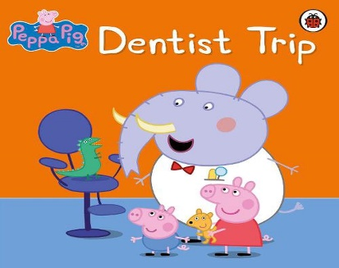
9 years to 16 years | Many people feel anxious about visiting the dentist. The resources linked will help you support your child to feel less worried when they visit the dentist. Use ‘SUPPORT’:  S- Show your child positive ways of coping when you visit the dentist together.  U- Understand and recognise your child’s needs.  P- Patience.  P- Promote new skills and teamwork.  O- Offer practical and emotional support.  R- Reward their efforts.  T- Talk about it. | A guide for parents of children who are scared to visit the dentist.  Parent of child 9-16 years | LLTTF Dental  ‘A message to the dentist’ activity sheet for young people.  Dental-Worksheet_2015.pdf (llttf.com)

Oral Health Resources
Fun videos to teach children about oral health
- Tooth Brushing Song by Blippi | 2-Minutes Brush Your Teeth for Kids - Bing video
- CBeebies | Something Special | Mr Tumble's Brush Your Teeth Song - Bing video
- The Toothbrush Song from Hey Duggee
- CBeebies: Topsy and Tim - Visit The Dentist - Bing video
- Mr Tumble the Dentist - Bing video
- Ceebies | Something Special | Mr Tumble's Eat Our Greens Song! - Bing videoB

Books
- For ages 0-2, Brush, Brush, Brush!
- For ages 2-4, Sesame Street, Ready, Set, Brush
- For ages 4-6, Sugar bug Doug: all about Cavities, Plaque and Teeth
- For ages 6-10, The Tooth Book, A Guide to Healthy Teeth and Gums

Apps/ games
Teach Kids Oral Care Habits With Disney Timer App | Oral-B (oralb.co.uk)
Brush DJ
Shine Time | Games | Health for Kids

Dr Ranj
- Dental Check by One with Dr Ranj (CBeebies presenter)
- How to care for the teeth of children aged 0-3 with Dr Ranj and Supertooth! (CBeebies presenter)
- How to care for the teeth of children aged 3-6 with Dr Ranj and Supertooth! (CBeebies presenter)
- How to care for the teeth children aged 7+ with Dr Ranj and Supertooth! - Bing video

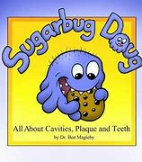
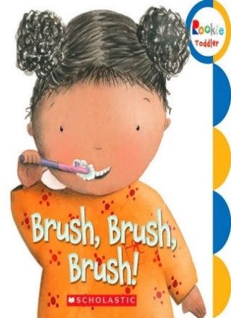
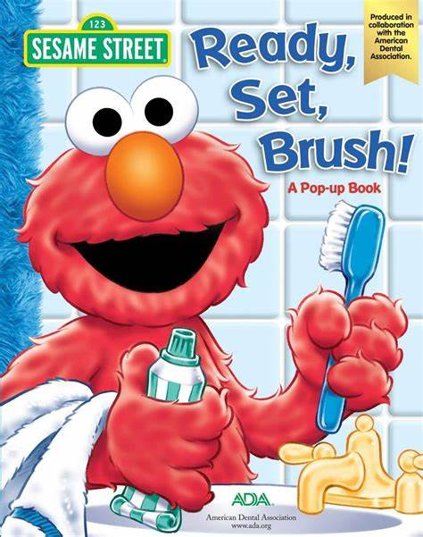
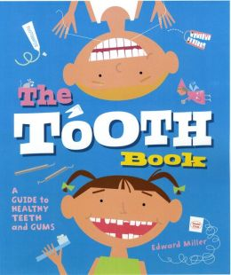

Resource | Key points/ topic’s covered
Healthy eating: Right from the start | HENRY | Part 1:  -Sitting, slowly, sociably.  -Limits are very important.  -You provide, they decide (be guided by signs of hunger and fullness)  -Let them feed themselves.  Part 2:  -Food is a family affair (balanced meals for the whole family.)  -Let babies try different kinds of foods.  -Balance different food groups from age of 1.  -Use hands as a guide for potion sizes.  -Involve children in planning and preparing of meals.  -Offer children choice between healthy alternatives.
Growing up with healthy teeth | HENRY | Part 1:  -3 meals and 2 healthy snacks a day.  -Introduce savoury foods when weaning before sweet foods such as fruit.  -Breast milk for as long as you and your baby want as it is the best protection for teeth.  -Only give milk and water to drink.  -Use free flow cups from 6 months and aim to stop using bottles by 12 months.  Part 2:  -Brush teeth 2x a day with fluoride toothpaste.  -Start as soon as the 1st tooth appears.  -Make it fun. It should last around 2 minutes.  -Spit don’t rinse.  -Have regular dental check-ups.
Institute of Health Visiting, 2015 provide a quick 3-page guide on how to protect your children’s teeth.  Childrens-Teeth-support-iHV.pdf (pacey.org.uk) | -Top tips for bushing.  -Fluoride toothpaste.  -Healthy eating.  -Visiting dentist.
Children's Oral Health - eLearning for healthcare (e-lfh.org.uk) | Takes 20 minutes to complete- Provides information and advice on oral health.
A parent’s guide to oral health and dental care for children with a learning disability, autism, or both  a_parents_guide_to_dental_care__web_single.pdf (contact.org.uk) | -Why dental checks are important.  -How the checks are done.  -How to access dental checks.  -How you can prepare and support your child.  -How to find out more.
Change4life  Be Food Smart - Breakfast - YouTube  Food facts - Healthier Families - NHS (www.nhs.uk) | Video:  -Highlights how much sugar is in our breakfast foods such as cereal.  -Use the smart food app to see how much sugar is in the food you are eating.  Website (Includes links to different pages such a):  NHS food scanner app, Healthier food swaps, Snacks, Sugar, Sugar calculator, Salt and Fat.
NHS Website  Looking after your baby's teeth - NHS (www.nhs.uk)  How do I brush my child's teeth? (6 months to 7 years) | NHS - YouTube  Baby teething symptoms - NHS (www.nhs.uk)  Children's teeth - NHS (www.nhs.uk) | -How to brush your baby’s teeth guide.  -How to brush your baby’s teeth video.  -Teething.  -Toothbrushing tips.
A parents guide to oral health and dental care for children with a learning disability, autism, or both.  a_parents_guide_to_dental_care__web_single.pdf (contact.org.uk) | -Why dental, hearing and eye checks are important  -How checks are done  -How to access dental, hearing and eye checks  -How you can prepare and support your child  -How to find out more
Videos from the Clinical Commissioning Group (CCG)  Mouth care for people with learning disabilities: Making Reasonable Adjustments (Dental Services) - YouTube  Mouth care for people with learning disabilities: Brushing your Teeth - YouTube | 1st video:  -How services can adapt to meet patient’s individual needs and better their dental experiences.  2nd video:  -How and when to brush your teeth.  -How parents can brush their child’s teeth.
National Smile Month digital guides.  Free Downloads | Oral Health Foundation (dentalhealth.org) | -Diabetes and Oral Health  -Pregnancy and Oral Health  -Autism and Oral Health  -Mental and Oral Health  -Deafness and Oral Health  -Blindness and Oral Health  -Sports and Oral Health
Oral Health Foundation Downloads and Resources  Downloads and Resources | Oral Health Foundation (dentalhealth.org) | -Free presentations, lesson plans and activities for children aged 3 to 11.  -Why do we have teeth?  -First visit to dentist.  -Food and Drink.  -Diet and Snacking.  -Our smile.  -Types of teeth.  -Anatomy of teeth.  -Looking after our teeth.  -Sugar and out teeth.  -Includes a comprehensive guide to help children with brushing their teeth.
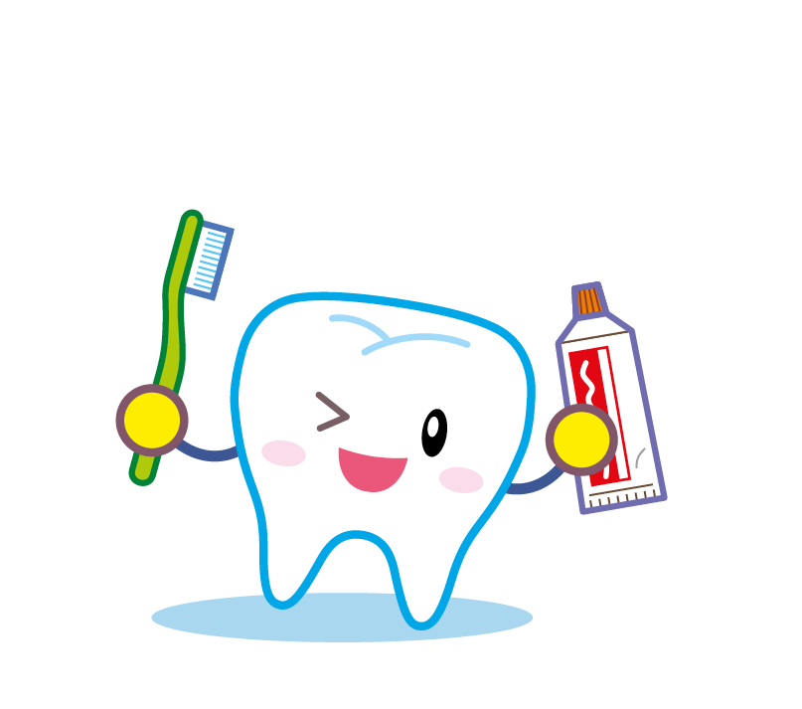

Dental Resources in Wakefield
Service | Contact details and information
Finding an NHS dentist | Find a dentist - NHS (www.nhs.uk)
Urgent Dental Care- Refers people who require dental attention within 24 hours.  -Severe dental and facial pain that can’t be controlled by over-the-counter medicine.  -Infection and swelling (which is not rapidly swelling around the throat or eye.) | Contact your regular dentist to arrange to be seen there.  If the dentist is closed or if you have no dentist, ring NHS 111 for advice.
Emergency Dental Care- Refers to people who require immediate attention in an A&E department.  -Uncontrollable dental haemorrhage (bleeding) following extractions.  -Rapidly increasing swelling around the throat or eye.  -Severe dental trauma should go to A&E when dental surgeries are closed. | Go straight to A&E to minimise the risk of serious medical complications and prevent any long-term medical complications.
Community Dental Services- Provides dental care for children and adults that are unable to access or receive routine dental care in a general practice. This is a referral only service, referrals can be made by general dental practitioners, doctors and other health professionals. | Community Dental Service | Mid Yorks

Other useful resources
Resource | What is it? | Telephone helpline | Website
Families and Babies (FAB) | FAB are based in Wakefield. They provide peer support services offering evidence-based information and support to help improve health and wellbeing within families. | 01924851901 | Wakefield - Families and Babies (FAB)
Wakefield Health visiting single point of contact | Open 9am-5pm. Families can speak with a health visitor for advice and support around feeding your baby. | 01924327591 | Single Point of Contact (SPOC) | Mid Yorks
Healthy Start | If you are more than 10 weeks pregnant or have a child under 4, you may be entitled to help to buy healthy food and milk. You’ll be sent a Healthy Start card with money on it which you can use for:  - Plain liquid cow’s milk  -Fresh, frozen, and tinned fruit and veg.  -Fresh, dried, and tinned pulses.  -Infant formula milk.  -Healthy start vitamins  -Vitamin drops for babies and young children. |  | Get help to buy food and milk (Healthy Start)
National Breastfeeding Helpline | Breastfeeding information and support available from 9:30 am to 9:30 pm every day of the year. | 03001000212 | National Breastfeeding Helpline – Helpline
The Mid Yorkshire Hospitals NHS Trust | Mid York’s community dental service provide a consultant led service for referred children and adults with special requirements who cannot be seen within the General Dental Service. |  | Community Dental Service | Mid Yorks

