[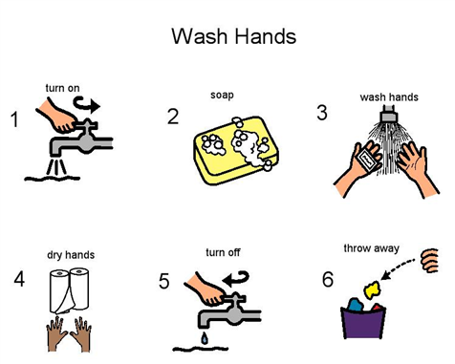](http://lifespantherapies.com/wp-content/uploads/2013/03/handwashing-visual-aid.bmp)