Thank you to all the parents and carers who contacted KIDS, WESAIL and Wakefield Parent Carer Forum to raise questions and concerns around Special Educational Needs and Disabilities during the current coronavirus situation.

To respond to these questions, they have been compiled and sent to Wakefield Local Authority and Wakefield Clinical Commissioning Group to respond to in partnership to help answer concerns and questions from parents.

We hope you find this helpful, in this ever changing situation. As time changes and there are further questions a new email box has been put in place for families to post new questions that we can collectively seek responses from partners.

If you have any further concerns please email enquires.wakefield@kids.org.uk

Parent Questions and Answers

- How can we contact the SEN team and other teams within children and young people’s specialist services?

SENART can be contacted via senart@wakefield.gov.uk as all staff are working from home and do not have work mobiles. The inbox is being monitored daily and messages will be passed onto staff via email and Skype.

The Educational Psychology Service can be contacted on 01924 307403 or by email EPS@wakefield.gov.uk. The EPS inbox is being monitored on a daily basis and messages passed onto relevant members of the team. Alison McCoy (Principal Educational Psychologist) can be contacted by email amccoy@wakefield.gov.uk
SENSS staff ( Learning Support Service (LSS) , Communication Interaction and Access Team (CIAT) , Social Emotional Mental Health team (SEMH ) and Children’s Sensory Impairment Team (CSIT) ) are all working remotely but can be contacted via the SENSS inbox which is regularly monitored - senss@wakefield.gov.uk

- Is my SENART worker currently at work?

At this moment in time all SEN Casework Officers remain at work albeit working from home and can be contacted via the process above.

- What will happen with my direct payments (personal budget) payments?

All EHCP funding streams are unaffected and payments will continue to be made. For specific enquires re short break direct payments please contact SEND Team on 01924 302410

- My child has an EHC plan and attends an independent school, are they remaining open?

Independent schools are applying the notices as per the Coronavirus Act 2020 guidelines. If a parent has a specific concern/query they can discuss this with the individual school or contact senart@wakefield.gov.uk and we will deal with the query.

All guidance can be found on the Gov.uk website and is updated regularly

- Can we request an EHC assessment for my child at the moment?

There has been no change to the legislation in terms of disapplication at this stage so a parent can still make an EHC assessment request. The parent would need to be advised on the fact that face to face assessments are not being carried out and, therefore, need to be aware of the impact of this on the reports received. Wakefield SENART are providing business as usual and are making all attempts to meet statutory timescales. Any changes that are brought about by the Secretary of State Powers to disapply the legislation entirely or modify the legislation will be shared.

- Can parent carers contact the Educational Psychology Service if they have concerns about their child's learning and or social/emotional wellbeing?

This is the advice that was provided by Alison McCoy, Principal EP on 31st March 2020:-
The EP Service can currently provide:
- Telephone consultations with parents/ carers and school staff in relation to children and young people already known to the EPS;
- Liaison/ guidance to school staff on managing anxiety relating to the current pandemic;
- Consultation support to consider organisational arrangements being made in relation to vulnerable children;

You can contact your school EP using their usual contact details. Alternatively, please contact the EPS on 01924 307403 or Alison McCoy (Principal Educational Psychologist) by email amccoy@wakefield.gov.uk

- Transitions – moving to high school all work that would have been done now to support child

This is a very difficult question to answer given that we are unclear on how or when the social distancing and “lockdown” guidelines are likely to last. The Department for Education have released a statement today that confirms that schools will remain closed until further notice for all except the children of critical workers and vulnerable children. It goes further to say that schools will only open when the scientific advice says it would be safe to do so.

Transitioning children are likely to be one of the priority groups when consideration is being given to reintroducing children to schools but this is an area we have raised as a concern to the DfE and I will update as soon as it is possible to do so. Our EP team are working on some guidance to be issued to schools to support arrangements.

- Child’s behaviours – both in terms of deterioration but also hearing of improved behaviour as anxiety of being in school not present at moment – however these parents worrying about when child has to go back to school

The answer to this question is very much in the same vein as Q7 and these cases will have to be dealt with on an individual basis. I will also add this as an area for discussion in Senior Leadership meetings. Our EPs are carrying out some planning around providing advice around this issue to ensure schools, children and young people and families will be supported

- Not being able to effectively follow EHCPs as limited resources/staffing
The Secretary of State has not yet applied any of the categories of notice that are referred to in the Coronavirus Act 2020 so consideration should still be given to the delivery of provision within the EHCP. We are working with schools and partners advising when possible work is provided to support outcomes in EHCPs. Parents should raise any concerns via senart@wakefield.gov.yuk

Helpful links to guidance
Interpretation of guidance Please see links below for national guidance for children and young people with SEND during the coronavirus

https://www.gov.uk/government/publications/coronavirus-covid-19-guidance-on-vulnerable-children-and-young-people/coronavirus-covid-19-guidance-on-vulnerable-children-and-young-people

https://councilfordisabledchildren.org.uk/help-resources/resources/covid-19-support-and-guidance

Benefit/money issues

https://contact.org.uk/advice-and-support/covid-19/coronavirus-welfare-benefits-money/

https://contact.org.uk/advice-and-support/covid-19/the-coronavirus-act/

Food deliveries/issues

If you need help getting food and supplies the government advises to ask family, friends and neighbours to support you and use online services. If this is not possible, then the public sector, business, charities, and the general public are gearing up to help those advised to stay at home.
You can visit https://covidmutualaid.org to see if there are any voluntary support groups in your area.

Managing Anxiety – please see information below to help support managing your family’s anxiety.

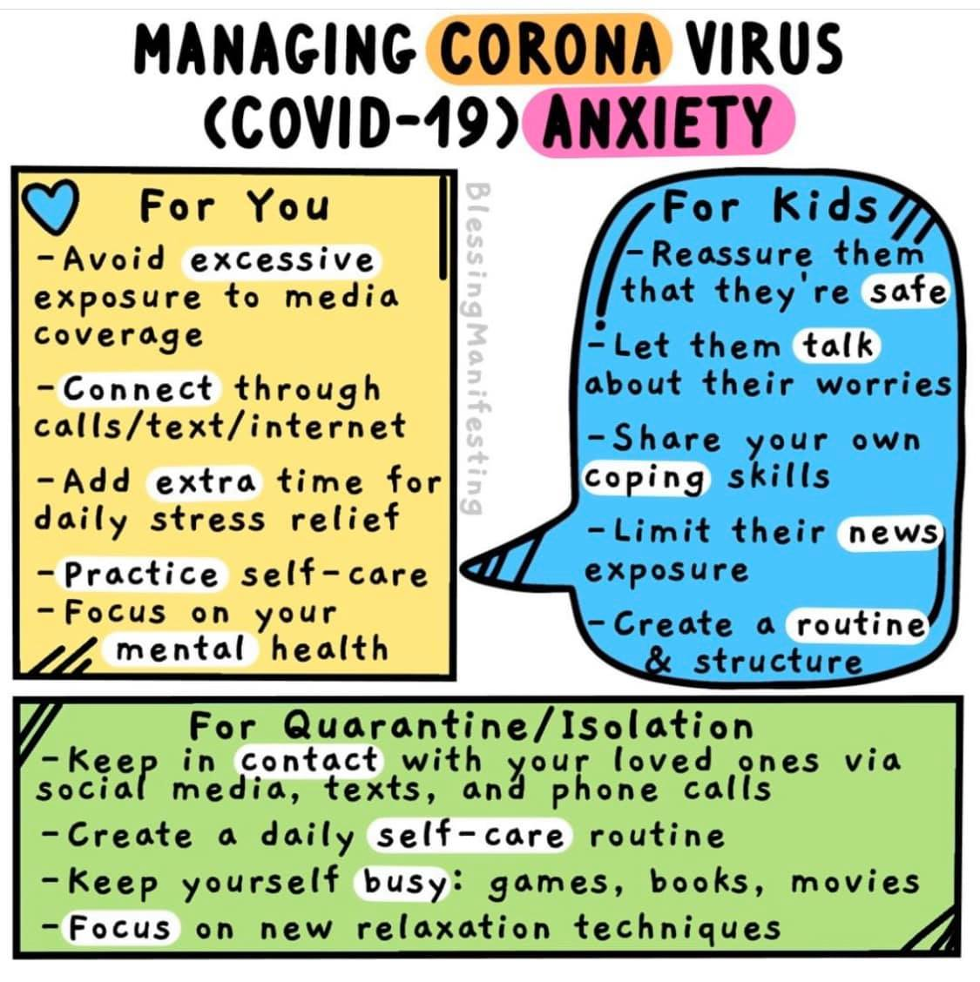

10 tips to help you if you're worried about the current situation:

- Stay connected with people
- Talk about your worries
- Support and Help others
- Feel prepared
- Look after your body
- Stick to the facts
- Stay on top of difficult feelings
- Do things you enjoy
- Focus on the present
Look after your sleep

https://www.nhs.uk/oneyou/every-mind-matters/coronavirus-covid-19-anxiety-tips/?WT.tsrc=Paid_Social&WT.mc_id=coronavirus-mh

Great resource on anxiety in autism

https://www.city.ac.uk/__data/assets/pdf_file/0010/466039/Anxiety-in-Autism-A5-guide.pdf

https://www.sunshine-support.org/covid-19-downloads

Every mind matters

The coronavirus (COVID-19) outbreak means that life is changing for all of us for a while, and you might be feeling stressed, worried or anxious.

But there's some simple things you can do to help you take care of your mental health and wellbeing during this time. We've pulled together a list of our top 10 tips - have a read

http://content.e.oneyou.nhs.uk/?XuJuZ8oz.s37jXEtlkLvFuYOYV7YMjLaX

THINK NINJA
As a direct response to the COVID-19 crisis we have updated ThinkNinja with specific COVID-19 content. This will bring self-help knowledge and skills to children and young people (10-18 years old) who may be experiencing increased anxiety and stress during the crisis.
https://healios.org.uk/services/thinkninja1

For continued local information and updates from Wakefield Metropolitan District Council please see links below.

Local Offer Home page -
http://wakefield.mylocaloffer.org/Home

Local Offer Coronavirus specific page –
http://wakefield.mylocaloffer.org/s4s/WhereILive/Council?pageId=5109

If you have any further concerns or questions please email enquires.wakefield@kids.org.uk

