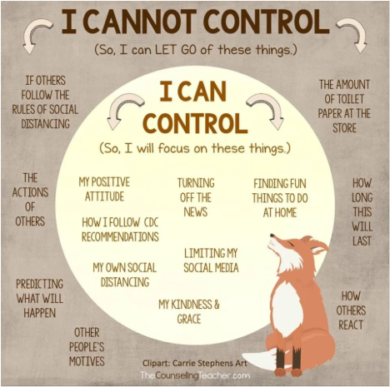
The Uncontrollable:
We have no control over many of the things we worry about. They will be the case even if you worry as hard as you can. With Coronavirus at the moment no one is quite sure what is going to happen and therefore worrying when you don’t know the outcome is easier to do as it enables the ‘what if’ questions to crop up.
Combat this by:
- Journaling- write down your thoughts and feelings. Don’t worry if it doesn’t make much sense, just the process of putting things on paper will help stop it going round. Limit yourself to once a day. When you find yourself worrying in between- tell yourself you will write that down when you journal. Tip- it doesn’t have to be lots of writing. Just words, spider diagrams or pictures work too.
- Look for the positives- Find a positive in each day and journal it. Or get the kids involved- sticky notes on the wall, a jar full of notes. It’s something to refocus on when things are a bit rubbish.
- Keep the conversation open- Kids worry too, let them talk and ask questions. Remember it’s ok to not know all the answers. Let them be creative too to get their worries out.
- Don’t get lost on the internet. There are so many different outlets online that are giving different advice. Watch the news once a day to keep up to date of changes and advice, but try avoid Facebook feeds and forums as these aren’t regulated and can cause worry. BBC News or the NHS sites are best and are all you need.

- Keep Connected – Use phone call, text, video calls to stay in touch with those closest to you. with friends, family and neighbours. Keep in contact via text, calling, emailing and video-call. Get creative and involve the children, get them to write letters or draw pictures to send to loved ones or even care homes or people that might be isolated.
- Get fresh air everyday- even if its just opening a window. Listen to the sounds outside if you are feeling anxious, get the kids outside to play or have a picnic at lunch. Being outside and perhaps practising some mindfulness or just quiet time will help to calm down your body and your mind if it is feeling stressed.
- Celebrate the small wins- It is ok not to be perfect!!! No one is! (As much as social media will have you believe!) Celebrate the moments of fun, good behaviour, good listening, helping each other and be kind to yourself when it doesn’t go to plan. It’s ok! This is a learning curve for all of us and we all need time to adjust.

