Covid-19 Emotional Well-being Toolkit

Information for children about corona virus:
Video by Newsround doctors answering questions from children about the Covid-19.
https://www.bbc.co.uk/newsround/51861089

A workbook to complete / read together with children up to 7 years which explains Covid-19. It is available on the website in many different languages.
https://www.mindheart.co/descargables

Looking after yourself as a parent:
The Good Thinking website developed by the Healthy London Partnership provides a range of useful guidance and online apps to support mental health and wellbeing. This resource is funded and endorsed by the NHS and is focused on supporting cognition, anxiety and low mood.
https://www.good-thinking.uk

The World Health Organisation (WHO) have created a list of mental health considerations during Covid-19 this can be accessed here
The mental health charity MIND have recently published advice and guidance about anxiety and mental health during the Covid-19 pandemic this can be accessed here

The British Psychological Society have also updated their website with a number of resources relating to Covid-19 which can be accessed here

If you are working from home it is important to consider both your mental and physical health and wellbeing. Physical wellbeing including taking appropriate breaks and regularly moving is especially important. This website provides a desk-excise routine you can do to help your posture and wellness if you are indoors here

Tips for being at home with your family:
- organise social get together on line. Virtual coffees and chat for adults and play dates for children. Apps such as “house party” let you video chat with up to 20 people at a time

- have a good list of Netflix, amazon prime and film recommendations to help pass the time and unwind in the evenings and at weekends

- have some relaxing hobbies / list of jobs you want to get done around the house; it will feel good to get one checked off every so often whilst you are at home

- if able do try and get outdoors for a walk or a run even for just a few minutes at least a couple of times a week this will help maintain your mood

- https://www.cosmickids.com/
online yoga and relaxation for all the family to do together

- If both parents are working from home negotiate a routine where you can share the child care responsibility throughout the day to allow you each to work during the day. Try shifts in 2 hour stints or morning / afternoon sessions where you swap roles working or parenting.

- Try to keep some sort of routine to keep weekdays feeling different to weekends- you might consider a routine like this for your weekdays:
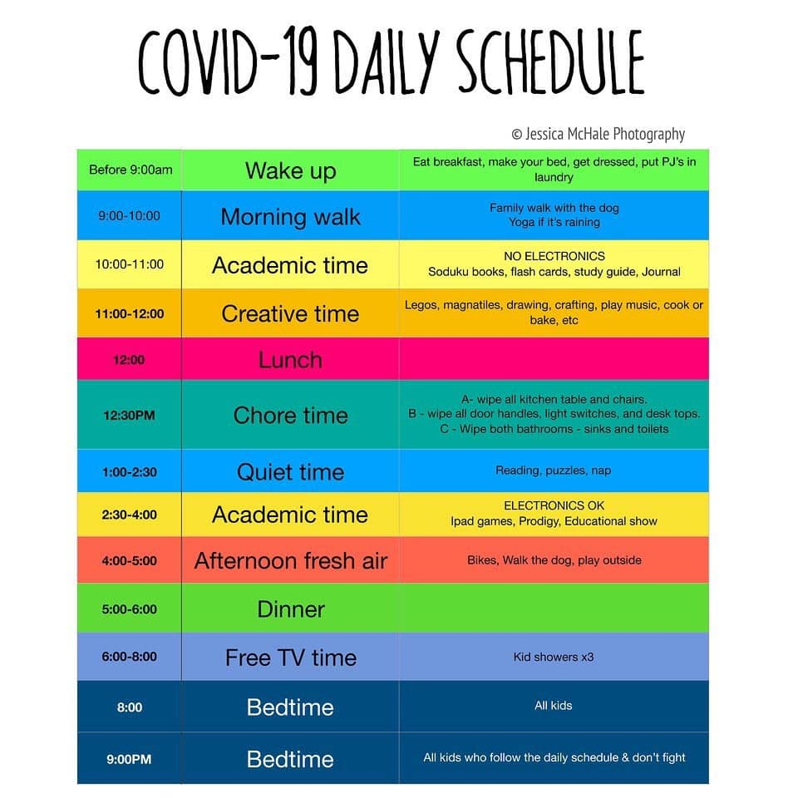

Things to do with your children at home:
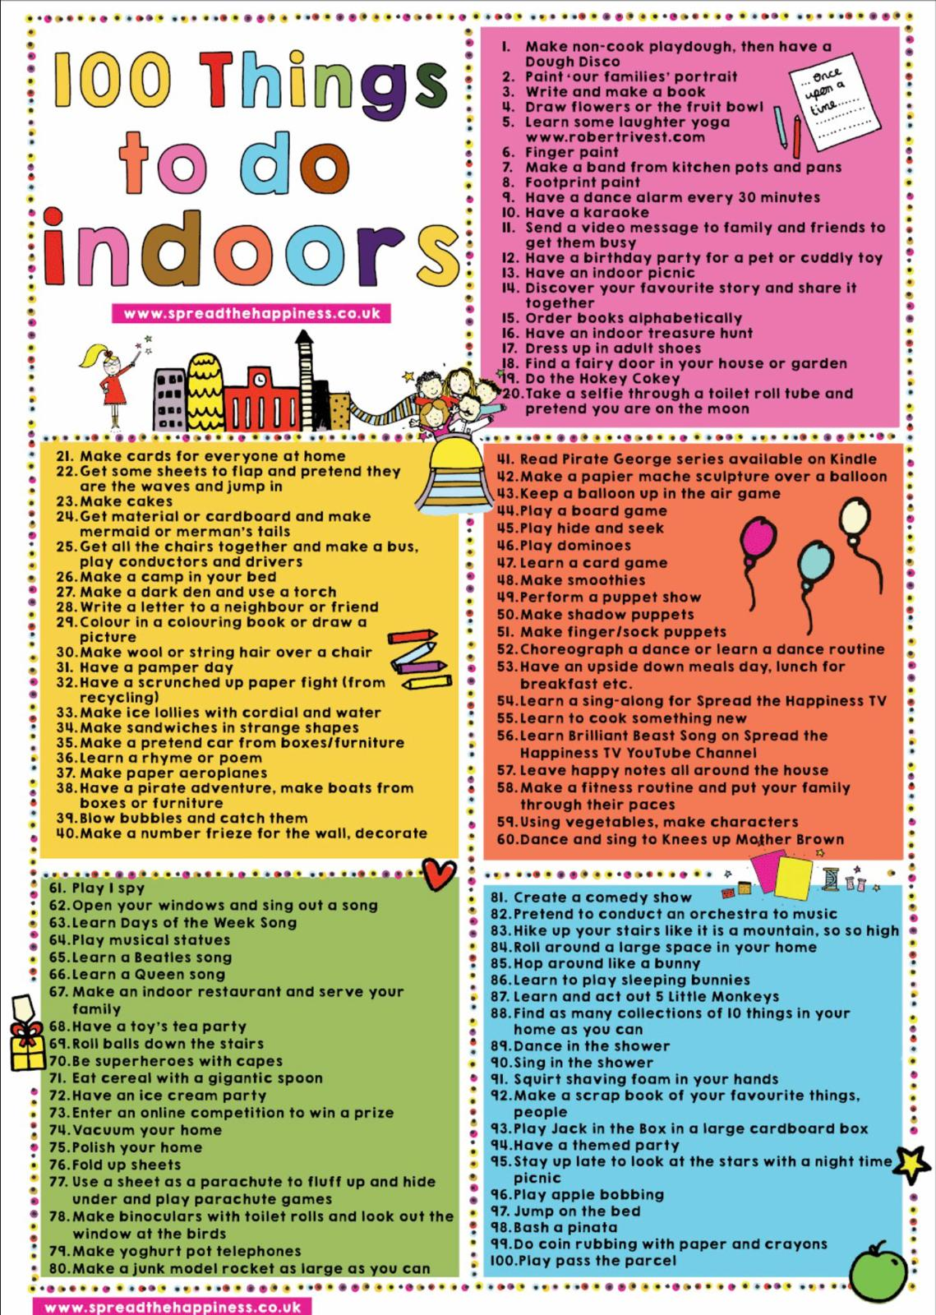
Educational resources for children:
Many of these links have been tested but not all but they do come from reliable sources. There are lots of free on line resources you can access which will enable you to support your child’s education whilst at home and also help provide structure and variety in your day. Do remember to spend some time away from computers and screens during each day! Many of these links will give you ideas and resources to do away from the computer with your children.

GENERAL
*Scholastic has created a free learn-from-home site with 20+ days of learning and activities.
https://classroommagazines.scholastic.com/support/learnathome.html

*This is the awesome free curriculum that we use. Everything from preschool activities to 12th grade is here!
https://allinonehomeschool.com/

*List of thinking games by grade:
https://allinonehomeschool.com/thinking

Lots of learning and crafts / resources with Dr Seuss character
https://www.seussville.com/

https://www.abcya.com/
https://www.funbrain.com/
https://www.splashlearn.com/
https://www.storylineonline.net/
https://www.turtlediary.com/
https://www.e-learningforkids.org
http://www.sheppardsoftware.com/
https://www.primarygames.com/
https://www.bbc.co.uk/bitesize/collections/primary-games/1
https://www.education.com/games/
https://www.learninggamesforkids.com/
https://pbskids.org/games/
https://mrnussbaum.com/
https://kids.nationalgeographic.com/games/
https://www.poptropica.com/
https://www.funbrain.com/

Oxford Owl for Home
www.oxfordowl.co.uk/for-home/
Lots of free resources for Primary age

ENGLISH
https://www.spellingcity.com/spelling-games-vocabulary-games.html
http://www.funenglishgames.com
https://pbskids.org/wordgirl/games/
https://www.gamestolearnenglish.com
https://www.hello-world.com/languages.php/?language=English

pre school and reception years
http://www.literactive.com/Home/index.asp
on line short books
https://www.uniteforliteracy.com/

Reading aids for younger children
https://www.starfall.com/h/

MATHS
https://www.topmarks.co.uk/maths-games
https://pbskids.org/games/math/
https://nrich.maths.org/
https://www.mathplayground.com/math-games.html
https://mathpickle.com/
https://www.coolmath4kids.com/
http://www.mathgametime.com/

Prodigy Maths
www.prodigygame.com
Is in U.S. grades, but good for UK Primary age.

SCIENCE
https://littlebinsforlittlehands.com/science-experiments-and-activities/
https://www.steamsational.com/science-experiments-for-kids/
https://www.turtlediary.com/games/science.html
http://www.sheppardsoftware.com/science.htm
https://www.learn4good.com/games/scienceforkids2.htm
http://www.sciencekids.co.nz/
https://www.switchzoo.com/

Mystery Science
https://mysteryscience.com/
Free science lessons

Crest Awards
www.crestawards.org
Science awards you can complete from home.

Academy
www.khanacademy.org
Especially good for maths and computing for all ages but other subjects at Secondary level. Note this uses the U.S. grade system but it's mostly common material.

Futurelearn
www.futurelearn.com
Free to access 100s of courses, only pay to upgrade if you need a certificate in your name (own account from age 14+ but younger learners can use a parent account).

Seneca
www.senecalearning.com
For those revising at GCSE or A level. Tons of free revision content. Paid access to higher level material.

Openlearn
www.open.edu/openlearn/
Free taster courses aimed at those considering Open University but everyone can access it. Adult level, but some e.g. nature and environment courses could well be of interest to young people.

Blockly
https://blockly.games/
Learn computer programming skills - fun and free.

Scratch
https://scratch.mit.edu/explore/projects/games
Creative computer programming

Ted Ed
https://ed.ted.com/
All sorts of engaging educational videos

Big History Project
www.bighistoryproject.com/home
Aimed at Secondary age. Multi disciplinary activities.

National Geographic Kids
www.natgeokids.com/uk/
Activities and quizzes for younger kids.

Duolingo
www.duolingo.com
Learn languages for free. Web or app.

The Kids Should See This
https://thekidshouldseethis.com/
Wide range of cool educational videos

Crash Course
https://thecrashcourse.com/
You Tube videos on many subjects

Crash Course Kids
https://www.youtube.com/user/crashcoursekids?app=desktop
As above for a younger audience

iDEA Awards
https://idea.org.uk/
Digital enterprise award scheme you can complete online.

Paw Print Badges
www.pawprintbadges.co.uk
Free challenge packs and other downloads. Many activities can be completed indoors. Badges cost but are optional.

Tinkercad
www.tinkercad.com
All kinds of making.

Cbeebies Radio
www.bbc.co.uk/cbeebies/radio
Listening activities for the younger ones.

Nature Detectives
https://naturedetectives.woodlandtrust.org.uk/naturedetectives/activities/
A lot of these can be done in a garden, or if you can get to a remote forest location!

British Council
www.britishcouncil.org/school-resources/find
Resources for English language learning

BBC Learning
www.bbc.co.uk/learning/coursesearch/
This site is old and no longer updated and yet there's so much still available, from language learning to BBC Bitesize for revision. No TV licence required except for content on BBC iPlayer.

Geography Games
https://world-geography-games.com/world.html

Blue Peter Badges
www.bbc.co.uk/cbbc/joinin/about-blue-peter-badges
If you have a stamp and a nearby post box.

Arts and Crafts Ideas
The Artful Parent
www.facebook.com/artfulparent/
Good, free art activities

Red Ted Art
www.redtedart.com
Easy arts and crafts for little ones

The Imagination Tree
https://theimaginationtree.com/
Creative art and craft activities for the very youngest.

Toy Theatre
http://toytheater.com/
educational games for younger children

DK Find Out
www.dkfindout.com/uk
Activities and quizzes

Twinkl
www.twinkl.co.uk
This is more for printouts, and usually at a fee, but they are offering a month of free access to parents in the event of school closures
Culture
Wind in the Willows west end production – on line streaming
https://www.whatsonstage.com/london-theatre/news/wind-in-the-willows-coronavirus-stream-free_51205.html?utm_source=facebook&utm_medium=email&utm_campaign=17march2020
Pretend to travel the world. Go on a virtual tour of these 12 famous museums.
https://www.travelandleisure.com/attractions/museums-galleries/museums-with-virtual-tours

Other Online resources:
- BrainPop
- Curiosity Stream
- Tynker
- Outschool
- Udemy
- iReady
- Beast Academy (Math)
- Creative Bug
- Discovery Education

YouTube Channels:
- Crash Course Kids
- Science Channel
- SciShow Kids
- National Geographic Kids
- Free School
- Geography Focus
- TheBrainScoop
- SciShow
- Kids Learning Tube
- Geeek Gurl Diaries
- Mike Likes Science
- Science Max
- SoulPancake

Do enjoy your time at home together

