COMPLEX CARE NEEDS TEAM – BULLETIN No.2

Covid-19
Hello! We have made the decision to continue with a bulletin to keep families updated with the progress being made, and also to provide any additional support and ideas which will help meet the needs of children with complex care needs! We aim to try and provide creative ideas to engage children in a range of activities.
You should have already been contacted by your social worker to discuss your family circumstances.
Your social worker will have agreed what level of contact you would like. We aim to speak to most families weekly as we are aware family situations will alter depending on whether anyone becomes ill or depending on changing Government advice.

The Complex Care Needs Team will continue to be working and are contactable daily. Monday- Thursday 8.30 – 5.00 and Fri 8.30 – 4.30 tel. 01924 302124. Individual Social workers will share their contact details with you.
Explaining Corona Virus to your children
We understand that trying to explain what is going on to your child, can be quite difficult! Here are some Top Tips to help!

TIP #1 – Stay up to date with the latest Advice
Before you talk to your child(ren), make sure you know what the latest news and guidance is about the corona virus. There can often be a lot of fake news! Therefore it is best to stick to the source which we can trust, for example the NHS website or the Government Website.

Tip #2 – Don’t be afraid to bring it up
You may feel like your child is unaware of what is going on. But just because they haven’t brought it up, or asked, doesn’t mean that they are not thinking about it, or worried. More often than not, children are aware of changes in their routines, and the people who are supporting them on the day to day basis, therefore if this has changed, they may want to understand why!

Tip #3 – Choose a calm moment
Pick a moment when your child isn’t stressed, in a hurry or hungry! Also when you when you are able to talk about things properly. Remember that children might be scared initially, so it is important to provide emotional support by hugging the child. It is okay for them to know that you are worried, however try not to let them see you panic! That way they can see that any worries can be managed. It might help for you to talk to someone about any worries you might have before you speak to them.

Tip #4 – Think about how much they need to know
Talking to you child depends on how old they are! You know your child best, so only explain as much as you think they need to know. If you have more than one child, what you say to older children may be different to those who are younger. Maybe remind the older child to look after the younger ones and all think together about how to manage any worries.
Tip #5 Listen to their concerns
Be careful not to dismiss anything they’re worries about. They may understand better than you think and their concerns will be real. Calmly reassure them that it’s okay to be worried, but for most people the illness is mild. Keep information, simple and factual. Remind them that everyone has had colds and they have recovered!
Tip #6 – Tell them how they can help!
Make sure they understand the importance of washing hands, and doing this is fighting the virus! Helping keep other people safe. This should be done for 20 seconds, for example singing happy birthday twice! Give them praise for doing this. There are also a lot of funny videos online of children and adults washing their hands, some celebrities have provided videos which are funny of them singing whilst washing their hands!

Tip #7 – Try not to avoid difficult questions
If they are worries about relatives or friends, ignoring their worry doesn’t mean it will go away! Let them know that you are also thinking about them, and explain that everything you are doing is help keeping loved ones safe! If possible do video chats with these people! However, don’t make promises that can’t be kept. Do let them know that the people they love also have support, so they do not need to feel responsible.

Tip #8 – Make sure they know you’re there for them Let them know that you are happy to talk to them about anything. Remind them of things they can do if they get scales, this could be games, story books, films or even a hug!

Tip #9 – Let them know about the good news
Talk about positive things, for example kind things people are doing in this time
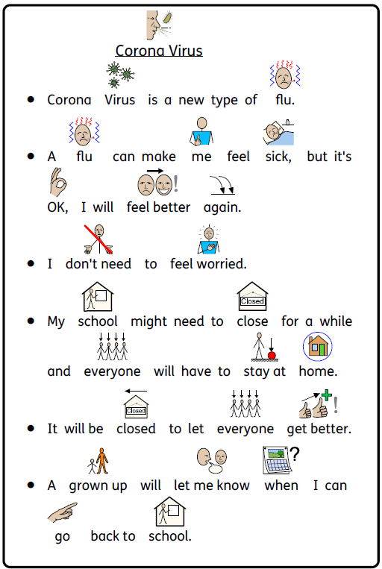
Here is a tool to help you explain the current situation to your child:

David Walliam’s has begun a daily podcast of his books daily!
If you head over to his website: www.worldofdavidwilliams.com/elevenses to gain access to the daily podcasts.
This website also has a range of different resources which are fun games/activities for children to play. For example learning how to draw, spot the difference activities and much more

Google Chrome Music Lab
Accessible through your internet on your phones/tablet. It is a fun website which your children can play on, it allows children to experiment with different sounds of music, also helping children learn new sounds, rhythms, melody and more!

Even though school, early years provision or college might be closed for your child to attend, please remember school staff are available for support in this time. They will be happy to help with resources that you might need.

If any families are aware of any resources or ideas that may help other families please email these ideas to: complexcare@wakefield.gov.uk and we can include in the next bulletin
If you would prefer to receive the bulletin by email please email: complexcare@wakefield.gov.uk
PLEASE NOTE IF EMAILING COMPLEX CARE USE – complexcare@wakefield.gov.uk and copy in INDIVIDUAL WORKERS

