COMPLEX CARE NEEDS TEAM – BULLETIN No.1

Covid-19

We know that Coronavirus (Covid-19) is very worrying for all families. In particular families who need additional support to meet the needs of children with complex care needs. We cannot predict the full impact of this pandemic on services, and will need to remain in regular contact with you to update you of any changes to services. We are aware that this crisis will be causing additional stress and anxiety on you and your children, and that many young people can no longer access their education provision. We hope to use this bulletin to share information and to provide useful guidance and ideas for support.

You should have already been contacted by your social worker to discuss your family circumstances.

Your social worker will have agreed what level of contact you would like. We aim to speak to most families weekly as we are aware family situations will alter depending on whether anyone becomes ill or depending on changing Government advice.

The Complex Care Needs Team will continue to be working and are contactable daily. Monday- Thursday 8.30 – 5.00 and Fri 8.30 – 4.30 tel. 01924 302124. Individual Social workers will share their contact details with you.

Keeping children active – Most children may struggle is they feel confined to the house. Here are some ideas to keep the whole family active
- Joe Wicks – PE lesson at home each day on YouTube 9.00
- Play loud music and dance together
- Water play
- Get some bubbles to blow together
- Try to keep to the usual routine
- If you are able and it is possible get outside. Parks are fine as long as they are not too busy.
- ‘Chase the Rainbow’ campaign – draw, paint, glue a picture of a rainbow and stick it in the window. When families manage to go out for a walk try to find rainbows in other houses windows.
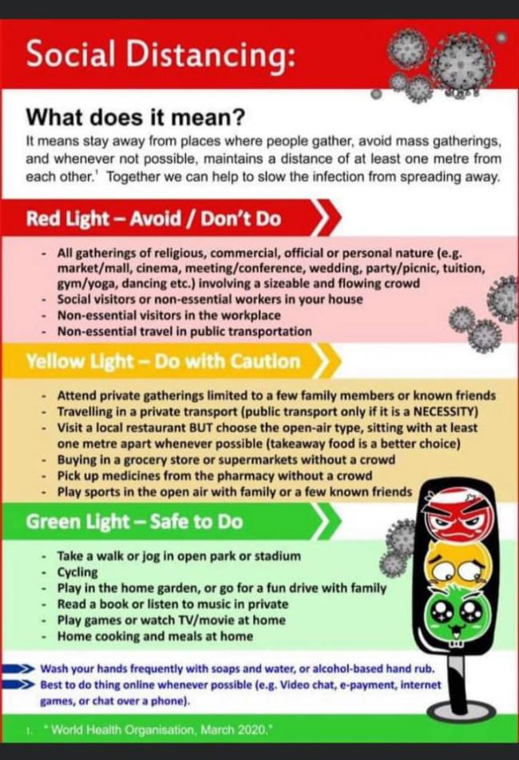

10 top tips
- Try not to shield your child from the news, as it’s likely they will find out somehow from school, being online or from friends.
- Talk to your child about what is going on. You could start by asking them what they have heard.
- Try to answer their questions and reassure them in an age appropriate manner. Remember, you do not need to know all the answers, but talking can help them feel calm.
- Reassure your child that it is unlikely they will get seriously ill, and if they do you feel ill you will look after them. Your child might be concerned about who will look after you if you catch the virus. Let them know the kind of support you have as an adult so that they don’t feel they need to worry about you.
- Give some practical tips to your child about how they can look after themselves. For example, show them how to wash their hands properly, and remind them when they should be doing it.
- Keep as many regular routines as possible, so that your child feels safe and that things are stable.
- Spend time doing a positive activity with your child (e.g. reading, playing, painting, cooking) to help reassure them and reduce their anxiety.
- Encourage your child to think about the things they can do to make them feel safer and less worried.
- Be aware that your child may want more close contact with you at this time and feel anxious about separation. Try to provide this support whenever possible.
- Remember to look after yourself too. If you yourself are feeling worried, or anxious about coronavirus, talk to someone you trust who can listen and support you.

Learning at home : Apps – for tablets or phones
Otsimo – Educational game developed for individuals with learning disorders, attention deficit, autism, downs syndrome, Asperger’s, and other special needs.
Sensory Magma – Magma is a simple calming and relaxing visual app for people with special/complex needs of ALL ages.
Autism nonverbal therapy game – Create your very own artwork using assorted shapes and materials.
Touch Follow FREE – Touch Follow Shapes, Touch Follow Alphabet, Touch Follow Number.
Build it up ADHD & Autism – Build it up app helps with visual perception skills and fine motor skills among toddlers aged 2.5 + years old. It also helps concepts such as size, top and bottom, before and after.

Websites -
Twinkl – Free for the month offering support with home learning packs. Learning videos.
TheSchoolRun – 14 day free trial offering support and home learning for children with SEN.
Sky Badger – Offers resources and advice about home learning for children with SEN.

Even though school, early years provision or college might be closed for your child to attend, please remember school staff are available for support in this time. They will be happy to help with resources that you might need.

If any families are aware of any resources or ideas that may help other families please email these ideas to : complexcare@wakefield.gov.uk and we can include in the next bulletin
If you would prefer to receive the bulletin by email please email: complexcare@wakefield.gov.uk

