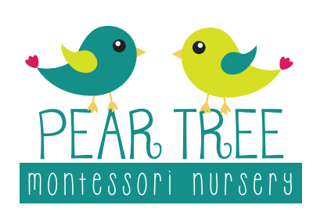
Activities at home
(Under 2’s)
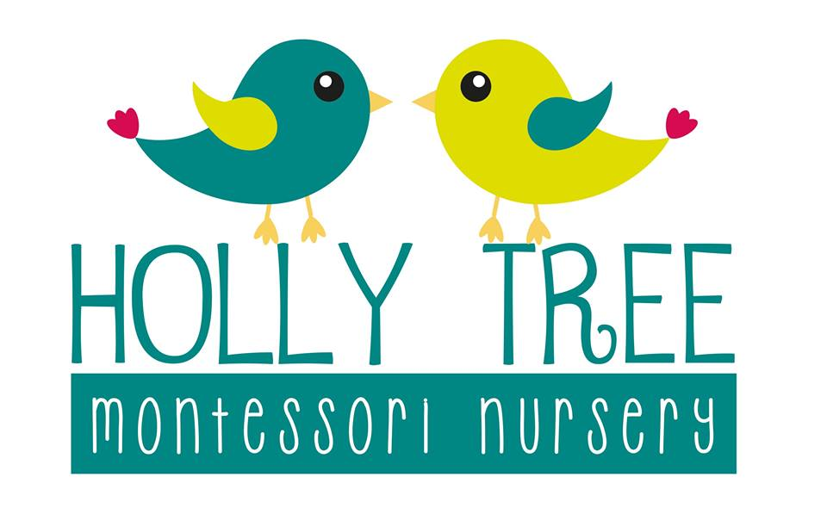

Sensory activities
- Baking – flapjacks, fruit skewers, icing biscuits
- Ice play (could put flowers of food colouring in
- Sponge painting/foil painting
- Shaving foam play
- Make your own scented playdough with scented oils
- Counting number songs/nursery rhymes
- Heuristic play/treasure baskets
- Cereal play
- Flour play
- Feeling for texture e.g in the garden leaves/grass/concrete
- Texture walks – using bare feet

Small activities (work cycle)
- Posting activities – use pipe cleaners/straws/utensil pots
- Mini dustpan and brush
- Sensory basket e.g different types of metal
- Family photo sharing
- Season change sensory bottles
- Tweezers and pom poms
- Representing numbers using mark making tools
- Jigsaws
- Books with puppets
- Sorting coloured balls into groups
- Pouring with plastic jugs
- Transferring with a spoon
Helping around the house
- Helping to colour sort the washing
- Helping to prepare snack e.g cutting banana
- Washing own dolls with soap and water
- Holding the hoover together
- Setting the timer on the microwave when preparing food
- Wiping windows
- Sweeping under the table
- Changing bed covers
- Loading/unloading the dryer
- Planting seeds such as tomato/sunflowers

