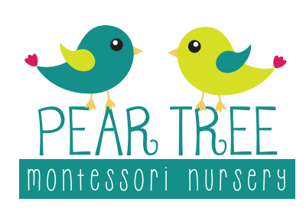
Activities at home
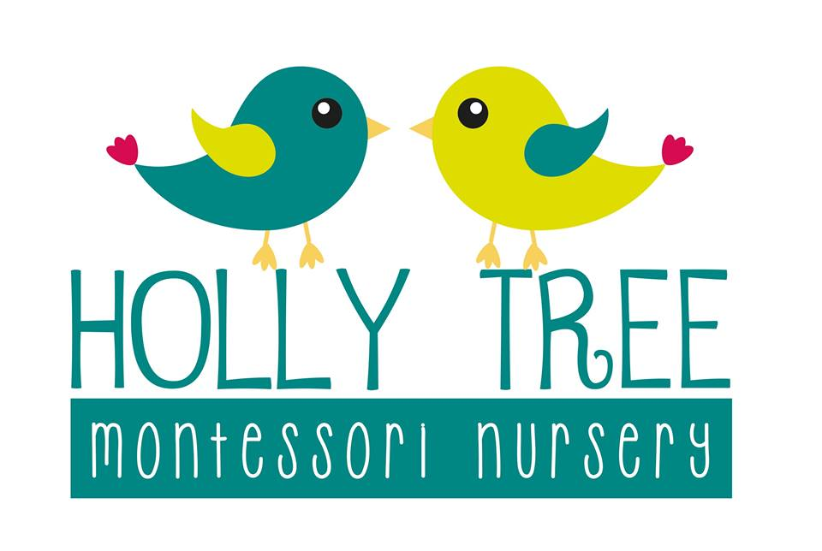
(3+ years)

Literacy
(Promoting use of language, phonetical awareness, rhyming, letter recognition)
- Introducing initial sounds, e.g s, t, c
- Rhyming games
- Matching letters and sounds
- Matching objects to sounds
- Large Moveable Alphabet is free to print at www.naturalbeachliving.com
- Google ‘say it, make it, write’ (CVC words)
- Making rhyming ‘odd one out’ cards
- Building words with lego bricks
- Google phase 1 letters and sounds – so many ideas on here!

Mathematics
(Numerals, quantities, counting, writing, shape recognition, curiosity of the environment, ordering, categorising)
- Sorting shapes
- Looking for shapes in the environment
- Looking for numbers in the environment
- Junk modelling using waste due to be recycled
- Looking at the properties of 2D/3D shapes e.g faces and edges
- Following patterns e.g with beads, lego etc
- Weighing objects – heavy and light
- Sink or float activities
- Number and quantity activities match the amount to the numeral
- Writing numbers using sensory materials
- Matching pegs to number cards
- Playdough splat (addition and subtraction)
Activities of Everyday Living
(supports concentration, fine motor skills, care of self and the environment)
- Pouring (rice, sand, water (with a drop of food colouring), into another jug, into equal measures with multiple cups, pouring through a funnel)
- Folding clothes
- Pairing socks
- Matching nuts to bolts
- Using a screwdriver
- Locks and keys
- Cleaning their own faces
- Brushing teeth
- Polishing mirrors/shoes/brass
- Sweeping using a small dustpan
- Washing pots after meals/drying them too
- Preparing a snack e.g cutting strawberries/bananas
- Peeling vegetables
- Transferring objects from one pot to another
- Threading beads onto a shoelace
- Using the hoover, microwave, dishwasher
- Zipping up coats, putting them onto hangers
Knowledge and Understanding the World
Biology
- Care of plants
- Farmyard animal families e.g pigs, sheep
- Life cycles – frogs/butterfly
- Parts of a….. bird/fish/flower/tree
- Learning about the human body, e.g layers of the body, effects of activity on body
Geography
- Make own land, water, air jars (print of animals/transport to categorise in each)
- Looking at a specific country learning about food, clothing, climate, ways of life
- Jigsaws – maps of the world, oceans
- Use Youtube to look at the structure of the Earth/volcanoes
Investigating
- Experiments – looking at objects that are living/non living
- Floating and sinking
- Paper clip and magnet maze
History
- Look through photo albums, recognising change of self and family members
(Find many free printables online – Instagram/twinkl)
Sensory activities
- Making gloop – cornflour and water (talk about liquids and solids)
- Blow football – straws/paper balls – blow them into the goal
- Make a rainbow experiment (mirror and a bowl of water – pinterest)
- Cars down ramps
- Magnetic and non-magnetic objects
- Magic milk experiment
- Baking soda and vinegar fizz
- Rain cloud in a jar
- Walking water science experiment
- Pepper and soap science experiment
(Pinterest!!!)

