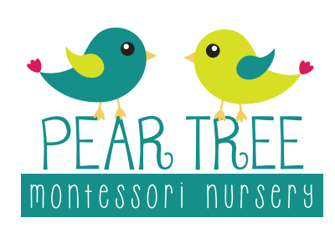
Activities at home
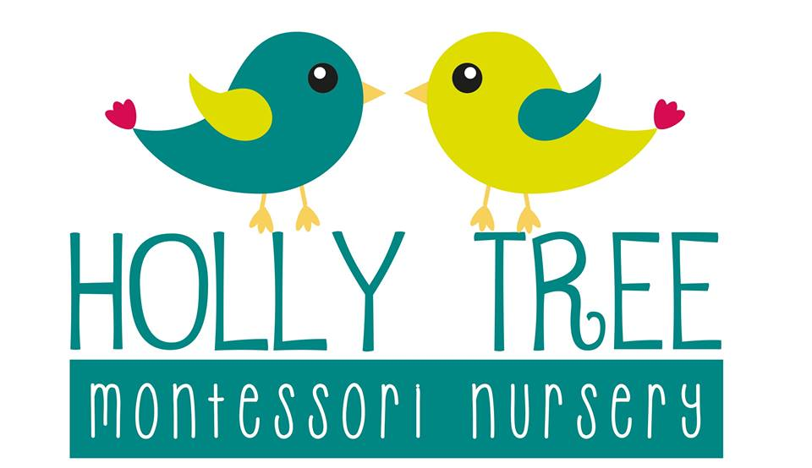
(2 - 3 years)

Creative
- Nature collages using mud/sticks/leaves etc
- Leaf rubbing/bark rubbing with crayons
- Make a ‘story stick’ by trying natural objects to a stick and using them to make up a story or represent a known story
- Set up mud kitchen with some of your spare pans/Tupperware/utensils
- Cutting out of magazines
- Water paints
- Gluing and sticking collage
- Making own playdough with kitchen ingredients

Activities of Everyday Living
- Threading with leaves
- Using tongs to sort objects such as stone, shells, pinecones
- Pouring using dry objects e.g rice, lentils or using water
- Transferring with a spoon, pipette, tweezers or tongs
- Cutting playdough with a knife and fork
- Cleaning a shell, some wellies, glasses
- Shredding paper by ripping
- Cleaning leaves of a plant
- Pegging
- Arranging flowers
- Folding cloths

Literacy
- Reading and writing stories, both indoors and outside – drawing illustrations
- Using sticks to mark make in the mud
- Treasure hunt for things beginning with….
- Making up rhymes
- Odd one out rhyming
- Using an old telephone and notepad
- Mystery bag – alliteration/rhyme
- Simon says
- Dough disco
- Drawing pictures from events of the day – share with nursery at a later date
- Talking jar – fill it with objects from the day to talk about at bedtime

Sensorial
- Making material baskets e.g all metal, wooden materials
- Digging, mixing pouring activities
- Distinguishing between weight using a blindfold
- Stereognotic bag activities (pinterest)
- Scented playdough
- Tasting activities
- Make smell pots with herbs and spices
- Herbs/spice painting
- Make flower perfume

Mathematics
- Sorting sticks and stones by size
- Number hunt with hidden numbers
- Looking for shapes in the environment
- Use a torch to spot the numbers around us in a dark room
- Representing numbers in paint, mud, shaving foam
- Matching socks together by their design
- Making shapes and patterns with found objects
- Writing numbers on stones found outside
- Matching number and quantity

Knowledge and Understanding the World
- Looking for insects/making a bug hotel
- Growing seeds – sunflowers to bring back to nursery
- Making land see and air jars – match with transport and animals in these areas
- Looking through city brochures, different places in the world
- Helping to care for a pet, brushing/feeding
- Looking at google maps – where we live
- Going for a walk in your local streets – looking for street names
- Parts of the body
- Categorising animals into habitats
- Looking through photos – timeline of a child’s life
- Learning dinosaur names with flashcards

