Wakefield Local Offer - You Said, We Did
September 2016

Contents:
Chapter | Page Number
- Introduction | 2
- What is the Local Offer | 2
- How can you ‘Have Your Say’? | 2
- Local Offer Summary | 3
- What is working well? | 3
- What are we worried about? | 3
- What needs to happen? | 3
- You Said We Did about Wakefield’s Local Offer and Services | 4
- Offline Local Offer | 4
- Training Needs | 4
- Short Breaks | 5
- Having Your Say | 7
- Local Offer Website - Summary of Your Feedback and Usage | 8
- Web Statistics for Wakefield’s Local Offer website | 9
- Page Views | 10
- Users | 10
- New and Returning Visitors | 11
- Local Offer Website – Things You Like | 12
- Local Offer Website - Your comments and Our Answers | 13

Report Author:
SEND Transformation Team
- Introduction

What is the Local Offer?
The SEND Code of Practice states that local authorities must publish a Local Offer, setting out in one place information about provision they expect to be available across education, health and social care for children and young people in their area who have Special Education Needs and/or Disabilities (SEND).

In Wakefield, we provide a Local Offer Website . We also produce three newsletters a year, called News and Views, which highlights key services, support, activities and events. We also hold an annual Local Offer Live Event, with over 50 stalls of providers who are part of the Wakefield Local Offer.

How can you ‘Have Your Say’?
We are always collecting feedback throughout the year to help us improve Wakefield’s Local Offer. This feedback is published each September in a You Said, We Did document. All information and feedback in this document is for the period September 2015 until August 2016.
User feedback is very important to us and we value all your comments. We want Wakefield’s Local Offer to meet your needs and to do this we need your help. Please continue to contact us and tell us about your experiences using the Local Offer website and our Offline Offer including support services available in Wakefield.
If you would like to be more involved in having a say in Local Offer Services you can:
- Email us on localoffer@wakefield.gov.uk
- Join the Information Network by clicking here Information Network
- Follow us on Facebook
- Contact TEAM, the Parent Carer Forum for Wakefield on 01924 379015 or email Mellissa.mackell@kids.org.uk
- Contact KIDS WESAIL on 01924 379015 or email wesail@kids.org.uk
- Contact the Youth Service here Youth Service

- Local Offer Summary
What is working well…?
- We have provided a range of ways for people to have their say about Wakefield Local Offer
- The Local Offer website is fully compliant with what the Law tells us should be listed and it offers children, young people, parents, carers and practitioners a searchable site for all relevant information.
- The majority of people like say they like the appearance and content of the Local Offer website.
- The website is constantly updated, with reminders sent 6-monthly to all services listed to double check their information and make sure it is up to date and accurate.
- There are a lot of strengths which we need to keep such as the visual aids and animations.

What are we worried about…?
- Not everyone feels that their voice is being heard.
- The Local Offer website usage statistics indicate the site is used mostly by professionals looking for information on behalf of families rather than families looking themselves.
- People are having to click too many times to find the information they need quickly.

What needs to happen…?
- Keep promoting the feedback pathways and encourage families to register on the Information Network
- Make sure everyone’s contact details on the Local Offer Website are up to date
- Use the feedback to redesign the ways that people can navigate the information available to make it easier and with fewer clicks, i.e. the most searched for information is the easiest to find.
- Highlight the benefits of joining the Information Network to receive regular offline information.
- Simplify the amount of information and make sure all of the links work.
- Find new ways to promote the Local Offer website and help more people to use it.

- You Said We Did about Wakefield’s Local Offer and Services
Off-line Offer
You Said
- You need a handy leaflet about the Local Offer so that we know how to get information quickly, without having to always go online.
- You would like News and Views to have more information about activities and things to do. We also want more real-life stories.
We Did
- We are creating a new Local Offer leaflet – After listening to your feedback this will be wallet sized and fold out displaying what information is available on the Local Offer website and who to contact if you don’t want to go online.
- We now have a separate section for Activities in News & Views and will highlight some of the different groups and organisations in each edition. We have plans to have more interview articles, such as “Meet the provider”… and a section where young people contribute the articles.
- On 9th November 2015 Wakefield Council in partnership with KIDS, TEAM and Oakfield Park School held the SEND Fest at Cedar Court Hotel. The annual event has a number of information and market stalls. This has been a great way for families to find the information they need and speak to representatives from support services as well as view disability aids and toys which are available.
- The Market Place Event develops each year and we have been listening to your feedback. Our newly branded Local Offer Live event will take place on 29th November 2016 and we have been working hard on ensuring more of the support services you want will be attending.

Training Needs
You said
- There needed to be more training available to parents and carers.
- There needed to be more training on specific topics for schools and support services, such as SEN Support, Short Breaks and Personal budgets.

We did
- In December 2015, we delivered 2 briefing sessions to staff in Social Care and the Early Help Hubs about the SEND Reforms.
- In December, we also delivered two information sessions to parents and carers about Personalisation and what this means for families.
- We delivered three training sessions, throughout the year, to school SENCOs and parent carers about Person-Centred Planning.
- In February and March 2016, we delivered two training sessions with schools about Transitioning into Adulthood.
- In April and May 2016, 6 training sessions were delivered on Managing SEN Support in Schools. Over 200 Headteachers and SENCOs attended, representing 130 schools and academies. This is a 92% uptake.
- In April, we delivered two briefing sessions for staff working in the Early Help Hubs about the SEND Reforms, what support and services are available and what they all do as well as information about Short Breaks and how they can support families with these.
- KIDS WeSAIL and Wakefield Council’s SEND Support Services have produced a training plan for parents for the next academic year. The information is available here Training Opportunities
- We have recently completed a Training Needs consultation to help gather more feedback from families, schools and support services about what training they need.
- The questionnaire was available on the Local Offer website so families could complete this and it was also circulated to schools and services. We are currently analysing this feedback and this will help form our Training Plan. The plan will ensure that the training needed is provided in a timely and co-ordinated fashion.

Short Breaks

You said
- You didn’t feel there was enough opportunities for ALL families to have their say about the ongoing Short Breaks consultation
- There wasn’t enough notice about consultation events and they weren’t always at times that suited you.
- The information about the Short Breaks Review was difficult to understand and not everyone could see how it related to them
- The Short Breaks review had been going on for a while and you needed regular updates.

We did
- We redesigned the Short Breaks Consultation documents and made sure that everything was covered in one go.
- We worked with parent reps and the organisations that support families to help make sure the wording and questions were as easy to understand as possible.
- They also helped us produce a series of Frequently Asked Questions and Case Studies to help families understand what was being asked and how it might affect them.
- We made sure we gave plenty of notice about the upcoming consultation events and planned events to run on different days and different times, including evenings at locations throughout the whole district. We also ran a family fun day during February half term so that families could attend together.
- We attend groups where parents already met to do more face to face consultations and answer questions.
- We sent the consultation directly to over 1300 addresses. We published information on our Facebook page and Local Offer website and made sure all of the schools, support organisations and staff working with families had the information to share and promote the consultation, to make sure no one was missed out.
- We created a page on the Local Offer website to keep everyone updated. More information is below:

During February 2016 Wakefield Council consulted with families about Short Breaks

The purpose of the consultation was;
- To share proposals for Short Breaks for children and young people with disabilities
- To enable you to have your say about each of these and let us know if we could do anything differently to help improve the proposals
- The consultation helped inform the future decision making process regarding Short Breaks.

There were four main proposals which families had the opportunities to feedback about;
- Community-Based Groups
- Eligibility
- Allocating Support Based on Need
- Transport

How we consulted;
- A questionnaire was available online
- A questionnaire was posted out to families
- We held workshops with exercises to help gather feedback
- We offered 1 to 1 discussions

A summary of the feedback is available on the Local Offer website here as is an update on what has happened since the consultation finished.

Having Your Say
You said
- We still don’t feel that our voice is being heard.

We did
- To improve ways in which feedback can be listened to and actioned, we have developed a Feedback Pathways system. This system allows parent/carer groups, young people’s groups and community sector groups meet in their usual ways and then pass their feedback and issues arising upwards into the Local Offer & Engagement workstream hosted by Wakefield Council.
- All feedback brought to the attention of the workstream is recorded in the Feedback Log, and actions agreed by the various working groups and workstreams. Updates are provided back to representatives to share with everybody so that people can see more clearly that their feedback is important and we do listen and action what we can.
Below is a snapshot of some of your feedback recorded in the feedback log;
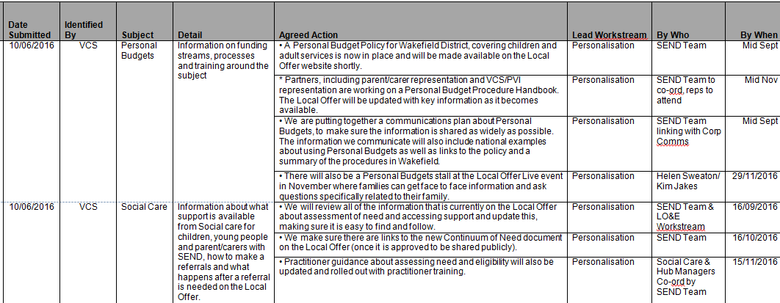

If you would like to be more involved in having a say in Local Offer Services, please see the contact details in the Have Your Say section at the beginning of this document.

- Local Offer Website - Summary of Your Feedback and Usage
During summer 2016 we opened a Local Offer questionnaire to help us review the website. This questionnaire was circulated to Parent/Carer, Young People, Schools, Colleges, NHS and Voluntary/Community sector groups. It was also available on the Local Offer website itself. 42 people responded.
Below is a summary of the feedback.
How users rate the appearance of Wakefield’s Local Offer website?
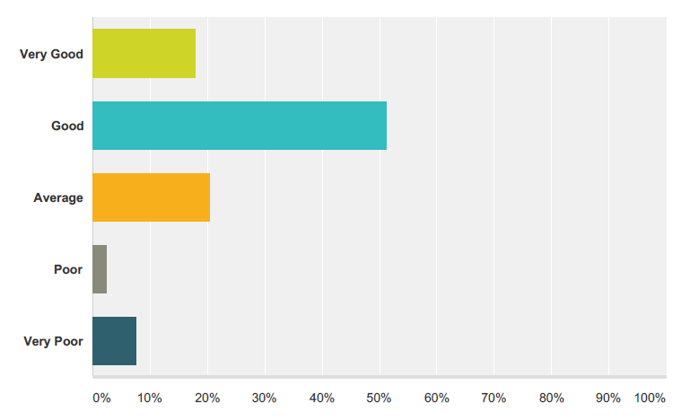
How users rate the content and information on Wakefield’s Local Offer website?
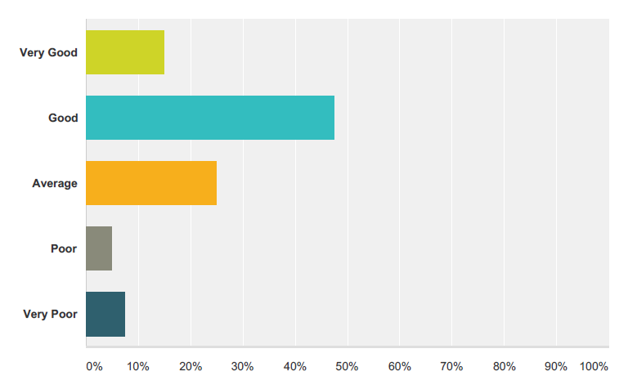
Can users find information quickly and easily on Wakefield’s Local Offer website?
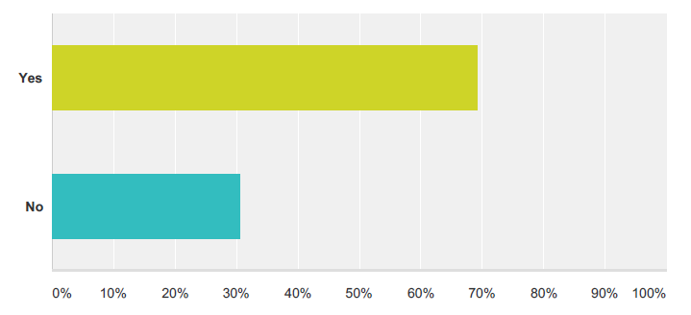
Is Wakefield’s Local Offer website meeting its user’s needs?
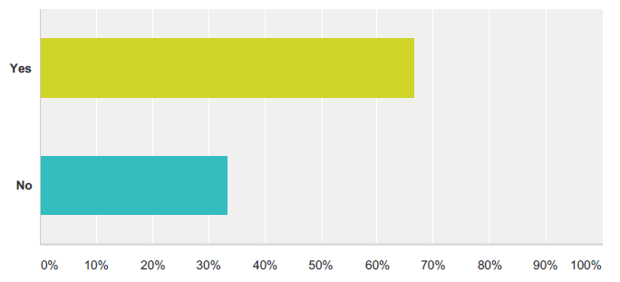
Web Statistics for Wakefield’s Local Offer website
Below are the web stats from the Local Offer website for the period September 2016 to August 2016.
- 63% of respondents to a recent survey about the Local Offer thought the content on the Local Offer website was good or very good, however, 13% thought the content was poor/very poor.
- 69% of respondents could find the information they needed quickly and easily with almost the same number (67%) stating it currently meets the needs of its users. However around a third of respondents did not agree.
- The number of page views of the Local Offer Website shows a downward trend since January 2016 whilst the number of users appears to fluctuate over term times and schools holidays .
- Approximately a third of visitors to the website each month are new.
- There were 349 unique users of the Local Offer website in the last 12 months.
- The average time spent looking at information was 7 minutes 39 seconds

Page Views
There were a total of 11,968 Page views in the last 12 months. The monthly split is below:

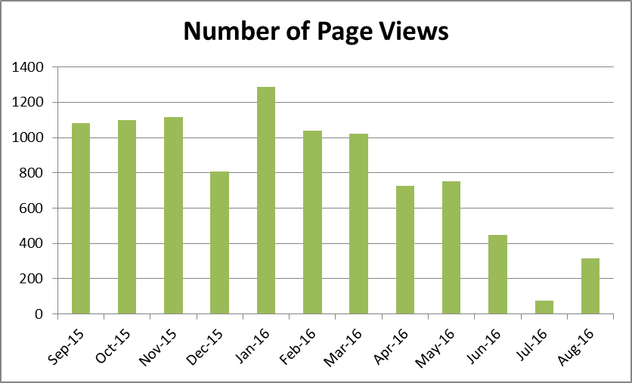

Users
There were 349 unique users of the Local Offer website in the last 12 months. The monthly split is below:

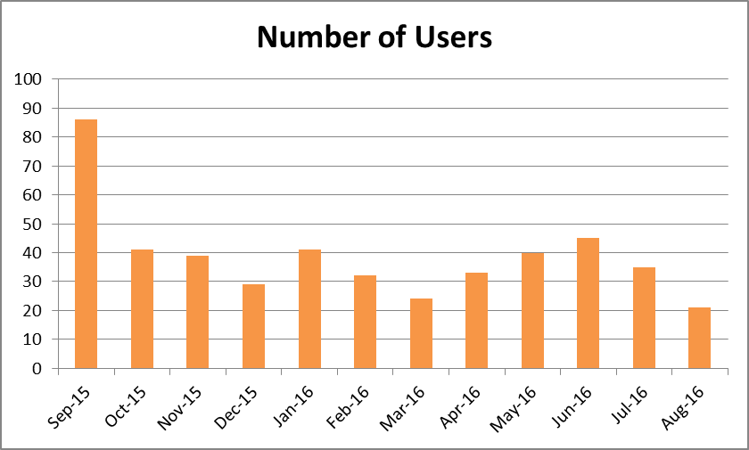

New and Returning Visitors
In the last 12 months, 30.3% of visitors were new to the website.

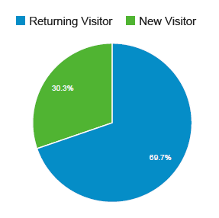

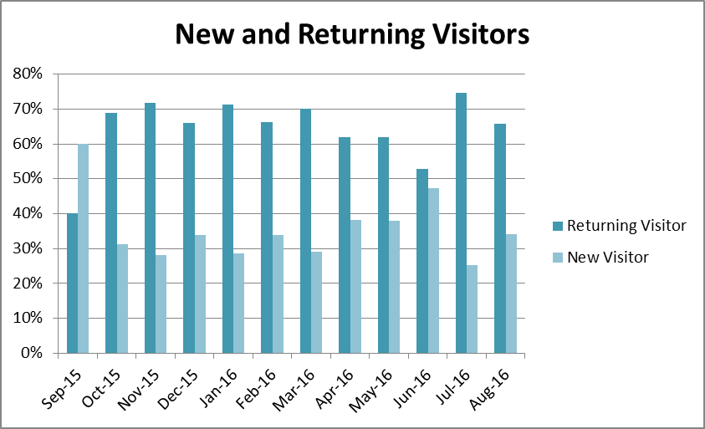

- Local Offer Website – Things You Like
Users of Wakefield’s Local Offer website identified the following strengths;
- Like the animations for parents.
- Simple layout, good search function, easy to find information.
- Easy to use, clearly signposted information.
- Information is set out clearly and seems user friendly.
- I like that it is accessible and readable. The question and answer format works very well.
- It is easy to use and directs you to the right place easily.
- Lots of information, clear sections.
- Visually very clear.
- Most of the information I need is there.
- The separate age categories to find specific information.
- The links to other sites e.g. Connect to Support Wakefield.
- The exemplar forms are useful for SENCOs.
- Easy to find information.
- Has links to other sites and help.
- Looks nice.
- It is clear and succinct.
- Simple and easy to use.
- The navigation is quick and gets you to where you need to be fast.
- Useful to have visual aid information as well as just written.
- Visual aids fab.
- Good range of videos and links to documents as well as lists of other services.
- Lots of information.
- I like the little film shows for the EHCP.

- Local Offer Website - Your comments and Our Answers
We value and consider all your feedback and where possible strive to action these. Where we have received a few comments that are similar, we have grouped them.
Below are the comments we have received along with our answers.

Your comment: Events in the area and activity groups.
Our answer: We do have a calendar of events which can be found on the homepage of the Local Offer website. We try to add as many events to the calendar as possible; however we need people to make us aware of events they know about. We are making efforts to strengthen links with Parent/Carers, Young People, Schools, Colleges, NHS and Voluntary/Community sector groups so they inform us of any upcoming events and activities.
We also publish news on events and activity groups on our Facebook page and in the News & Views newsletter.

Your comment: There are no Nursery Schools listed on the site either under Early Education and Childcare Providers or Schools. All 3 Nursery Schools offer provision from 2 years old including for children with SEND. This is a grave oversight and omission of settings which can offer parents of children with SEND high quality Early Education
Our answer: Thank you for pointing this out. We will add details of the three Nursery Schools as soon as possible.
We do not list all other nurseries individually on the Local Offer as we have a link through to the Wakefield District Family Services Directory where users can find information on Nurseries, Childminders, Holidays Clubs and more.
This may not be easy to find and we are currently reviewing the structure of the website so users can find the information they need.

Your comment: Clearer contact details for some of the services - LSS/EP/CIAT
Our answer: Each service’s webpage should display clear contact details for the service, although we are aware some contact details are missing. We contact services every 6 months asking them to update their webpage and will continue to do this. We have also been checking through each webpage and trying to update these ourselves.

Your comment: More activities for the children with disabilities, better support for parents and carers, and more training at a time when parents can attend.
Our answer: We have created a Feedback Pathways system so parent/carers, young people and support groups can let us know about any activities for children with disabilities so we can add them to the Local Offer, advertise on the SEND Facebook page and in the News & Views newsletter.
We have recently done a Training Audit to identify the types of training parents feel is needed most. After each training session provided we use evaluation forms so we can gather feedback to help improve future sessions.
KIDS and the Council’s SENDS Services are also providing a number of information and training opportunities for parents, carers and professionals. Please click here.

Your comment: I'd like to find out more about a medical condition, help available and to help me understand what the condition is, does and how I can help my son in ways that he will understand, and hopefully lead to a happy family life.
Our answer: Information on medical conditions can be found in the ‘Health’ section of the Local Offer and we will expand this section, however if the medical condition isn’t there which you are looking for please tell us – localoffer@wakefield.gov.uk
There are also links on the Local Offer to the NHS website which has further information on medical conditions - http://www.nhs.uk/Conditions/Pages/hub.aspx We will add a link to this page on the Local Offer website too.

Your comment: I worry that parents with learning difficulties will struggle.
Our answer: When we have asked services to review their webpages we have asked them to ensure information is written in plain English, is clear and abbreviations aren’t used.
We have made many small changes to the structure of the website so users can find what they are looking for such as an improved search function, more categories and added more videos.
We have also displayed the contact details for KIDS WeSail for users who can’t find the information they are looking for or who are having difficulties with the website. KIDS WeSail are happy to answer any queries and offer support to those who may need it over the phone.

Your comment: Instead of the individual boxes for each club, should have a list and a short intro to the club/service. It takes too long to click on all of the boxes and then frustrating when it is not the info you want.
Our answer: When the Local Offer first went live in September 2014 the services were in a list format and this wasn’t popular with users, however it is possible to add filters so users can view services which are only appropriate to them.
We know clicking lots of boxed can be frustrating so we are looking to introduce more hover buttons so users can see what a service does without clicking into the service/box.

Your comment: Paper based promotion materials would be useful at the start of each year to handout to parents etc. to make them aware of the site.
Our answer: We have designed a Local Offer leaflet in form of a Z-card, new in September 2016. This is wallet sized and will fold out displaying further information on the Local Offer. We will distribute these throughout our networks including those who deal directly with parents.

Your comment: A pretty pathetic offer to be honest. This is just a compilation of lists that can be accessed from anywhere online. Seems like there's little information on provision outside the Wakefield District. As provision within the district has proved to be woefully inadequate at best and downright discriminatory at times the very least this site could do is provide detailed information to alternatives. Although I assume there is little point to this as Wakefield Council would prefer that children receive a substandard education rather than spend money investing in their future by paying for education which would meet their special educational needs when the local authority has repeatedly failed to do so. Not at all impressed and unfortunately not at all surprised.
Our answer: We are sorry to hear that you feel this way about the Local Offer.
Every Council has to produce a Local Offer of services and support it expects to be available in its local area. As such, we try to keep the services and providers in the Wakefield District as up to date as possible and we have links to all of our neighbouring Council’s Local Offer websites. Our neighbouring Councils do the same to make sure that everyone can search for the information they need.

Your comment: Not easy to find the information you need.
Our answer: We have re-structured areas of the website, added in tabs, more categories and added filters to search results. We are aware the structure of the website needs reviewing and we are currently doing this; we are hopeful that further improvements to the structure will be made shortly.

Your comment: There's an awful lot of white, inconsistences with images, where text is i.e. not all the same height in boxes etc. There’s addresses missing off activities so you don't know where things are taking place. There's very little info about some activities. It's boring once you get off the home page.
Our answer: Unfortunately the current structure of the website doesn’t allow us to fill all the white space as users may like, this is something we are researching.
Images used were approved by groups including parent/carers, young people and support services, however we are always on the lookout for more images and encourage people to send us images they would like to see on the website so please contact us.
We have been working through the webpages, tidying text boxes and filling in missing information, including addresses, and will continue to do this.

Your comment: If it's not emailed to parents about what actually is on offer it gets missed, why is there no newsletter emailed out on activities and support?
Our answer: We currently produce a termly newsletter which includes information on activities and support. Parent/carers are eligible for this newsletter to be emailed or posted to them, but need to be registered on the Disabled Children’s Register (Information Network). Please click here if you would like to register.

Your comment: I think the appearance is a little bland. I tried to find the page for our organisation and couldn't find it via the menus.
Our answer: The search function has been developed and is proving to be very useful in finding the service users are looking for, however the structure of the website still needs to be improved and this is something we are developing, including the appearance.

Your Comment: what is referred to as the 'matrix' is not there. It is very difficult to find what you need if you are not already a professional working in the authority. Some of the steps on the pathway are misleading e.g. MSP to be reviewed 3x a year before EHC request can be made. Sometimes it is clear on first review that EHCP is needed especially in early years.
Our answer: The matrix can be found in the Education Health & Care Plan section - http://wakefield.mylocaloffer.org/education-health-and-care-plans. Thank you for highlighting that the one link was not working.
We are aware that some users are having problems finding what they are looking for and we are looking at ways of restructuring the website including the Education Health and Care Plan section to make it easier to find the information you want, quickly.
We are also looking to simplify the amount of information currently available about Education, Health and Care Plans.
Your Comment: Not all of the links actually link e.g. the link to named schools. The videos on EHCP cannot be viewed because 'Content was blocked because it was not signed by a valid security certificate'.
Our answer: We request all services to view and update their webpage every six months ensuring all web links are checked and work, however we now have access to a Content Management System so we can update web links ourselves. Over the next few months we will check each webpage, ensuring information and web links are up to date.
Unfortunately we can’t help you with the videos not working because of the security certificate. All security certificates are updated regularly and we have been informed that this issue is likely down to the computer/internet browser being used by the person searching needing to be updated. We haven’t had any reports of users experiencing this problem, but iIf you are having this problem on multiple computers then please contact us and we will explore further.

Your Comment: Some information I can't find as quickly as I'd like - contact details
Our answer: We request all services to view and update their webpage every six months ensuring all contact details are available and up to date, however we now also have access to a Content Management System and we can update details ourselves. Over the next few months we will check each webpage ensuring information is up to date and we will also be developing the structure of the website.

Your Comment: Kids WeSail does not have the support or information offered to parents, I work full time and so does my partner. We struggle for support as school don't offer breakfast club or after school club for my disabled child. Is ok having the information online but it's not being emailed or shown to parents, we all don't get much time to browse the Internet.
Our answer: Kids WeSail are available to provide information and advice and you can contact them by phone or email. We are also happy to email information to users. Please contact us with the information you need and we can email or post this to you - http://wakefield.mylocaloffer.org/feedback
Families can also register onto the Information Network Database and receive our termly newsletter, News & Views, which includes information on services, upcoming events and more.
There is an annual Local Offer Live event, where families can meet providers face to face. This is taking place on 29th November 2016.
Your Comment: I had never heard of it, it's clearly badly advertised
Our answer: We have tried many ways to advertise the Local Offer website. We circulate leaflets with schools, Early Help Hubs, Practitioners and WeSail circulate the Local Offer leaflet with families. We have also attended a number of events with a Local Offer stand where people can find out more information. Furthermore we have attended Parent and Young People’s groups to make them aware of the website.
Unfortunately we are aware our advertising isn’t reaching everyone it needs to and we will look at new ways to do this. If you have any suggestions, please contact us to let us know.

Your Comment: Depending on how you search it can sometimes be difficult to find what you are looking for.
Our answer: We have made a number of changes to the structure of the website including adding more categories, more tabs to split information and improved the search function.
We are still aware some users can’t find the information they are looking for and we will continue to improve this. The search function is being looked at as part of a website restructure.

Thank you for all your feedback –
For further comments please contact us at: localoffer@wakefield.gov.uk

