**Barnardo’s Wakefield CAPS**

**Helping young people to stop, start and change**



CAPS Quarterly Newsletter August 2015

**Hello there from the Wakefield CAPS team!**

Welcome to the first addition of our new newsletter! We will be emailing out a newsletter to share an overview of the work we have done every 3 months. This newsletter covers our work April – June 2015. This is the first newsletter in the new CAPS contract. Below are some of the headlines of changes. We continue to provide advocacy support to young people who at looked after, subject to child protection plans or having an Education Health and Care plan reviewed or written. We also run a busy Independent Visitor Service, undertake missing interviews, intro to care visits and placement move interviews and participation work. Each newsletter we will have an area of work ‘in the spot light’. Any ideas for future features please get in touch.

**CAPS Staff update**

CAPS have waved goodbye to Chris Winship – Senior Advocate with CAPS since the early 2000’s. She made the brave decision to move on to pastures new and left the team in May. We had a great send off for her in York.

July saw a new Advocate start with the team. Leanne Abbott had an interview with professionals and a young people’s panel, we are really pleased to welcome her to the team. Leanne has recently finished her social work degree and was with CAPS on placement last year.

Also joining the team is Nina Bukowski. Nina joins the team as an As and When Worker and will support us with Placement Move Interviews and Child Protection work as needed.

Leanne Abbott Nina Bukowski

**What’s New?**

**MISSING**

We can now support all young people who looked after **and** missing for 24hrs or more. Ring the team with your referrals once a LAC manager has approve it.

**HELPLINE**

We now have a young person’s out of hours number for all children who meet our criteria and want an Advocate. This number will be staffed by Barnardo’s staff who will take the call, offer support and get an CAPS Advocate to ring them back the next day. The number for young people is:

**07825377513**

**FAMILY GROUP CONFERENCING.**

IST can now refer for advocacy support from CAPS if the young person is at risk of being accommodated.

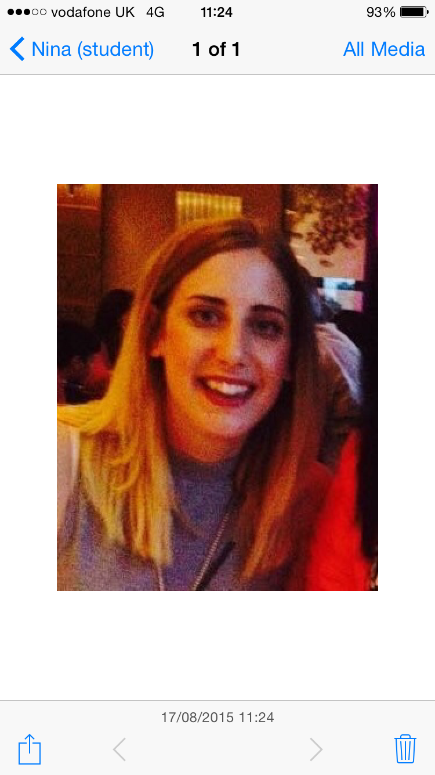



**Mailing List -**We are looking at starting an (e)mailing list for the newsletter. If you would like a direct copy of our newsletters and updates from CAPS please send your name and email address to:

[WakefieldCAPS@barnardos.org.uk](mailto:WakefieldCAPS@barnardos.org.uk)

Young person feedback…how has advocacy helped?

**Helped me gain more understanding of the process** (LAC)

**What we have been up to in numbers:**

This quarter CAPS has received:

**64 Looked after Children’s Advocacy Referrals.**

**52 Placement Move Referrals** (We visit young people who have moved placement to feedback their experienced to the local authority)

**16 Intro to Care Referrals** (we visit all young people over 10 who have recently come into care to ask about their experiences and give them information and guidance)

**9 Missing from Care Referrals**

**40 Child Protection Advocacy Referrals**

**1 complaint advocacy referral**

In addition to this we continue to do regular drop ins at Dacre, Benson and York Villas

As part of this work we have made 35 out of area visits to see young people and offer support.

**EHCP**  
Our Advocacy within Education Health & Care Plan project is now funded to the end of July 2016 with 61 advocacy referrals so far and many more expected in September 2015!

**Independent Visitor Service**

We currently have 15 young people matched with an independent visitor with more recruits recently been trained in June.

**Participation Work**

We continue to support and attend young people’s forums such as 16+ forum, CICC and MAD.

In the last 3 months we have also trained and supported young people to deliver part of the Core Group Briefings alongside the Safeguarding Team.

Barnardo's Wakefield CAPS

Castleford Civic Centre

Ferrybridge road, Castleford

WF10 4JH Phone: 01977 552 493

Free phone: 0800 0121 552

E-mail: wakefieldcaps@barnardos.org.uk

**Want to make a referral? Please contact us at**

**CAPS NEEDS YOUR HELP!**

**Don’t forget if you have a young person who needs advocacy support and they are looked after or on a child protection plan just ring and make a referral**

**(no forms to fill in!)**

**CAPS visits to Teams**

CAPS would like to come to team meetings to talk more about our work and how it fits in with the Signs of Safety model adopted by Wakefield. So far we have booked in with SENART and IST.

We are particularly interested in services that support young people who are looked after or subject to child protection plans. Please email your team meeting dates or ring the team to arrange a visit.